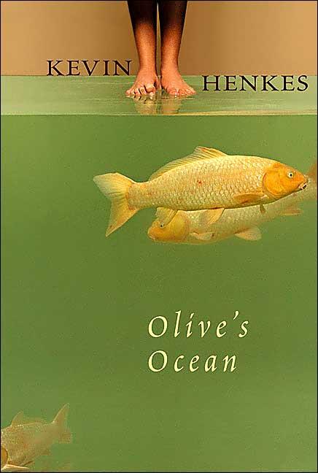
Olive’s Ocean
By Kevin Henkes

Just before going to her grandmother’s, Martha receives a strange gift -- a page from the journal of a dead classmate she hardly knew. Upon reading Olive’s words, Martha realizes that she and the friendless girl were very much alike and could have been friends.

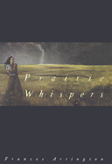
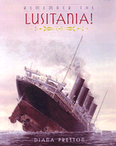
Prairie Whispers
By Frances Arrimgton

Only Colleen knows that her baby sister died just after she was born and that Colleen put another baby in her place. Then that baby’s father shows up and makes trouble for her and her family on the South Dakota prairie in the 1860s.
Remember the Lusitania!
By Diana Preston

An account of the World War I German torpedo attack on and the sinking of the passenger liner, the Lusitania, describing the experiences of some of those involved.

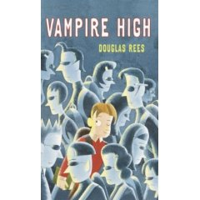
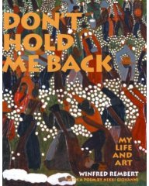
Vampire High
By Douglas Rees

When Cody enters Vlad Dracul Magnet School, many things seem strange, from the dark-haired, pale-skinned, supernaturally strong students to Charon, the wolf who guides him around campus on the first day.
Don’t Hold Me Back
By Winfred Rembert

Through words and paintings, an artist tells about growing up on a cotton plantation in Cuthbert, Georgia, serving time in prison for his actions during a civil rights demonstration, and finding a purpose and direction in life.

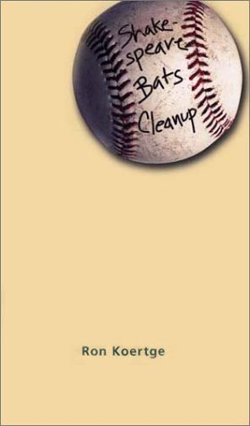
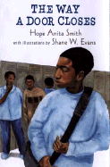
Shakespeare Bats Cleanup
By Ron Koertge

When a baseball player catches mononucleosis, he discovers that keeping a journal and experimenting with poetry not only helps fill the time, it also helps him deal with life, love, and loss.
The Way a Door Closes
By Hope Smith

A young African-American teen struggles to accept a father who has walked out on his family. (A novel in poems)

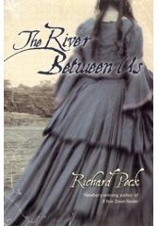
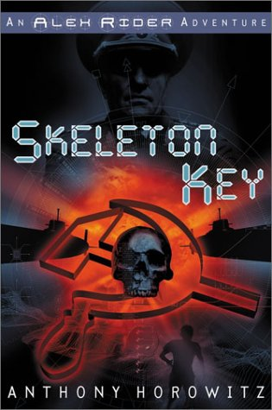
The River Between Us
By Richard Peck

During the early days of the Civil War, the Pruitt family takes in two mysterious young ladies who have fled New Orleans to come north to Illinois.
Skeleton Key
By Anthony Horowitz

Reluctant teenage-spy Alex Rider, on a routine mission at the Wimbledon tennis championships, gets caught up in Chinese gangs, illegal nuclear weapons, and the suspect plans of his Russian host, General Sarov.

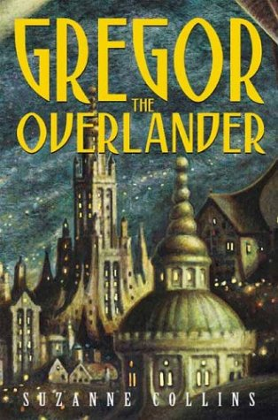
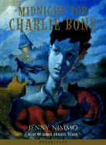
Midnight for Charlie Bone
By Jenny Nimmo

Charlie Bone’s life with his mother undergoes a dramatic change when he discovers that he can hear people in photographs talking.
Gregor the Overlander
By Suzanne Collins

When Gregor and his two-year-old sister are pulled into a strange underground world, they trigger an epic battle involving men, bats, rats, cockroaches, & spiders while on a quest foretold by an ancient prophecy.

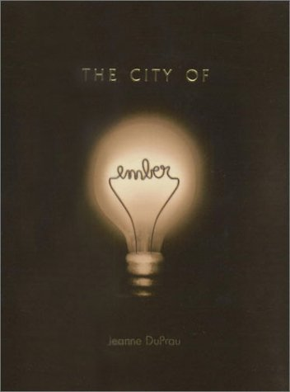
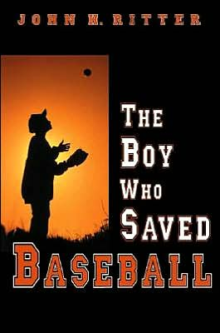
The Boy Who Saved Baseball
By John Ritter

The fate of a small California town rests on the outcome of one baseball game, and Tom Gallagher hopes to lead his team to victory with the secrets of the now disgraced player, Dante Del Gato.
City of Ember
By Jeanne DuPrau

The city of Ember is a decaying place with no natural light surrounded by the vast unknown. Most of the complacent citizens seem to ignore the food shortages and frequent blackouts. Lina and Doon seem to be the only ones looking for a way out.

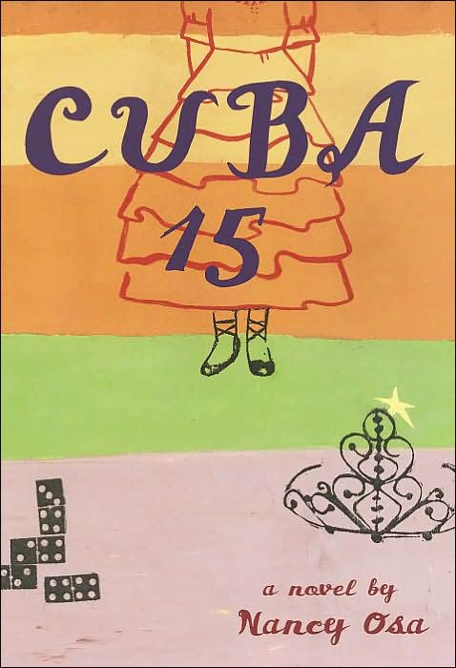
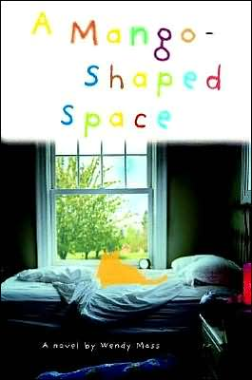
Cuba 15
By Nancy Osa

Violet Paz, a Chicago high school student, reluctantly prepares for her upcoming “quince,” a Spanish nickname for the celebration of a Hispanic girl’s fifteenth birthday..
A Mango-Shaped Space
By Wendy Mass

Afraid that she is crazy, thirteen-year-old Mia, who sees a special color with every letter, number, and sound, keeps this a secret until she becomes overwhelmed by school, changing relationships, and the loss of something important to her.

