Hurricane Katrina Restoration Assistance
On behalf of:
Alabama, Louisiana, and Mississippi

Katrina:

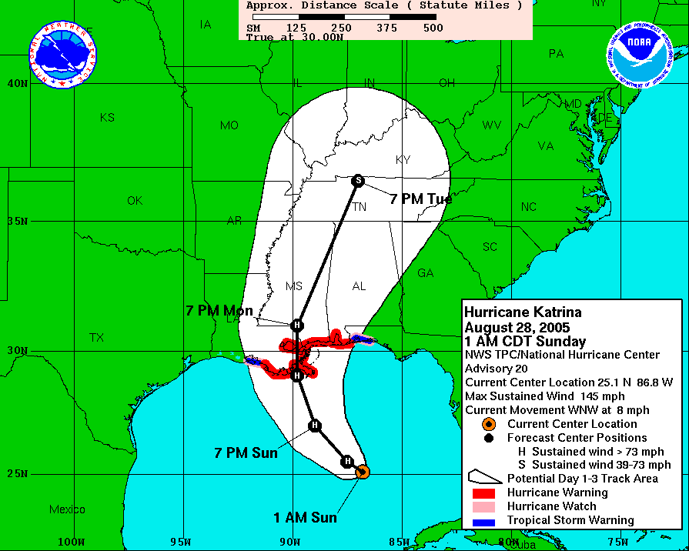

Timeline:
August 29
• 4 a.m.: Hurricane Katrina is downgraded to a strong Category 4 storm.
• 7 a.m.: Katrina makes landfall on the Louisiana coast between Grand Isle and the mouth of the
Mississippi River.
• 11a.m. Katrina makes another landfall near the Louisiana-Mississippi state line with 125 mph
winds.

Quote:

CBS News – Sept. 11, 2005: The government never has dealt with a disaster of this scale: 90,000 square miles of the Gulf Coast affected, with hundreds of thousands of people displaced and an entire metropolitan area under water.

Preliminary Data on Affected Schools and Libraries in
Alabama, Louisiana, and Mississippi

State | Libraries Destroyed | Schools Destroyed | Libraries  Damaged  Condition | Schools  Damaged  Condition | Affected Population
Alabama | 1 | 1 | 0 | 0 | 3212
Louisiana | 4 | 82 | 70 | 229 | 968,096
Mississippi | 6 | 28 | 29 | 280 | 320,266

Note: Many Mississippi and Louisiana schools and libraries are inaccessible and contaminated; therefore, have not been fully assessed (Louisiana has 212 schools and 13 libraries remaining to be assessed).

Representatives from the three affected states: Alabama, Louisiana, and Mississippi respectfully request the FCC grant a reconsideration of rules that restrict when and how an eligible entity may request discounts for eligible products and services. The replacement of technology within schools and libraries is just a small portion of what is needed to get schools and libraries back to the point that they can perform their functions of teaching and providing community service.

Following the guidance issued by the Ysleta Order (adopted December 04, 2003), specifically Paragraph 67:

67. A rule may be waived where the particular facts make strict compliance inconsistent with the public interest.177 In addition, the Commission may take into account considerations of hardship, equity, or effective implementation of overall policy on an individual basis.178 In sum, a waiver is appropriate if special circumstances warrant a deviation from the general rule, and such deviation would better serve the public interest than strict adherence to the general rule.179

We request the FCC to “direct the Administrator to re-open the Funding Year 2005 filing window for all of the applicants” (Para 74, Ysleta) affected by the Katrina disaster. This would allow those affected schools and libraries the opportunity to rebuild and repair their Local Area Networks and Wide Area Networks in order to get students back into their classrooms with some semblance of normalcy.

There are four scenarios in which the affected schools and libraries may find themselves:

- Minor damage to structures, but after repair, will allow the schools and libraries to re-open in a few weeks.
- Major damage to structures, but after repair, will allow the schools and libraries to re-open in a few months, but prior to June 30, 2006.
- Schools or libraries, primarily due to levels of damage, will have to relocate in a temporary location, until structures are repaired or rebuilt.
- Total destruction to structures which will have to be repaired or rebuilt, starting after July 1, 2006.

We are seeking immediate assistance for those entities that fall into categories 1, 2, or 3. These entities will need assistance prior to June 30, 2006.

All affected entities, regardless of current discounts, and regardless of current FY2005 471 filings, should be allowed to post a FY2005 471 seeking a 90% discount on E-Rate eligible services, covering the period of September 2005 through September 30, 2006 for non-recurring services and July 1, 2005 to June 30, 2006 for recurring services.

Many affected entities, and certainly those that fall into categories 3 and 4 above, will need the ability to apply for Katrina relief in the subsequent funding years, until reconstruction has been completed.

The State E-rate Coordinators, acting under the guidance of the state and the FCC, and on behalf of the affected entities, will coordinate the application process to limit the potential for Waste, Fraud, and Abuse within this special period.

Funding for this critical time (FY 2005-06) of need should be provided by the $365 million rollover funds that are available to the Administrator. Also, with the cancellation of many of the existing FRNs currently held by the affected entities, and with those monies becoming additive to the $365 million, there should be adequate funds to cover these special needs. With the funding for this special period being provided by carryover funds, the remaining FY2005 applicants and specifically FY2005 requests for Internal Connections should not be affected. The Administrator should be directed by the FCC to continue issuing FCDLs for FY2005 so the rest of the country can get back to business-as-usual.

Further Details are provided below.

FCC Hurricane Katrina Restoration Assistance

A reconsideration of E-Rate rules is being requested for hurricane relief in the states of Alabama, Louisiana, and Mississippi.

Goal: To expedite the restoring of network infrastructures in schools and libraries in three states to the same functionality prior to hurricane Katrina. Restoring may include temporary relocation of services until permanent facilities are completed.

We request the FCC to consider:

- Opening a special Katrina filing window similar to that set by the Ysleta decision for affected entities

- Allow affected eligible entities to receive E-Rate eligible products and services at a 90% discount for reconstruction and/or temporary services only. Reconstruction is not limited to a single funding year

- Reconsideration of technology plan approval for services requested during the Katrina window

- Extensions of form deadlines for all affected entities

- Reconsideration of “2 out of 5” rules for affected entities and entities that procure on behalf of entities

- Reconsideration of rules governing transfer of equipment

- Reconsideration of certifications where necessary

- Reconsideration of recordkeeping rules for damaged or missing documents

- Allowing Block 4 data to follow the guidelines of new construction

- Flexibility in determining the contract end date for services requested in the special Katrina window

- Reconsideration of LOA requirement for filing a state Consortium Form 470

- Reconsideration of Form 470 28-day rule if allowable under State Emergency Procurement rules

- Reconsideration of the service start date to allow entities to purchase items prior to July 1

14. Reconsideration of the Item 25 certification on Form 471

The state E-Rate Coordinators for Schools and Libraries in Alabama, Louisiana, and Mississippi commit to develop safeguards to protect the fund from Waste, Fraud and Abuse and insure that only affected entities apply for funding under this Reconsideration.

Process for Implementation of requests:

- Special Katrina Window

The state E-Rate Coordinators will identify and certify affected entities eligible to file in the Katrina Restoration assistance. One method of uniquely identifying eligible entities is to add a “K” to the present entity number.

This special entity number can only be used for restoring networks to the same degree of functionality prior to the hurricane. Restoring services may include temporary services for temporary locations.

Entities with unique identifiers will be given funding priority during the duration of reconstruction. Special identifiers will be removed upon certification of project completion by State E-Rate Coordinators.

Open special Katrina Form 471 60-day filing window for affected entities to install goods and services by June 30, 2006.

Affected applicants will be allowed to apply for E-Rate eligible products and services required to restore the network infrastructures and/or establish temporary services.

Form 471’s will be processed as a first priority and FCDL’s will be issued upon immediate completion of the review.

- Form 471 filing process for affected entities beginning FY2006-07

Affected entities will continue to use the pre-assigned (non-K) entity number, and revert to previously defined discount mechanisms for requests of non-reconstruction products and services.

Affected entities will be allowed to use the post-hurricane unique identifier (K) for reconstruction products and services until completion.

“K” entities’ Form 471 will be given priority without regard to demand estimates being filed.

- Additional Certifications

Applicants will certify to the following:

  - I certify that the services and products on this application will be solely used to restore the network to the same pre-Katrina degree of functionality (prior to August 29, 2005).

  - I certify that any duplicate funding (i.e. insurance, FEMA, community resources) in excess of 90% of the cost for products or services requested on this application will be returned to the Universal Service Fund.

Created by:

Annie Brown Alabama Public Library Service
Rebecca Mitchell Alabama Public Library Service
Kelyn Ralya Alabama Public Library Service
Jerome Browning Alabama Department of Education
Cyn Bertrand Louisiana Department of Education
Carol Mosley Louisiana Department of Education
Teri Lawrence Louisiana Resource Center for Educators
Caroline LeBlanc State Library of Louisiana
Gary Rawson Mississippi Department of Information Technology Services
Patricia Dalton Mississippi Department of Education
Vivian Sanderford Mississippi Library Commission
Ruth Pierce Mississippi Library Commission

http://hraunfoss.fcc.gov/edocs_public/attachmatch/FCC-03-313A1.pdf

