LOUISIANA YOUNG READERS’ CHOICE AWARD 2009
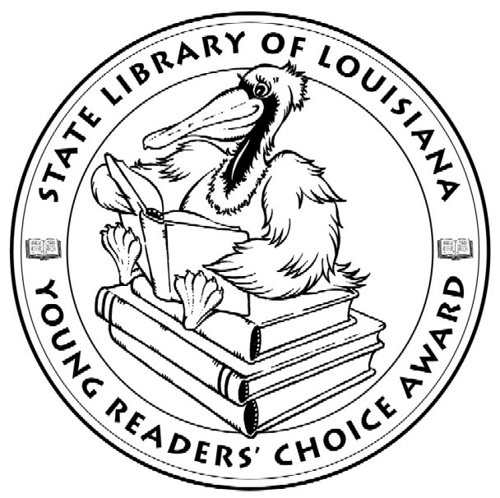

Good books that students will want to read!

WEB SITE
www.state.lib.la.us
Click on Center for the Book, LA Young Readers’ Choice.
Booklists, PowerPoint, Study Guides and information.
Email larbuthn@state.lib.la.us

SPECIAL NEEDS
Talking Books, Braille and large print books are available from SBPH.
1-800-543-4702 Email sbphkids@slol.lib.la.us

FREE PROMOTIONAL MATERIALS
Posters, Bookmarks, Brochures, Ballots, Award Seals, Book Labels
Online order form: http://www.state.lib.la.us/lyrc2008order.php

READ NOW! VOTE BY FEBRUARY 1, 2009
Students read or listen to 3 or more books.
Request a Voting Machine from Secretary of State Naomi.guidroz@sos.louisiana.gov (225) 342-4479
A tally of all votes must be submitted directly to the State Library.
Using the voting machine does not replace submitting the votes.
Tally Forms
http://www.state.lib.la.us/la_dyn_templ.cfm?doc_id=364
http://www.state.lib.la.us/la_dyn_templ.cfm?doc_id=365

The Louisiana Young Readers’ Choice Award is a reading enrichment program of the Louisiana Center for the Book, a department of the State Library of Louisiana, and underwritten by Capital One with generous support by
Perma-Bound Books.

