County Durham
England
Summer 2009

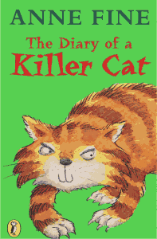
Dear Everyone,
When Tuffy and I heard the brilliant news that his book had won the 2009 Louisiana Young Readers Choice Award, we were both thrilled. We want to congratulate everyone who read the books and voted, because we both agree that the books other people like a lot are very often the ones we end up liking best too, so it's really, really helpful to know which books are everyone else's favourites.
And Tuffy is particularly proud because, although he has now written four books all by himself, and been a runner up for lots of book prizes, he has never actually won an award before. So he is purring madly, and has promised to stop scratching up the garden and scaring off the birds for just this one special Louisiana Young Readers Award Day.

I wish I could bring him along to Baton Rouge so you could all meet him. But, as you know, cats now have to have loads of injections before they can travel on planes to other countries. And if you remember, Tuffy is not at all fond of the vet; and the vet is not at all fond of Tuffy. So it's better that he stays home.
But he will be waving a thank-you paw to you all. And so will I.
Have another splendid reading year. And maybe if any of Tuffy's books (or any of the other books I've written) win your award another year, I'll get to meet you all in Baton Rouge.
With love,

Anne Fine

Visit Anne's website at www.annefine.co.uk
The Diary of a Killer Cat The Return of the Killer Cat
The Killer Cat Strikes Back The Killer Cat's Birthday Bash
also available soon: The Killer Cat's Christmas

