┘ ┴ ┴ ┴ ┴ └
┐ ┬ ┬ ┬ ┬ ┌
FRONT

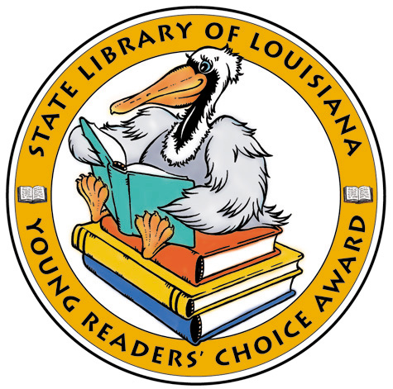
Apples to Oregon: Being the (Slightly) True Narrative of How a Brave Pioneer Father Brought Apples, Peaches, Pears, Plums, Grapes, and Cherries (and Children) Across the Plains by Deborah Hopkinson

The Champ: The Story of Muhammad Ali by Tonya Bolden

Coming On Home Soon by Jacqueline Woodson

Gator Gumbo: A Spicy-Hot Tale by Candace Fleming

Louisiana Young Reader’s Choice Award
Grades 3-5
Louisiana Young Reader’s Choice Award
Grades 3-5
Louisiana Young Reader’s Choice Award
Grades 3-5
Louisiana Young Reader’s Choice Award
Grades 3-5
Louisiana Young Reader’s Choice Award
Grades 3-5

Apples to Oregon: Being the (Slightly) True Narrative of How a Brave Pioneer Father Brought Apples, Peaches, Pears, Plums, Grapes, and Cherries (and Children) Across the Plains by Deborah Hopkinson

The Champ: The Story of Muhammad Ali by Tonya Bolden

Coming On Home Soon by Jacqueline Woodson

Gator Gumbo: A Spicy-Hot Tale by Candace Fleming

Apples to Oregon: Being the (Slightly) True Narrative of How a Brave Pioneer Father Brought Apples, Peaches, Pears, Plums, Grapes, and Cherries (and Children) Across the Plains by Deborah Hopkinson

The Champ: The Story of Muhammad Ali by Tonya Bolden

Coming On Home Soon by Jacqueline Woodson

Gator Gumbo: A Spicy-Hot Tale by Candace Fleming

Apples to Oregon: Being the (Slightly) True Narrative of How a Brave Pioneer Father Brought Apples, Peaches, Pears, Plums, Grapes, and Cherries (and Children) Across the Plains by Deborah Hopkinson

The Champ: The Story of Muhammad Ali by Tonya Bolden

Coming On Home Soon by Jacqueline Woodson

Gator Gumbo: A Spicy-Hot Tale by Candace Fleming

Apples to Oregon: Being the (Slightly) True Narrative of How a Brave Pioneer Father Brought Apples, Peaches, Pears, Plums, Grapes, and Cherries (and Children) Across the Plains by Deborah Hopkinson

The Champ: The Story of Muhammad Ali by Tonya Bolden

Coming On Home Soon by Jacqueline Woodson

Gator Gumbo: A Spicy-Hot Tale by Candace Fleming

Ida B: …And Her Plans to Maximize Fun, Avoid Disaster, and (Possibly) Save the World by Katherine Hannigan

Last Holiday Concert by Andrew Clements

Mighty Jackie: The Strike-Out Queen by Marissa Moss

Ruby Lu, Brave and True by Lenore Look

Science Verse by Jon Scieszka

Secret Identity (Shredderman series) by Wendelin Van Draanen

Sweet Music in Harlem by Debbie A. Taylor

Thunder from the Sea by Joan Hiatt Harlow

Why Epossumondas Has No Hair on His Tail by Coleen Salley

The World According to Humphrey by Betty G. Birney

Worth by A. LaFaye

BACK
┐ ┬ ┬ ┬ ┬ ┌
┘ ┴ ┴ ┴ ┴ └
Ida B: …And Her Plans to Maximize Fun, Avoid Disaster, and (Possibly) Save the World by Katherine Hannigan

Last Holiday Concert by Andrew Clements

Mighty Jackie: The Strike-Out Queen by Marissa Moss

Ruby Lu, Brave and True by Lenore Look

Science Verse by Jon Scieszka

Secret Identity (Shredderman series) by Wendelin Van Draanen

Sweet Music in Harlem by Debbie A. Taylor

Thunder from the Sea by Joan Hiatt Harlow

Why Epossumondas Has No Hair on His Tail by Coleen Salley

The World According to Humphrey by Betty G. Birney

Worth by A. LaFaye

Ida B: …And Her Plans to Maximize Fun, Avoid Disaster, and (Possibly) Save the World by Katherine Hannigan

Last Holiday Concert by Andrew Clements

Mighty Jackie: The Strike-Out Queen by Marissa Moss

Ruby Lu, Brave and True by Lenore Look

Science Verse by Jon Scieszka

Secret Identity (Shredderman series) by Wendelin Van Draanen

Sweet Music in Harlem by Debbie A. Taylor

Thunder from the Sea by Joan Hiatt Harlow

Why Epossumondas Has No Hair on His Tail by Coleen Salley

The World According to Humphrey by Betty G. Birney

Worth by A. LaFaye

Ida B: …And Her Plans to Maximize Fun, Avoid Disaster, and (Possibly) Save the World by Katherine Hannigan

Last Holiday Concert by Andrew Clements

Mighty Jackie: The Strike-Out Queen by Marissa Moss

Ruby Lu, Brave and True by Lenore Look

Science Verse by Jon Scieszka

Secret Identity (Shredderman series) by Wendelin Van Draanen

Sweet Music in Harlem by Debbie A. Taylor

Thunder from the Sea by Joan Hiatt Harlow

Why Epossumondas Has No Hair on His Tail by Coleen Salley

The World According to Humphrey by Betty G. Birney

Worth by A. LaFaye

Ida B: …And Her Plans to Maximize Fun, Avoid Disaster, and (Possibly) Save the World by Katherine Hannigan

Last Holiday Concert by Andrew Clements

Mighty Jackie: The Strike-Out Queen by Marissa Moss

Ruby Lu, Brave and True by Lenore Look

Science Verse by Jon Scieszka

Secret Identity (Shredderman series) by Wendelin Van Draanen

Sweet Music in Harlem by Debbie A. Taylor

Thunder from the Sea by Joan Hiatt Harlow

Why Epossumondas Has No Hair on His Tail by Coleen Salley

The World According to Humphrey by Betty G. Birney

Worth by A. LaFaye

