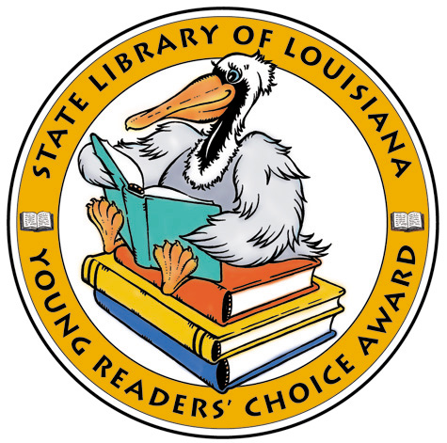
Airborn by Kenneth Oppel

Al Capone Does My Shirts by Gennifer Choldenko

Becoming Naomi León by Pam Ryan Muñoz

Bird by Angela Johnson

Dragon Rider by Cornelia Funke

Escape from Saigon: How a Vietnam War Orphan Became an American Boy by Andrea Warren

Journey to the Bottomless Pit: The Story of Stephen Bishop and Mammoth Cave by Elizabeth Mitchell

Never Mind! A Twin Novel by Rachel Vail and Avi

The Sea of Trolls by Nancy Farmer

So B. It: A Novel by Sarah Weeks

The Tarantula Scientist by Sy Montgomery

The Teacher’s Funeral: A Comedy in Three Parts by Richard Peck

Technically It’s Not My Fault: Concrete Poems by John Grandits

The Truth About Sparrows by Marian Hale

The Young Man and the Sea by Rodman Philbrick

Louisiana
Young Reader’s Choice Award
Grades 6-8
Louisiana
Young Reader’s Choice Award
Grades 6-8
Louisiana
Young Reader’s Choice Award
Grades 6-8
Airborn by Kenneth Oppel

Al Capone Does My Shirts by Gennifer Choldenko

Becoming Naomi León by Pam Ryan Muñoz

Bird by Angela Johnson

Dragon Rider by Cornelia Funke

Escape from Saigon: How a Vietnam War Orphan Became an American Boy by Andrea Warren

Journey to the Bottomless Pit: The Story of Stephen Bishop and Mammoth Cave by Elizabeth Mitchell

Never Mind! A Twin Novel by Rachel Vail and Avi

The Sea of Trolls by Nancy Farmer

So B. It: A Novel by Sarah Weeks

The Tarantula Scientist by Sy Montgomery

The Teacher’s Funeral: A Comedy in Three Parts by Richard Peck

Technically It’s Not My Fault: Concrete Poems by John Grandits

The Truth About Sparrows by Marian Hale

The Young Man and the Sea by Rodman Philbrick

Airborn by Kenneth Oppel

Al Capone Does My Shirts by Gennifer Choldenko

Becoming Naomi León by Pam Ryan Muñoz

Bird by Angela Johnson

Dragon Rider by Cornelia Funke

Escape from Saigon: How a Vietnam War Orphan Became an American Boy by Andrea Warren

Journey to the Bottomless Pit: The Story of Stephen Bishop and Mammoth Cave by Elizabeth Mitchell

Never Mind! A Twin Novel by Rachel Vail and Avi

The Sea of Trolls by Nancy Farmer

So B. It: A Novel by Sarah Weeks

The Tarantula Scientist by Sy Montgomery

The Teacher’s Funeral: A Comedy in Three Parts by Richard Peck

Technically It’s Not My Fault: Concrete Poems by John Grandits

The Truth About Sparrows by Marian Hale

The Young Man and the Sea by Rodman Philbrick

