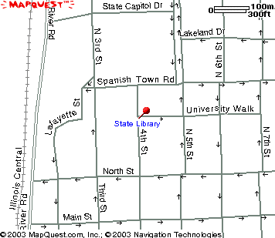
LaSalle Garage
Parking
Garage
State
Library
State
Museum

