2021-2022 LTRC Annotated Nominated Title List
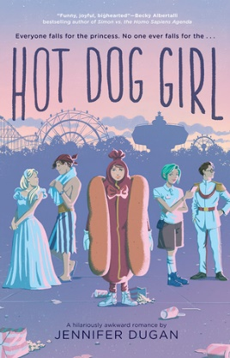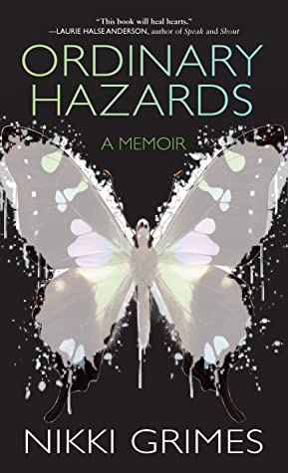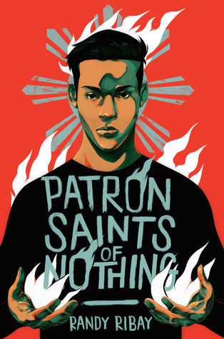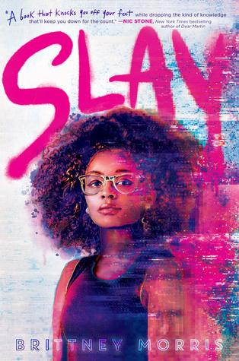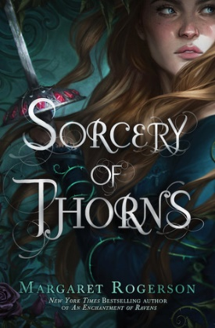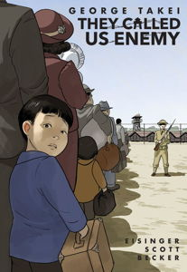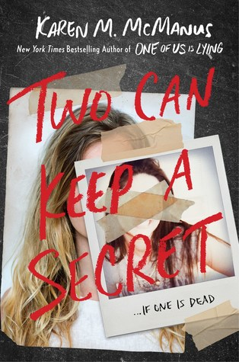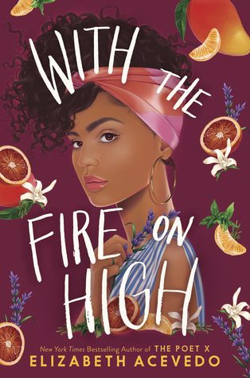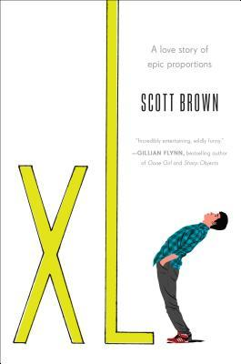

- Downstairs Girl, The by Stacey Lee
G.P. Putnam’s Sons Books for Young Readers (Penguin Random House), 2019. HC: 978-1524740955, 384 pp., $17.99. PB: 978-1524740979, 384 pp., $10.99 (coming April 2021).
[Historical Fiction, 1890 Atlanta, Chinese American female protagonist, racism, advice column]
Summary: By day, seventeen-year-old Jo Kuan works as a lady's maid for the cruel Caroline Payne, the daughter of one of the wealthiest men in Atlanta. But by night, Jo moonlights as the pseudonymous author of a newspaper advice column for “the genteel Southern lady.” (LOC)
Awards: YALSA Best Fiction for Young Adults List, Crystal Kite Award Winner, a Junior Library Guild Selection, Washington Post: Best Children’s Books of 2019, School Library Journal: Best Books of 2019, Publishers Weekly: Best Books of 2019, New York Public Library: Best Books for Teens 2019, BookPage: Best Books of 2019
Accelerated Reader: IL: MG+ - BL: 5.5 - AR Pts: 14.0 AR Quiz No. 506285

- Hot Dog Girl by Jennifer Dugan
G.P. Putnam’s Sons Books for Young Readers (Penguin Random House), 2019. HC: 978-0525516255, 320 pp., $17.99. PB: 978-0525516279, 336 pp., $9.99
[Realistic Fiction, romance, white female protagonist, summer job, amusement park, LGBTQIA+]
Summary: A lovesick teenager schemes to win the heart of her crush at her amusement park summer job, all while dressed as a hot dog. (LOC)
Awards: YALSA Quick Pick for Reluctant Readers List, a Junior Library Guild Selection
Accelerated Reader: IL: UG - BL: 5.0 - AR Pts: 11.0 AR Quiz No. 504415

- Ordinary Hazards by Nikki Grimes
Wordsong (Penguin Random House), 2019. HC: 978-1629798813, 336 pp., $19.99.
[Memoir, verse, black female protagonist, mental illness, foster care]
Summary: Growing up with a mother suffering from paranoid schizophrenia and a mostly absent father, Nikki Grimes found herself terrorized by babysitters, shunted from foster family to foster family, and preyed upon by those she trusted. At age six, she poured her pain onto a piece of paper late one night – and discovered the magic and impact of writing. (Publisher)
Awards: Michael L. Printz Honor Book, Robert F. Sibert Informational Honor Book, Arnold Adoff Poetry Award for Teens, ALSC Notable Children’s Book
Accelerated Reader: IL: UG - BL: 5.5 - AR Pts: 4.0 AR Quiz No. 507146

- Patron Saints of Nothing by Randy Ribay
Kokila (Penguin Random House), 2019. HC: 978-0525554912, 352 pp., $17.99. PB: 978-0525554929, 352 pp., $10.99.
[Realistic fiction, Filipino-American male protagonist, family, cultural identity, grief, Filipino drug war]
Summary: When seventeen-year-old Jay Reguero learns his Filipino cousin and former best friend, Jun, was murdered as part of President Duterte's war on drugs, he flies to the Philippines to learn more. (LOC)
Awards: National Book Award Finalist, Freeman Book Award Winner, Edgar Award Winner, CILIP Carnegie Medal, Amelia Elizabeth Walden Book Award Winner, YALSA Top Ten Best Fiction for Young Adults, YALSA Quick Pick for Reluctant Readers List, LA Times Book Prize for Young Adults, Publishers Weekly: Best Books of 2019
Accelerated Reader: IL: UG - BL: 5.3 - AR Pts: 12.0 AR Quiz No. 502466

- SLAY by Brittney Morris
Simon Pulse (Simon and Schuster), 2019. HC: 978-1534445420, 336 pp., $18.99. PB: 978-1534445437, 352 pp., $11.99 (coming September 2020).
[Realistic fiction, black female protagonist, racism and discrimination in gaming, stereotypes]
Summary: An honors student at Jefferson Academy, seventeen-year-old Keira enjoys developing and playing Slay, a secret, multiplayer online role-playing game celebrating black culture, until the two worlds collide. (LOC)
Awards: YALSA Top Ten Best Fiction for Young Adults, YALSA Quick Pick for Reluctant Readers List, Publishers Weekly: Best Books of 2019
Accelerated Reader: IL: UG - BL: 6.0 - AR Pts: 13.0 AR Quiz No. 505645

- Sorcery of Thorns by Margaret Rogerson
Margaret K. McElderry Books (Simon and Schuster), 2019. HC: 978-1481497619, 464 pp., $17.99. PB: 978-1481497626, 480 pp., $11.99.
[Historical Fantasy, white female protagonist, battling librarians, magical books, sorcerers, demons, romance, LGBTQIA+]
Summary: When apprentice librarian Elisabeth is implicated in sabotage that released the library's most dangerous grimoire, she becomes entangled in a centuries-old conspiracy that could mean the end of everything. (LOC)
Awards: YALSA Best Fiction for Young Adults List, Goodreads Choice Awards Nominee
Accelerated Reader: IL: MG+ - BL: 6.3 - AR Pts: 20.0 AR Quiz No. 502700

- They Called Us Enemy by George Takei, Justin Eisinger, and Steven Scott; illustrated by Harmony Becker
Top Shelf Productions (IDW Publishing), 2019. PB: 978-1603094504, 192 pp., $19.99.
[Graphic memoir, Japanese-American male protagonist, WWII, Japanese internment camps, civil rights, activism, LGBTQIA+]
Summary: Actor, author, and activist George Takei recounts his childhood imprisoned within American relocation camps for Japanese Americans during World War II, and the impact the experience had on his later life. (AR)
Awards: Asian/Pacific American Award for Literature, ALSC Notable Children’s Book, Goodreads Choice Awards Nominee, BookRiot: Best Books of 2019
Accelerated Reader: IL: MG+ - BL: 4.6 - AR Pts: 2.0 AR Quiz No. 504407

- Two Can Keep a Secret by Karen M. McManus
Delacorte Press (Penguin Random House), 2019. HC: 978-1524714727, 352 pp., $19.99. PB: 978-1524714710, 352 pp., $10.99 (coming March 2021)
[Realistic fiction, thriller, biracial (white and Latinx) female protagonist and white male protagonist, murder, LGBTQIA+]
Summary: While true-crime aficionado Ellery and her twin brother are staying with their grandmother in a Vermont community known for murder, a new friend goes missing and Ellery may be next. (LOC)
Awards: YALSA Top Ten Best Fiction for Young Adults, YALSA Quick Pick for Reluctant Readers List, Publishers Weekly: Best Books of 2019, Goodreads Choice Awards Nominee
Accelerated Reader: IL: UG - BL: 5.0 - AR Pts: 12.0 AR Quiz No. 500226

- With the Fire on High by Elizabeth Acevedo
Quill Tree Books (Harper Collins), 2019. HC: 978-0062662835, 400 pp., $17.99. PB: 978-0062662842, 416 pp., $12.99 (coming April 2021).
[Realistic fiction, Afro-Latinx female protagonist, stereotypes]
Summary: Teen mother Emoni Santiago struggles with the challenges of finishing high school and achieving her dream of working as a chef. (AR)
Awards: YALSA Quick Pick for Reluctant Readers List, Goodreads Choice Awards Nominee
Accelerated Reader: IL: UG - BL: 6.5 - AR Pts: 11.0 AR Quiz No. 502468

- XL by Scott Brown
Knopf Books for Young Readers (Penguin Random House), 2019. HC: 978-1524766245, 320 pp., $17.99. PB: 978-1524766276, 320 pp., $9.99.
[Realistic fiction, white male protagonist, body image, friendship, blended family]
Summary: Will has always been troubled by his short stature, but on his 16th birthday, he starts to grow--and grow, and grow. (LOC)
Accelerated Reader: N/A

