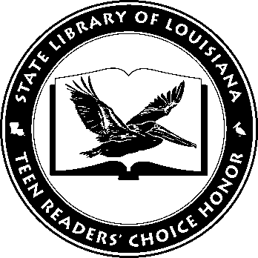

Louisiana Teen Readers’ Choice
Ballot 2021-2022
The Downstairs Girl Stacey Lee
Hot Dog Girl Jennifer Dugan
Ordinary Hazards Nikki Grimes
Patron Saints of Nothing Randy Ribay
SLAY Brittney Morris
Sorcery of Thorns Margaret Rogerson
They Called Us Enemy George Takei, Justin Eisinger, and Steven Scott; illustrated by Harmony Becker
Two Can Keep a Secret Karen M. McManus
With the Fire on High Elizabeth Acevedo
XL Scott Brown
The Louisiana Young Readers’ Choice Award is a reading enrichment program of the Louisiana Center for the Book in the State Library of Louisiana with additional support from the following:

Louisiana Teen Readers’ Choice
Ballot 2021-2022
The Downstairs Girl Stacey Lee
Hot Dog Girl Jennifer Dugan
Ordinary Hazards Nikki Grimes
Patron Saints of Nothing Randy Ribay
SLAY Brittney Morris
Sorcery of Thorns Margaret Rogerson
They Called Us Enemy George Takei, Justin Eisinger, and Steven Scott; illustrated by Harmony Becker
Two Can Keep a Secret Karen M. McManus
With the Fire on High Elizabeth Acevedo
XL Scott Brown
The Louisiana Young Readers’ Choice Award is a reading enrichment program of the Louisiana Center for the Book in the State Library of Louisiana with additional support from the following:

