2022-2023 LTRC Annotated Nominated Title List
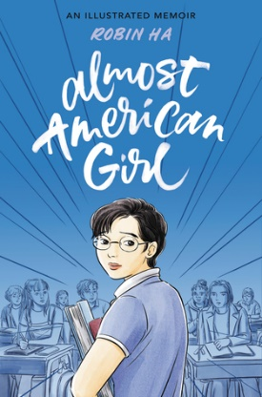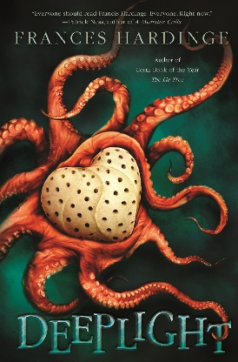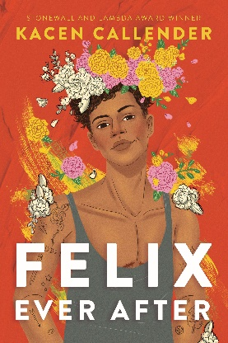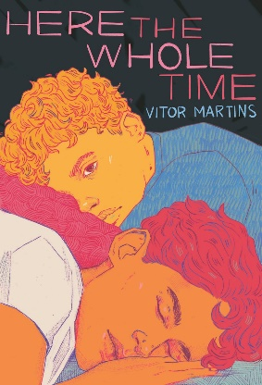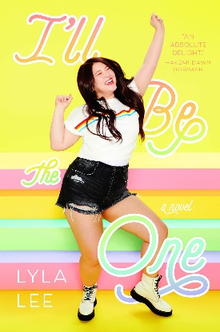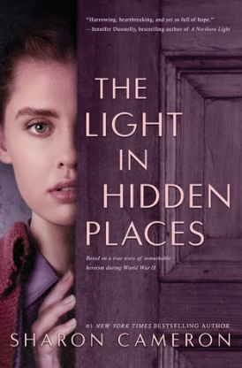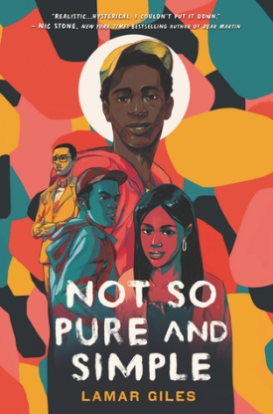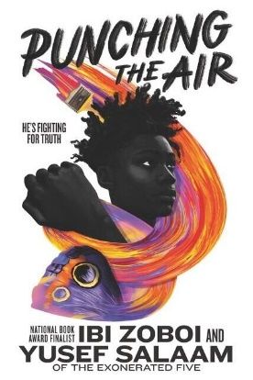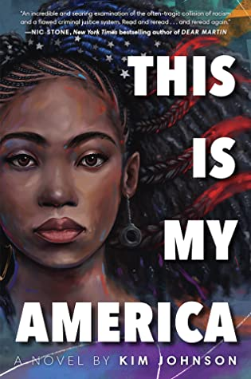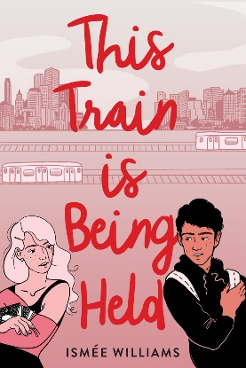

- Almost American Girl by Robin Ha
Balzer + Bray (HarperCollins), 2020. HC: 978-0062685100, 240 pp., $22.99. PB: 978-0062685094, 240 pp., $12.99.
[Graphic memoir, Korean female protagonist, immigration, family issues, mothers and daughters, comics, art]
Summary: This memoir tells a story about immigration, belonging, and how arts can save a life. (LOC)
Awards: YALSA Top Ten Great Graphic Novel List, a Junior Library Guild Selection, an Indie Next List Pick, Kirkus: Best Children’s Books of 2020, School Library Journal: Best Books of 2020, National Public Radio: Best Books of 2020, New York Public Library: Best Books of 2020, 4 starred reviews
Accelerated Reader: IL: MG+ - BL: 3.4 - AR Pts: 2.0 AR Quiz No. 507208

- Deeplight by Frances Hardinge
Harry N. Abrams (Abrams), 2020. HC: 978-1419743207, 432 pp., $19.99. PB: 978-1419743214, 432 pp., $10.99 (coming October 2022).
[Fantasy, male protagonist, 15y, sea monsters, toxic friendships, secrets, adventure]
Summary: When 15-year-old Hark finds the still-beating heart of a terrifying deity, he risks everything to keep it out of the hands of smugglers, military scientists, and a secret fanatical cult. (LOC)
Awards: 2021 CILIP Carnegie Medal Nominee, Kirkus: Best Books of 2020, 3 starred reviews
Accelerated Reader: IL: UG - BL: 5.9 - AR Pts: 19.0 AR Quiz No. 509435

- Felix Ever After by Kacen Callender
Balzer + Bray (HarperCollins), 2020. HC: 978-0062820259, 368 pp., $18.99. PB: 978-0062820266, 368 pp., $10.99.
[Realistic fiction, Black male protagonist, 17y, identity, catfishing, harassment]
Summary: Felix Love, a transgender seventeen-year-old, attempts to get revenge by catfishing his anonymous bully, but lands in a quasi-love triangle with his former enemy and his best friend. (LOC)
Awards: 2021 Stonewall Honor Book, YALSA Quick Pick for Reluctant Readers List, an Indie Next List Pick, New York Public Library: Best Books of 2020, 3 starred reviews
Accelerated Reader: IL: UG - BL: 5.1 - AR Pts: 13.0 AR Quiz No. 514598

- Here the Whole Time by Vítor Martins, translated by Larissa Helena
Scholastic Press (Scholastic), 2020. HC: 978-1338620825, 288 pp., $18.99. PB: 978-1338839777, 304 pp., $10.99 (coming October 2022).
[Realistic fiction, Brazilian male protagonist, 17y, body insecurity, body shaming, bullying, crushes]
Summary: When Felipe, who is very insecure about his weight, is forced to spend winter break with his long-term crush, Caio, he must face his unresolved issues head-on. (LOC)
Awards: 1 starred review
Accelerated Reader: N/A

- I’ll Be the One by Lyla Lee
Katherine Tegen Books (HarperCollins), 2020. HC: 978-0062936929, 336 pp., $17.99. PB: 978-0062936912, 336 pp., $10.99.
[Realistic fiction, Korean-American female protagonist, 16y, K-Pop, body positivity, competition, romance]
Summary: Sixteen-year-old Korean American Skye Shin competes on a reality television show, hoping to become the first plus-sized K-pop star, while falling for her competitor Henry Cho, who happens to be a world-famous celebrity. (LOC)
Awards: YALSA Quick Pick for Reluctant Readers List, YALSA Amazing Audiobooks List, Kirkus: Best Books of 2020, 2 starred reviews
Accelerated Reader: IL: UG - BL: 5.4 - AR Pts: 12.0 AR Quiz No. 512251

- Light in Hidden Places, The by Sharon Cameron
Scholastic Press (Scholastic), 2020. HC: 978-1338355932, 400 pp., $18.99. PB: 978-1338355949, 400 pp., $12.99.
[Historical fiction, 1943 Poland, white Catholic female protagonist, 17y, hiding, survival]
Summary: After the Nazis invade Poland, sixteen-year-old Stefania Podgórska embarks on a dangerous course--protecting thirteen Jews in her attic, caring for her younger sister, and keeping everything secret from the two Nazi officers who are living in her house. (LOC)
Awards: 1 starred review
Accelerated Reader: IL: UG - BL: 4.2 - AR Pts: 15.0 AR Quiz No. 506449

- Not So Pure and Simple by Lamar Giles
Quill Tree Books (HarperCollins), 2020. HC: 978-0062349194, 400 pp., $17.99. PB: 978-0062349200, 416 pp., $10.99.
[Realistic fiction, Black male protagonist, junior, crushes, celibacy club, sexuality, toxic masculinity]
Summary: High school junior Del Rainey unwittingly joins a Purity Pledge class at church, hoping to get closer to his long-term crush, Kiera. (LOC)
Awards: YALSA Amazing Audiobooks List, an Indie Next List Pick, Kirkus: Best Books of 2020, School Library Journal: Best Books of 2020, New York Public Library: Best Books of 2020, 4 starred reviews
Accelerated Reader: IL: UG - BL: 4.9 - AR Pts: 13.0 AR Quiz No. 508904

- Punching the Air by Ibi Zoboi and Yusef Salaam
Balzer + Bray (HarperCollins), 2020. HC: 978-0062996480, 400 pp., $19.99. PB: 978-0062996497, 400 pp., $12.99.
[Realistic fiction, verse, Black male protagonist, 16y, racism, racial profiling, incarceration]
Summary: A novel in verse about a boy who is wrongfully incarcerated. (LOC)
Awards: YALSA Top Ten Quick Pick for Reluctant Readers List, an Indie Next List Pick, Kirkus: Best Books of 2020, School Library Journal: Best Books of 2020, Publishers Weekly: Best Books of 2020, New York Public Library: Best Books of 2020, 5 starred reviews
Accelerated Reader: IL: UG - BL: 5.7 - AR Pts: 5.0 AR Quiz No. 509958

- This Is My America by Kim Johnson
Random House Books for Young Readers (Penguin Random House), 2020. HC: 978-0593118764, 416 pp., $17.99. PB: 978-0593118795, 416 pp., $10.99.
[Realistic fiction, Black female protagonist, 17y, racism, race relations, murder, secrets, incarcerated parent, wrongful accusation, wrongful conviction]
Summary: While writing letters to Innocence X, a justice-seeking project, asking them to help her father, an innocent black man on death row, teenaged Tracy takes on another case when her brother is accused of killing his white girlfriend. (LOC)
Awards: YALSA Amazing Audiobooks List, Kirkus: Best Books of 2020, National Public Radio: Best Books of 2020, 1 starred review
Accelerated Reader: IL: UG - BL: 4.3 - AR Pts: 12.0 AR Quiz No. 509901

- This Train Is Being Held by Ismée Williams
Harry N. Abrams (Abrams), 2020. HC: 978-1419734939, 336 pp., $17.99.
[Realistic fiction, Hispanic male and female protagonists, sports, baseball, ballet, family issues, romance]
Summary: Told in two voices, ballet dancer and private school student Isabelle Warren and poet and baseball star Alex Rosario grow closer after meeting on a subway, bonding over their parents' expectations and their own dreams. (LOC)
Awards: New York Public Library: Best Books of 2020
Accelerated Reader: IL: UG - BL: 3.6 - 12.0 AR Quiz No. 515488

