2022-2023 LYRC 3-5 Annotated Nominated Title List
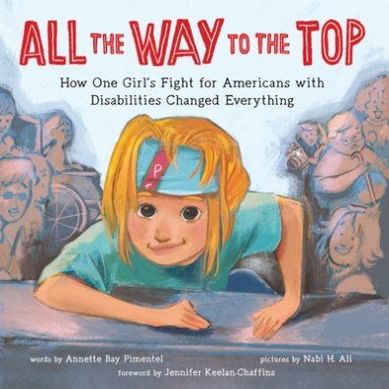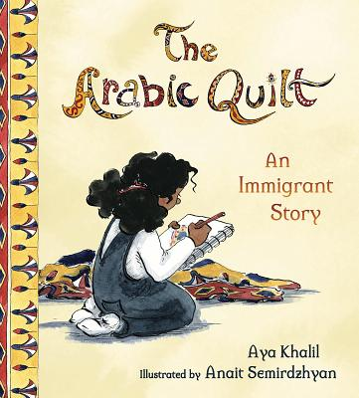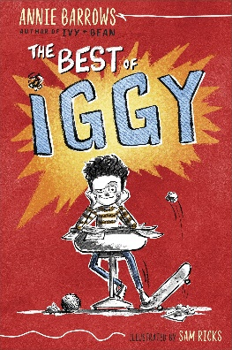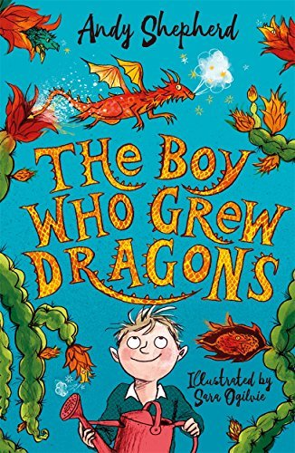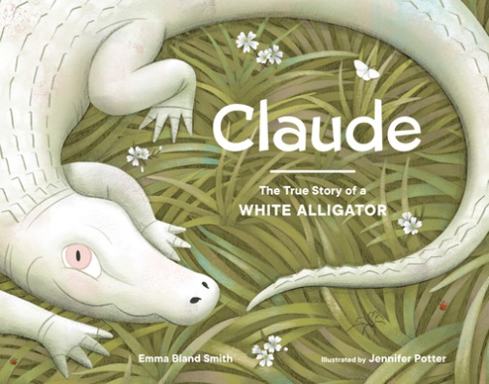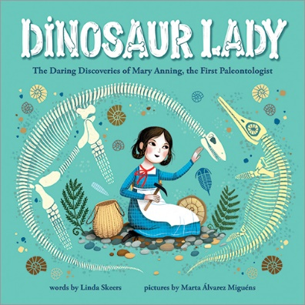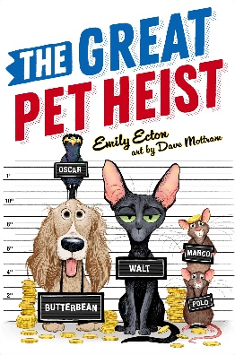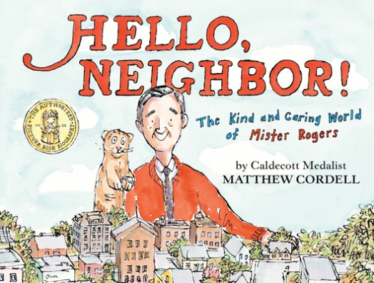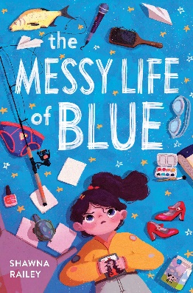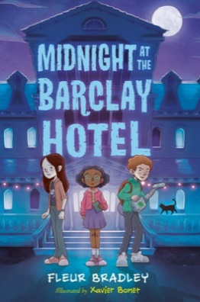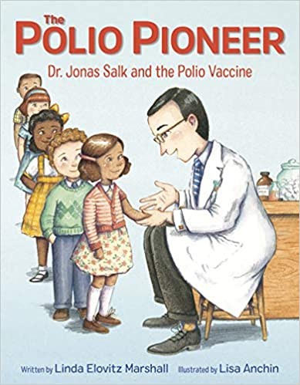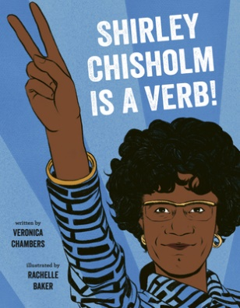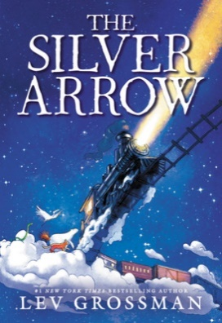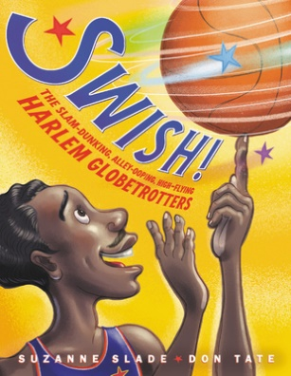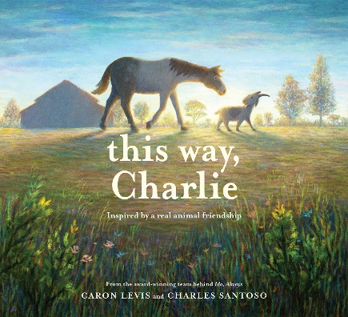
- All the Way to the Top: How One Girl’s Fight for Americans with Disabilities Changed Everything by Annette Bay Pimentel, illustrated by Nabi H. Ali
Sourcebooks Explore (Sourcebooks), 2020. HC: 978-1492688976, 32 pp., $17.99.
[Picture Book Biography, white female subject, cerebral palsy, disability rights]
Summary: Diagnosed with cerebral palsy at birth, Jennifer Keelan grew up battling-and overcoming-the limitations others set for her. From a lack of cutaway curbs and bus lifts to being denied enrollment at her neighborhood school, Jennifer was continually blocked from living the life she wanted. But after discovering the world of disability rights activism, she knew she had to use her voice to change things. When Jennifer was just eight years old, she participated in the Capitol Crawl. The deeply affecting image of Jennifer crawling up the steps of Capitol Hill went viral and helped pressure Congress into passing the Americans with Disabilities Act. (LOC)
Awards: 2021 Schneider Family Honor Book, Junior Library Guild Selection
Accelerated Reader: IL: LG - BL: 3.9 - AR Pts: 0.5 AR Quiz No. 508616

- The Arabic Quilt: An Immigrant Story by Aya Khalil, illustrated by Anait Semirdzhyan
Tilbury House Publishers, 2020. HC: 978-0884487548, 36 pp., $17.95.
[Picture Book Fiction, Egyptian female protagonist, 3rd grade, immigration, family, culture, acceptance]
Summary: The beautiful story of diversity follows a young girl named Kanzi whose most treasured reminder of her old home provides a pathway for acceptance in her new one. (LOC)
Awards: 1 starred review
Accelerated Reader: IL: LG - BL: 3.7 - AR Pts: 0.5 AR Quiz No. 513274

- The Best of Iggy by Annie Barrows, illustrated by Sam Ricks
G.P. Putnam’s Sons Books for Young Readers (Penguin Random House), 2020. HC: 978-1984813305, 144 pp., $13.99. PB: 978-1984813329, 160 pp., $7.99.
[Realistic Fiction, male protagonist, 4th grader, troublemaker, humor]
Summary: Relates three times that nine-year-old Iggy got into trouble, two of which he does not regret and one for which he is very, very sorry. (LOC)
Awards: Indie Next Pick, Junior Library Guild Selection, 1 starred review
Accelerated Reader: IL: MG - BL: 3.7 - AR Pts: 1.0 AR Quiz No. 506129

- The Boy Who Grew Dragons by Andy Shepherd, illustrated by Sara Ogilvie
Yellow Jacket (Little Bee Books), 2020. HC: 978-1499810110, 224 pp., $13.99.
[Fantasy, male protagonist, family, siblings, friendship, dragons, secrets, humor]
Summary: When Tomas discovers a strange old tree at the bottom of his grandfather's garden, he doesn't think much of it. But he takes the funny fruit from the tree back into the house and gets the shock of his life when a tiny dragon hatches! The tree is a dragon fruit tree, and Tomas now has his very own dragon, Flicker! While Tomas finds out that life with Flicker is fun, he also finds that it is very...unpredictable. Yes, dragons are wonderful, but they also set fire to your toothbrush and leave your underwear hanging from the TV antenna. Tomas has to learn how to look after Flicker---and quickly! And then something extraordinary happens: more dragon fruits appear on the tree! Now it's official, Tomas is growing dragons. (LOC)
Awards: 1 starred review
Accelerated Reader: IL: MG - BL: 5.5 - AR Pts: 4.0 AR Quiz No. 506130

- Claude: The True Story of a White Alligator by Emma Bland Smith, illustrated by Jennifer M. Potter
Little Bigfoot (Penguin Random House), 2020. HC: 978-1632172693, 32 pp., $18.99.
[Picture Book Nonfiction, animals, reptiles, alligators, Louisiana]
Summary: A nonfiction picture book about Claude the albino alligator at the California Academy of Sciences. (LOC)
Awards: Kirkus: Best Books of 2020, 1 starred review
Accelerated Reader: IL: LG - BL: 3.6 - AR Pts: 0.5 AR Quiz No. 514931

- Dinosaur Lady: The Daring Discoveries of Mary Anning, the First Paleontologist by Linda Skeers, illustrated by Marta Álvarez Miguéns
Sourcebooks, 2020. HC: 978-1728209517, 40 pp., $17.99.
[Picture Book Biography, white British female subject, scientist, paleontologist]
Summary: Mary Anning loved scouring the beach near her home in England for shells and fossils. She fearlessly climbed over crumbling cliffs and rocky peaks, searching for new specimens. One day, something caught Mary's eye. Bones. Dinosaur Bones. Mary's discoveries rocked the world of science and helped create a brand-new field of study: paleontology. But many people believed women couldn't be scientists, so Mary wasn't given the credit she deserved. Nevertheless, Mary kept looking and learning more, making discoveries that reshaped scientific beliefs about the natural world. (LOC)
Awards:
Accelerated Reader: IL: LG - BL: 4.1 - AR Pts: 0.5 AR Quiz No. 510789

- The Great Pet Heist by Emily Ecton, illustrated by David Mottram
Atheneum Books for Young Readers (Simon & Schuster), 2020. HC: 978-1534455368, 256 pp., $18.99. PB: 978-1534455375, 272 pp., $8.99.
[Mystery, animal protagonists, pets, friendship, robbery, secret plans, humor]
Summary: When their elderly owner goes to the hospital, Butterbean the dachshund, Walt the cat, Oscar the mynah bird, and rats Marco and Polo plan a robbery to support themselves. (LOC)
Accelerated Reader: IL: MG - BL: 3.8 - AR Pts: 6.0 AR Quiz No. 510531

- Hello, Neighbor!: The Kind and Caring World of Mister Rogers by Matthew Cordell
Neal Porter Books (Holiday House), 2020. HC: 978-0823446186, 40 pp., $18.99.
[Picture Book Biography, white male subject, television personality, puppeteer, activist]
Summary: A biographical look at the life and career of Fred Rogers and the impact of his show, Mister Rogers' Neighborhood. (LOC)
Awards: Junior Library Guild Selection, 4 starred reviews
Accelerated Reader: IL: LG - BL: 5.3 - AR Pts: 0.5 AR Quiz No. 508629

- The Messy Life of Blue by Shawna Railey
Yellow Jacket (Little Bee Books), 2020. HC: 978-1499810257, 240 pp., $16.99.
[Realistic Fiction, female protagonist, 11y, family, siblings, friendship, grief, humor]
Summary: Eleven-year-old Beulah "Blue" Warren, a fearless girl surrounded by boys, is beginning to forget her deceased mother but a new revelation gives her the strength to grieve for her mother once and for all. (LOC)
Accelerated Reader: IL: MG - BL: 4.3 - AR Pts: 7.0 AR Quiz No. 516789

- Midnight at the Barclay Hotel by Fleur Bradley, illustrated by Xavier Bonet
Viking Books for Young Readers (Penguin Random House), 2020. HC: 978-0593202906, 320 pp., $17.99. PB: 978-0593202913, 336 pp., $8.99.
[Fantasy, male protagonist, haunted houses, ghosts, murder mystery, friendship]
Summary: Five murder suspects are invited to the haunted Barclay Hotel for a weekend getaway, and it is up to twelve-year-old JJ and eleven-year-old Penny--and a lonely ghost--to figure out who committed the crime. (LOC)
Awards: 2020 Agatha Award Finalist, NPR: Best Books of 2020
Accelerated Reader: IL: MG - BL: 4.6 - AR Pts: 6.0 AR Quiz No. 509669

- The Polio Pioneer: Dr. Jonas Salk and the Polio Vaccine by Linda Elovitz Marshall, illustrated by Lisa Anchin
Knopf Books for Young Readers (Penguin Random House), 2020. HC: 978-0525646518, 40 pp., $17.99.
[Picture Book Biography, Jewish male subject, chemist, physician, virologist, vaccines]
Summary: Dr. Jonas Salk is one of the most celebrated doctors and medical researchers of the 20th century. The child of immigrants who never learned to speak English, Jonas was struck by the devastation he saw when the soldiers returned from battle after WWII. Determined to help, he worked to become a doctor and eventually joined the team that created the influenza vaccine. But Jonas wanted to do more. As polio ravaged the United States--even the president was not immune!--Jonas decided to lead the fight against this terrible disease. In 1952, Dr. Jonas Salk invented the polio vaccine, which nearly eliminated polio from this country. For the rest of his life, Dr. Salk continued to do groundbreaking medical research at the Salk Institute, leaving behind a legacy that continues to make the world a better place every day. (LOC)
Awards: 2021 Sydney Taylor Notable Book
Accelerated Reader: IL: LG - BL: 4.5 - AR Pts: 0.5 AR Quiz No. 513091

- Shirley Chisholm Is a Verb by Veronica Chambers, illustrated by Rachelle Baker
Dial Books (Penguin Random House), 2020. HC: 978-0803730892, 40 pp., $18.99.
[Picture Book Biography, Black female subject, politician, activist]
Summary: A picture book biography celebrating the life and contributions of Shirley Chisholm, the first Black woman in Congress, who sought the Democratic nomination to be the president of the United States. (LOC)
Awards: NYPL: Best Books of 2020
Accelerated Reader: IL: LG - BL: 5.1 - AR Pts: 0.5 AR Quiz No. 511237

- The Silver Arrow by Lev Grossman, illustrated by Tracy Nishimura Bishop
Little, Brown Books for Young Readers (Hachette Book Company), 2020. HC: 978-0316539531, 272 pp., $16.99. PB: 978-0316539548, 272 pp., $7.99.
[Fantasy, female protagonist, 11y, siblings, trains, adventure, magic]
Summary: Kate's humdrum life is transformed when her eccentric Uncle Herbert brings her a colossal locomotive train, the Silver Arrow, as her eleventh birthday gift, leading her and her younger brother on a mysterious quest. (LOC)
Awards: Indie Next Pick, 2 starred reviews
Accelerated Reader: IL: MG - BL: 4.9 - AR Pts: 5.0 AR Quiz No. 509903

- Swish!: The Slam-Dunking, Alley-Ooping, High-Flying Harlem Globetrotters by Suzanne Slade, illustrated by Don Tate
Little, Brown Books for Young Readers (Hachette Book Company), 2020. HC: 978-0316481670, 40 pp., $17.99.
[Picture Book Nonfiction, sports, basketball, performers]
Summary: The true story of the high-flying Harlem Globetrotters -- the team that changed basketball forever. (LOC)
Awards: Junior Library Guild Selection
Accelerated Reader: IL: LG - BL: 4.7 - AR Pts: 0.5 AR Quiz No. 510883

- This Way, Charlie by Caron Lewis, illustrated by Charles Santoso
Abrams Books for Young Readers (ABRAMS), 2020. HC: 978-1419742064, 40 pp., $17.99.
[Picture Book Fiction, animals, animal sanctuary, friendship, compassion, empathy, based on a true story]
Summary: Jack, an introverted goat, and Charlie, a blind horse, meet at Open Bud Ranch, an animal rehabilitation center, and form an unlikely friendship that grows stronger in the face of adversity. (LOC)
Awards: Indie Next List, Junior Library Guild Selection, 1 starred review
Accelerated Reader: IL: LG - BL: 3.5 - AR Pts: 0.5 AR Quiz No. 508875

