2022-2023 LYRC 6-8 Annotated Nominated Title List
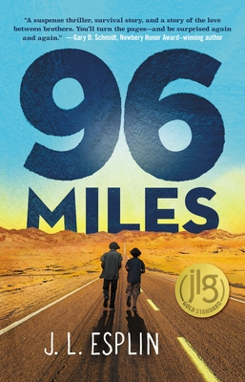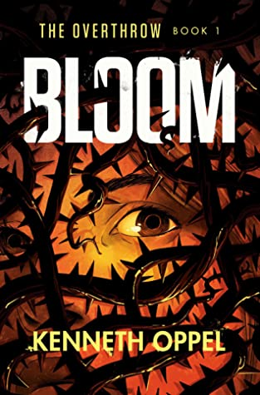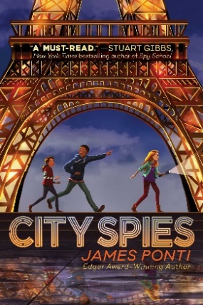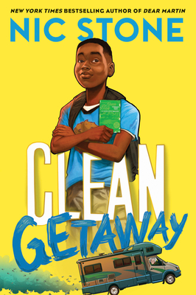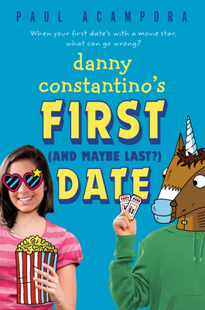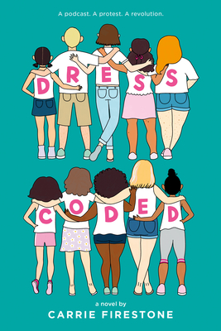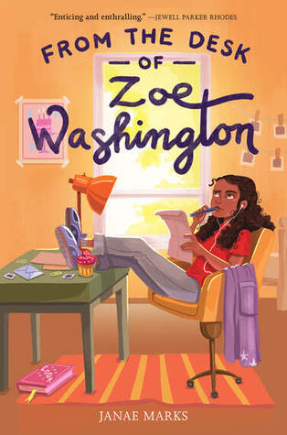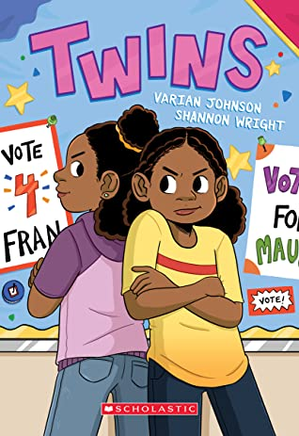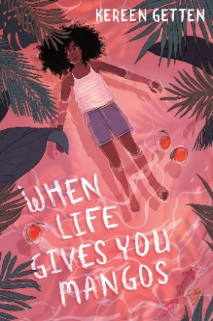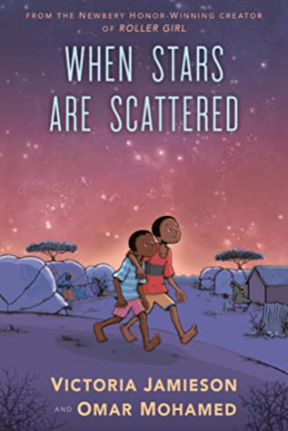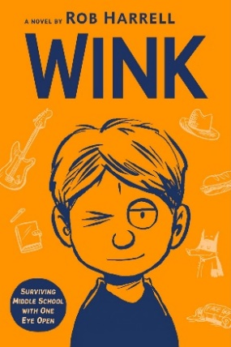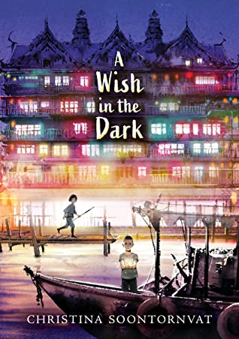

- 96 Miles by J.L. Esplin
Starscape (Macmillan), 2020. HC: 978-1250192301, 272 pp., $17.99. PB: 978-1250192288, 320272 pp., $9.99.
[Realistic fiction, survival, Nevada desert, white male protagonist, 13y, brothers, blackout, robbery]
Summary: During a massive blackout in rural Nevada, two brothers struggle to survive without their dad. After a robbery, they must set out across the desert to get help. (AR)
Awards: Junior Library Guild Selection
Accelerated Reader: IL: MG - BL: 5.2 - AR Pts: 11.0 AR Quiz No. 508763

- Bloom by Kenneth Oppel
Knopf Books for Young Readers (Penguin Random House), 2020. HC: 978-1524773007, 320 pp., $16.99. PB: 978-1524773038, 320 pp., $7.99.
[Science fiction, remote island in British Columbia, assumed white female/female/male protagonists, evil plants, horror, suspense]
Summary: The invasion begins with rain -- a rain that carries seeds that sprout overnight, everywhere. These new plants crowd out crops, release toxic pollens, and form large underground pods that swallow animals and people. They are unstoppable. (AR)
Awards: Junior Library Guild Selection, Indie Next List, LITA: Excellence in Science Fiction, YALSA: Quick Picks for Reluctant Readers, 1 starred review
Accelerated Reader: IL: MG - BL: 4.8 - AR Pts: 10.0 AR Quiz No. 508962

- City Spies by James Ponti
Aladdin (Simon and Schuster), 2020. HC: 978-1534414914, 384 pp., $17.99. PB: 978-1534414921, 400 pp., $8.99.
[Realistic fiction, adventure, Puerto Rican female protagonist, ethnically diverse side characters, computer hacking, foster care, secret agency, spies]
Summary: Sara Martinez is facing years in the juvenile detention system for hacking into the foster care computer system to prove that her foster parents are crooks. She gets a second chance when a mysterious man offers her a chance to join a group of spies. (AR)
Awards: NYPL: Best Books for Kids 2020
Accelerated Reader: IL: MG - BL: 5.6 - AR Pts: 10.0 AR Quiz No. 507798

- Clean Getaway by Nic Stone, illustrated by Dawud Anyabwile
Crown Books for Young Readers (Penguin Random House), 2020. HC: 978-1984892973, 240 pp., $16.99. PB: 978-1984893000, 240 pp., $7.99.
[Realistic fiction, Black male protagonist, 11y, road trip, family, racism, civil rights]
Summary: While suspended from school, eleven-year-old, racially-mixed William "Scoob" Lamar joins his white grandmother on a road trip, during which he learns about life in the Jim Crow South and a shocking secret about G'ma. (LOC)
Awards: Junior Library Guild Selection, Indie Next List, YALSA: Amazing Audiobooks 2021, YALSA: Quick Picks for Reluctant Readers 2021, SLJ: Best Books 2020, 2 starred reviews
Accelerated Reader: IL: MG - BL: 5.0 - AR Pts: 5.0 AR Quiz No. 506146

- Danny Constantino’s First (and Maybe Last?) Date by Paul Acampora
Dial Books for Young Readers (Penguin Random House), 2020. HC: 978-1984816610, 224 pp., $16.99.
[Realistic fiction, romantic comedy, white male protagonist, ethnically diverse side characters, 7th grade, friendship, family, small towns, school dances, fame]
Summary: Between going to the middle school dance with his celebrity crush and watching his mom campaign to be the next town mayor, Danny has a lot to learn about life in the spotlight. (LOC)
Awards: 1 starred review
Accelerated Reader: IL: MG - BL: 4.2 - AR Pts: 6.0 AR Quiz No. 509410

- Dress Coded by Carrie Firestone
G.P. Putnam’s Sons Books for Young Readers (Penguin Random House), 2020. HC: 978- 1984816436, 320 pp., $17.99.
[Realistic fiction, white female protagonist, ethnically diverse side characters, 8th grade, sexism, body objectivity, podcasts, vaping]
Summary: An eighth grader starts a podcast to protest the unfair dress code enforcement at her middle school and sparks a rebellion. (LOC)
Awards: Junior Library Guild Selection, Indie Next List, 4 starred reviews
Accelerated Reader: IL: MG - BL: 4.8 - AR Pts: 8.0 AR Quiz No. 508530

- From the Desk of Zoe Washington by Janae Marks
Katherine Tegen Books (HarperCollins), 2020. HC: 978-0062875853, 304 pp., $16.99. PB: 978-0062875860, 320 pp., $7.99.
[Realistic fiction, Black female protagonist, 12y, family, friendship, incarcerated parent, justice]
Summary: Avid baker Zoe Washington receives a letter on her twelfth birthday from her biological father, who is in prison for a terrible crime. (AR)
Awards: Junior Library Guild Selection, Indie Next List, Indies Introduce List, SLJ: Best Books 2020, Kirkus: Best Books 2020, YALSA: Amazing Audiobooks 2021, Edgar Award Nominee, 4 starred reviews
Accelerated Reader: IL: MG - BL: 4.4 - AR Pts: 8.0 AR Quiz No. 506687

- Twins by Varian Johnson, illustrated by Shannon Wright
Graphix (Scholastic), 2020. HC: 978-1338236170, 256 pp., $24.99. PB: 978-1338236132, 256 pp., $12.99.
[Realistic fiction, graphic novel, Black female protagonists, 6th grade, sisters, family, friendship, identity, individualism]
Summary: A contemporary middle-grade graphic novel about two twin siblings who begin to drift apart once they enter middle school. (AR)
Awards: Junior Library Guild Selection, SLJ: Best Books 2020, NPR: Best Books 2020, Kirkus: Best Books 2020, 4 starred reviews
Accelerated Reader: IL: MG - BL: 2.9 - AR Pts: 1.0 AR Quiz No. 509277

- When Life Gives You Mangos by Kereen Getten
Delacorte Press (Penguin Random House), 2020. HC: 978-0593173978, 208 pp., $16.99. PB: 978-0593173992, 208 pp., $8.99.
[Mystery, Black female protagonist, 12y, memory loss, friendship, family, community, hurricanes]
Summary: Living on an island that visitors call exotic, 12-year-old Clara struggles with her increasingly distant relationship with a best friend and her inability to clearly recall the traumatizing events that occurred a year earlier. (AR)
Awards: 2 starred reviews
Accelerated Reader: IL: MG - BL: 4.7 - AR Pts: 6.0 AR Quiz No. 511716

- When Stars Are Scattered by Victoria Jamieson and Omar Mohamed, illustrated by Victoria Jamieson and Iman Geddy
Dial Books (Penguin Random House), 2020. HC: 978-0525553915, 264 pp., $20.99. PB: 978-0525553908, 264 pp., $12.99.
[Nonfiction, graphic novel, Somali male, brothers, refugees, disability, survival, trauma]
Summary: Omar and his younger brother Hassan live in a refugee camp, and when an opportunity for Omar to get an education comes along, he must decide between going to school every day or caring for his nonverbal brother. (AR)
Awards: 2020 National Book Award Finalist, 2021 Walter Award Winner, 2021 Schneider Family Book Award Honor, SLJ: Best Books 2020, Kirkus: Best Children’s Books 2020, NYPL: Best Books for Kids 2020, NPR: Best Books 2020, Jane Addams Children’s Book Award Finalist, Charlotte Huck Award Honor Book, 2021 CILIP Carnegie Medal Nominee, YALSA: Excellence in Nonfiction Nominee 2021, YALSA: Top Ten Amazing Audiobooks 2021, YALSA: Great Graphic Novels 2021, YALSA: Quick Picks for Reluctant Readers 2021, 2021 Odyssey Honor Book, ALSC: Notable Books for Children 2021, 5 starred reviews
Accelerated Reader: IL: MG - BL: 3.7 - AR Pts: 4.0 AR Quiz No. 508950

- Wink by Rob Harrell
Dial Books (Penguin Random House), 2020. HC: 978-1984815149, 320 pp., $16.99. PB: 978-1984815163, 336 pp., $8.99.
[Realistic fiction, white male protagonist, 12y, 7th grade, illness, cancer, family, friendship, bullying, music]
Summary: After being diagnosed with a rare eye cancer, twelve-year-old Ross discovers how music, art, and true friends can help him survive both treatment and middle school. (AR)
Awards: NYPL: Best Books 2020, NPR: Best Books 2020, ALSC: Notable Books for Children 2021, 2 starred reviews
Accelerated Reader: IL: MG - BL: 3.9 - AR Pts: 8.0 AR Quiz No. 508415

- Wish in the Dark, A by Christina Soontornvat
Candlewick Press (Candlewick Press), 2020. HC: 978-1536204940, 384 pp., $17.99. PB: 978-1536222975, 384 pp., $8.99 (coming September 2021)
[Fantasy, Thai male and female protagonists, family, privilege, protest, justice, Les Misérables retelling]
Summary: After escaping from prison, Pong hides out in a city run by a governor who magically controls all light. Nok, whose father oversaw the prison, vows to find Pong and restore her family's good name. (AR)
Awards: 2021 John Newbery Honor Book, Indie Next List, SLJ: Best Books 2020, NYPL: Best Books 2020, 1 starred review
Accelerated Reader: IL: MG - BL: 5.2 - AR Pts: 11.0 AR Quiz No. 508811

