2020-2021 LYRC 3-5th Grade Annotated Nominated Title List

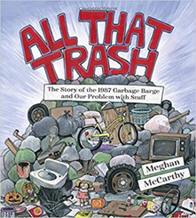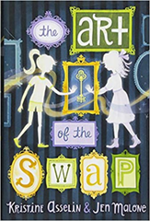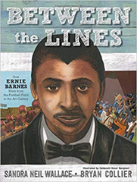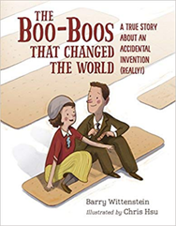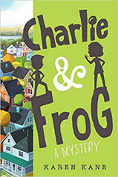

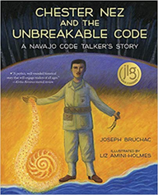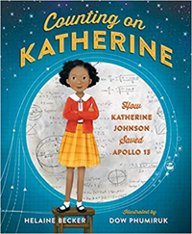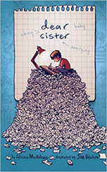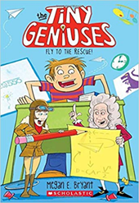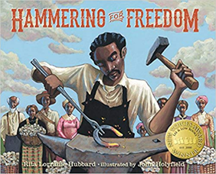

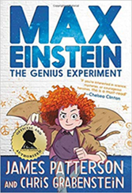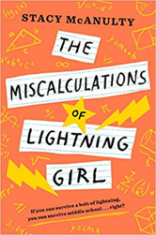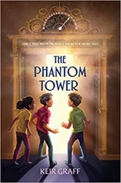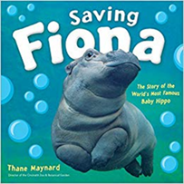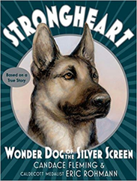

- All That Trash: The Story of the 1987 Garbage Barge and Our Problem with Stuff
written and illustrated by Meghan McCarthy
Simon & Schuster/Paula Wiseman Books, 2018. HC: 978-1481477529, 48 pp., $17.99
[Break of Dawn tugboat; Islip, NY; barges, transportation, history, waste, recycling, environment, STEM, 1980s]
Summary: The true story of a garbage barge that didn't have a place to dock-- and was one of the events that led to the recycling movement. (Publisher)
Awards: An ALA Notable Book
Accelerated Reader: IL: LG - BL: 5.0 - AR Pts: 0.5 AR Quiz No. 194390

- Art of the Swap, The
by Kristine Asselin and Jen Malone
Aladdin, 2018. HC: 978-1481478717, 352 pp., $16.99. PB: 978-1481478724, $8.99
[12 y/o female protags, contemporary/historical, light fantasy, time travel, art theft, impersonation, Rhode Island, mystery]
Summary: When twelve-year-olds Hannah and Maggie switch places, Hannah must prevent a famous art theft in 1905 and Maggie must cope with modern life until they can switch back. (LOC)
Accelerated Reader: IL: MG - BL: 5.3 - AR Pts: 10.0 AR Quiz No. 182330

- Between the Lines: How Ernie Barnes Went from the Football Field to the Art Gallery
by Sandra Neil Wallace, illustrated by Bryan Collier
Simon & Schuster/Paula Wiseman Books, 2018. HC: 978-1481443876, 48 pp., $17.99
[football players, painters, civil rights, African American]
Summary: Discover the true story of NFL star Ernie Barnes, who followed his dreams and became one of the most influential artists of his generation. (AR)
Awards: A 2019 Orbis Pictus Book Award Winner, An ALA-ALSC Notable Children’s Book, A SCBWI Golden Kite Honor Book Award, A Booklist Top 10 Biographies for Youth, A Booklist Top 10 Art Books for Youth, A New York Public Library (NYPL) Best Book for Kids, A Chicago Public Library Best of the Best Book
Accelerated Reader: IL: LG - BL: 4.0 - AR Pts: 0.5 AR Quiz No. 193445

- Boo-Boos That Changed the World, The: A True Story About an Accidental Invention (Really!)
by Barry Wittenstein, illustrated by Chris Hsu
Charlesbridge, 2018. HC: 978-1580897457, 32 pp., $16.99
[humor, medical innovation, Johnson & Johnson, first aid, health, science, history, science, invention]
Summary: Earle Dickson and his new bride Josephine begin their lives together. The end. (Not really. There's more.) Josephine has a proclivity for injuring herself. Earle attaches cotton to long strips of adhesive tape, telling Josephine to cut off a length when she needs one. Since Earle works as a cotton buyer at Johnson & Johnson, he shares his idea. They're a big hit. The end. (Again, not really!) After a few false starts (much like the hilarious "the end"s in this story), the Band-Aid is developed and becomes a massive hit. The end. (Really.) (Publisher)
Accelerated Reader: IL: LG - BL: 3.9 - AR Pts: 0.5 AR Quiz No. 193557

- Charlie and Frog (Book #1)
by Karen Kane
Disney-Hyperion, 2018. HC: 978-1368005821, 256 pp., $16.99. PB: 978-1368006309, $7.99
[10 y/o male protag, special needs, ASL, humor, grandparents, friendship, mystery]
Summary: While staying with his grandparents in Castle-on-the-Hudson, Charlie stumbles upon a mystery but must learn American Sign Language to keep up with Frog, a deaf girl who wants to help solve it. (LOC)
Awards: An Amazon Best Book of the Month
Accelerated Reader: IL: MG - BL: 4.1 - AR Pts: 6.0 AR Quiz No. 196540

- Chester Nez and the Unbreakable Code: A Navajo Code Talker's Story
by Joseph Bruchac, illustrated by Liz Amini-Holmes
Albert Whitman & Company, 2018. HC: 978-0807500071, 32 pp., $16.14
[World War II, military, US history, Native Americans, history]
Summary: As a boy, Chester Nez was taught that his native language and culture were useless, but he was later called on to use his Navajo language to help create an unbreakable military code during WWII. (AR)
Accelerated Reader: IL: MG - BL: 4.8 - AR Pts: 0.5 AR Quiz No. 194117
- Counting on Katherine: How Katherine Johnson Saved Apollo 13
by Helaine Becker, illustrated by Tiemdow Phumiruk
Henry Holt and Co. (BYR), 2018. HC: 978-1250137524, 40 pp., $17.99
[Katherine G Johnson, United States. National Aeronautics and Space Administration, African American women mathematicians, history, science]
Summary: The book is a story of Katherine Johnson, an African American mathematician who worked for NASA during the space race and was depicted in the film HIDDEN FIGURES. (AR)
Awards: A Junior Library Guild Selection, An NSTA Outstanding Science Trade Book, A NCTM Mathical Honor Book, An NCSS Notable Social Studies Trade Book for Young People, An ILA Notable Book for a Global Society, An ILA Teachers’ Choices Reading List Selection, An Amelia Bloomer List Selection, A Chicago Public Library Best Book of the Year, A Vermont Red Clover Award Master List Selection
Accelerated Reader: IL: LG - BL: 4.2 - AR Pts: 0.5 AR Quiz No. 196205

- Dear Sister
by Alison McGhee, illustrated by Joe Bluhm
Atheneum/Caitlyn Dlouhy Books, 2018. HC: 978-1481451420, 192 pp., $13.99. PB: 978-1481451437, $7.99 (avail Oct. 2019)
[8- teen y/o male protag, graphic fiction, humor, epistolary, brothers and sisters]
Summary: Brother chronicles life with his frequently-annoying Sister, from the time she is born until she is ten and he leaves for college, through a series of letters and drawings. (LOC)
Accelerated Reader: IL: MG - BL: 3.6 - AR Pts: 0.5 AR Quiz No. 198093

- Fly to the Rescue (Tiny Geniuses: Book 1)
by Megan E. Bryant
Scholastic Paperbacks, 2018. PB: 978-0545909518, 128 pp., $5.99
[4th grader male protag, school, friendship, science, fantasy, humor]
Summary: When Jake makes a desperate wish for homework help, he can't believe what happens next! His Heroes of History action figures come to life! (AR)
Accelerated Reader: IL: MG - BL: 4.6 - AR Pts: 2.0 AR Quiz No. 195713

- Hammering for Freedom
by Rita Lorraine Hubbard, illustrated by John Holyfield
Lee & Low Books, 2018. HC: 978-1600609695, 32 pp., $17.95
[Freedmen, blacksmiths, Chattanooga, African American, entrepreneurship, history]
Summary: This book tells the inspirational story of William "Bill" Lewis, a hardworking blacksmith who slowly saved his money to free his family. (AR)
Awards: A Lee & Low New Voices Award Winner, A Junior Library Guild Selection
Accelerated Reader: IL: LG - BL: 4.6 - AR Pts: 0.5 AR Quiz No. 198102

- Max Einstein: The Genius Experiment (Book #1)
by James Patterson and Chris Grabenstein, illustrated by Beverly Johnson
jimmy Patterson, 2018. HC: 978-0316523967, 352 pp., $14.99. PB: 978-0316523974, $8.99
[12 y/o female protag, action & adventure, science, problem solving creative ability, genius]
Summary: Max Einstein and a group of international geniuses use their creativity and curiosity to help solve some of the world's toughest problems with science. (LOC)
Accelerated Reader: IL: MG - BL: 3.8 - AR Pts: 7.0 AR Quiz No. 197536

- Miscalculations of Lightning Girl, The
by Stacy McAnulty
Random House Books for Young Readers, 2018. HC: 978-1524767570, 304 pp., $16.99. PB: 978-1524767600, 320 pp., $7.99
[12 y/o, female protagonist, contemporary, math, prodigy, homeschool, pets, social skills, savant, grandmothers, mean girls, OCD]
Summary: A lightning strike made Lucy, twelve, a math genius but, after years of homeschooling, her grandmother enrolls her in middle school and she learns that life is more than numbers. (LOC)
Awards: An Amazon Best Children's Book of the Year selection, An NPR Best Book of the Year, A Kirkus Reviews Best Book of the Year
Accelerated Reader: IL: MG - BL: 3.7 - AR Pts: 7.0 AR Quiz No. 195064

- Phantom Tower, The
by Keir Graff
G.P. Putnam's Sons Books for Young Readers, 2018. HC: 978-1524739522, 288 pp., $16.99
[12 y/o, male protag, brothers, twins, fantasy, single-parent families, apartment houses, blessing and cursing, supernatural, adventure, horror]
Summary: When the missing button for their new apartment building's thirteenth floor suddenly appears, identical twins Mal and Colm are pulled into an eerie adventure in a parallel dimension. (Publisher)
Awards: A Chicago Tribune Best Children's Book of 2018
Accelerated Reader: IL: MG - BL: 5.6 - AR Pts: 9.0 AR Quiz No. 198741

- Saving Fiona: The Story of the World's Most Famous Baby Hippo
by Thane Maynard
HMH Books for Young Readers, 2018. HC: 978-1328485137, 48 pp., $19.99
[zoology, baby animals, conservation, scientists, teamwork, science, veterinarians]
Summary: When Fiona, a baby hippo, was born prematurely at the Cincinnati Zoo, a team of scientists and caregivers nursed her to health and a vast community in Cincinnati and beyond rallied around her. (AR)
Accelerated Reader: IL: LG - BL: 5.8 - AR Pts: 0.5 AR Quiz No. 195657

- Strongheart: Wonder Dog of the Silver Screen
by Candace Fleming, illustrated by Eric Rohmann
Schwartz & Wade, 2018. HC: 978-1101934104, 256 pp., $17.99
[Dogs, Hollywood, 1920s, acting, German Shepherd, based on a true story, perseverance, historical]
Summary: A German shepherd is transformed from Etzel, a police dog in Berlin, to Strongheart, a silent movie star that will need his best acting skills to prove himself innocent of attacking a girl. (LOC)
Awards: New York Public Library Best Book of 2018, A Chicago Public Library Best Book of 2018
Accelerated Reader: IL: MG - BL: 4.1 - AR Pts: 2.0 AR Quiz No. 194405

