2020-2021 LYRC 6-8th Grade Annotated Nominated Title List
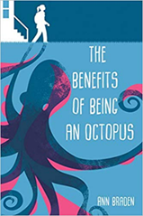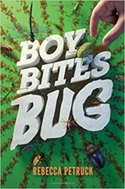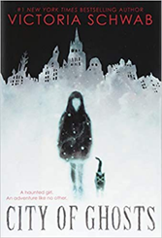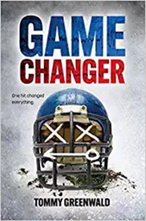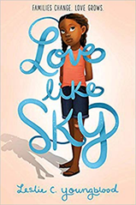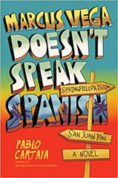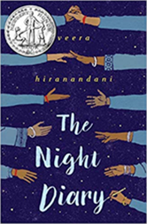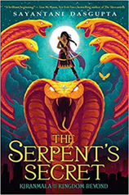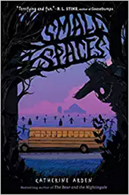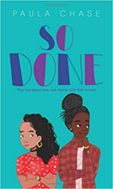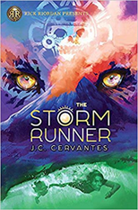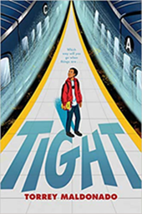

1. Benefits of Being an Octopus, The by Ann Braden
Sky Pony, 2018. HC: 978-1510737488, 256 pp., $16.99
[7th grader, female protag, brothers and sister, debates, middle school, gun debate, family problems, rural poverty, domestic abuse, cultural divide, Vermont, bullying, standing up for yourself and others] This is one of the more mature selections on this year’s list.
Summary: Seventh-grader Zoey Albro focuses on caring for three younger siblings and avoiding rich classmates at school until her fascination with octopuses gets her on the debate team and she begins to speak out.
Awards: Named an NPR Best Book of 2018, Named to the Bank Street List for Best Children's Books of 2019, Named to the Vermont Dorothy Canfield Fisher List, Named to the Maine's Student Book Award List, Named to the Rhode Island Middle School Book Award 2020 List, 2020 Oklahoma Sequoyah Book Award Nominee
Accelerated Reader: IL: MG - BL: 4.9 - AR Pts: 8.0 AR Quiz No. 198616

2. Boy Bites Bug by Rebecca Petruck
Harry N. Abrams, 2018. HC: 978-1419721410, 272 pp., $16.99; PB: 978-1419734816, 272 pp., $8.99
[7th grade, male protag, best friends, insects, race relations, Hispanic Americans, sports, friendships, wrestling]
Summary: To defuse a situation between his best friend and a new student, Nolan eats a live stink bug, gaining popularity and a class project idea but, perhaps, losing a friend.
Accelerated Reader: IL: MG - BL: 5.6 - AR Pts: 8.0 AR Quiz No. 197715

3. City of Ghosts by Victoria Schwab
Scholastic Press, 2018. HC: 978-1338111002, 304 pp., 17.99; PB (avail 9/3/19): 978-1338111026. 320
pp., $7.99
[12 y/o Female protag, adventure, ghost stories, haunted places, ghost television programs, parapsychology, best friends, Edinburgh (Scotland)]
Summary: Ever since her near-fatal drowning, Cassidy has been able to pull back the "Veil" that separates the living from the dead and see ghosts, not that she wants to, and she was really looking forward to a ghost-free summer at the beach; however her parents are going to start filming a TV series about the world's most haunted places, starting with Edinburgh with its graveyards, castles, and restless phantoms--and Cass and her personal ghost companion, Jacob, are about to find out that a city of old ghosts can be a very dangerous place indeed.
Accelerated Reader: IL: MG - BL: 4.8 - AR Pts: 7.0 AR Quiz No. 197414

4. Game Changer by Tommy Greenwald
Harry N. Abrams, 2018. HC: 978-1419731433, 304 pp., $16.99
[13 y/o male protag, nontraditional narrative (interview transcripts, text messages, hospital reports, etc.), football, sports injuries, coma, hazing, family problems, epistolary, mystery, multiple narrators, coma]
Summary: While thirteen-year-old Teddy fights for his life after a football injury at training camp, his friends and family gather to support him and discuss events leading to his coma. Told through dialogue, text messages, newspaper articles, transcripts, an online forum, and Teddy's inner thoughts.
Awards: An Amazon Best Book of the Month
Accelerated Reader: IL: MG - BL: 5.4 - AR Pts: 4.0 AR Quiz No. 196884

5. Love Like Sky by Leslie C. Youngblood
Disney-Hyperion, 2018. HC: 978-1368016506, 304 pp., $16.99; PB (avail 10/8/19): 978-1368019392, 304 pp., $7.99
[11 y/o female protag, African American, sisters, step-families, sickness, family life, Georgia, Louisiana, Bogalusa, divorce]
Summary: Eleven-year-old Georgie is still adjusting to leaving Atlanta for a small town, having a stepfather, and being unable to get close to her stepsister when her six-year-old sister, Peaches, suddenly becomes very ill.
Awards: Winter 2018 Kids' Indie Next List, SIBA 2018 Fall Okra Pick, Kirkus Reviews' Best Middle Grade Family Stories of 2018, Bookish: Brilliant Book Covers: The Best Covers of November 2018, Atlanta Parent: Best Books of 2018, PennGSE Newsroom: The Best Books of 2018 for Young Readers, BNKids: Our Favorite Contemporary Middle Grade of 2018, BookRiot: Black Kids on Book Covers: Middle Grade Edition, selection (2019)
Accelerated Reader: IL: MG - BL: 4.1 - AR Pts: 10.0 AR Quiz No. 199163

6. Marcus Vega Doesn't Speak Spanish by Pablo Cartaya
Viking Books for Young Readers, 2018. HC: 978-1101997260, 272 pp., $16.99. PB (avail 7/9/19): 978-
1101997284, 288 pp., $8.99
[14 y/o, 8th grader, male protag, families, Puerto Ricans, Down syndrome, middle school, learning disability, trips, extended family]
Summary: After a fight at school leaves Marcus facing suspension, Marcus's mother takes him and his younger brother, who has Down syndrome, to Puerto Rico to visit relatives they do not remember or have never met, and while there Marcus starts searching for his father, who left their family ten years ago and is somewhere on the island.
Accelerated Reader: IL: MG - BL: 3.9 - AR Pts: 6.0 AR Quiz No. 196042

7. Night Diary, The by Veera Hiranandani
Kokila (Penguin Books), 2018. HC: 978-0735228511, 272 pp., $16.99. PB: 978-0735228528, 288 pp.,
$8.99
[12 y/o female protag, refugees, India, diary, family life, Hindus, Muslims, 1947, siblings, epistolary, refugee, Pakistan, deceased mother]
Summary: Shy twelve-year-old Nisha, forced to flee her home with her Hindu family during the 1947 partition of India, tries to find her voice and make sense of the world falling apart around her by writing to her deceased Muslim mother in the pages of her diary.
Awards: A 2019 NEWBERY HONOR BOOK, A Walter Dean Myers Honor Winner, An ALA Notable Book, A Malka Penn Award Recipient, A New York Times Editor's Choice Pick, A Junior Library Guild Selection, Named a Best Book of the Year by Amazon, Kirkus Reviews, The New York Times, NPR, School Library Journal, and The Washington Post.
Accelerated Reader: IL: MG - BL: 4.5 - AR Pts: 8.0 AR Quiz No. 194398

8. Serpent's Secret, The (Kiranmala and the Kingdom Beyond #1) by Sayantani DasGupta
Scholastic Press, 2018. HC: 978-1338185706, 368 pp., $17.99. PB: 978-1338185713, 368 pp., $7.99
[12 y/o female protagonist, 6th grade, interdimensional demon slayer, Indian-American, missing persons, princesses, magic, quests, adventure, humor, for fans of Percy Jackson]
Summary: Up until her twelfth birthday, Kiranmala considered herself an ordinary sixth-grader in Parsippany, New Jersey, but then her parents disappear and a drooling rakkhosh demon shows up in her kitchen, and soon she is swept into another dimension, full of magic, winged horses, talking birds (very annoying), and cute princes--and somehow Kiranmala needs to sort it all out, find her parents, and basically save the world. (LOC)
Accelerated Reader: IL: MG - BL: 5.2 - AR Pts: 10.0 AR Quiz No. 193776

9. Small Spaces by Katherine Arden
G.P. Putnam's Sons Books for Young Readers, 2018. HC: 978-0525515029, 224 pp., $16.99.
[11 y/o female protagonist, suspense thriller mystery, scarecrows]
Summary: After eleven-year-old Ollie's school bus mysteriously breaks down on a field trip, she has to take a trip through scary woods, and must use all of her wits to survive. She must stick to small spaces.
Awards: A Kirkus Best Book of 2018, A Publishers Weekly Best Book of 2018, A Chicago Public Library’s Best of the Best Books of 2018, An Amazon Best Book, A CCBC Choices List Pick – 2019
A Great Texas Mosquito Reading List Pick, A Maine Student Book Award Nominee, A Sunshine State Young Readers Award Nominee, A Dorothy Canfield Fisher Children’s Book Award Nominee
Accelerated Reader: IL: MG - BL: 4.1 - AR Pts: 6.0 AR Quiz No. 197010

10. So Done by Paula Chase
Greenwillow Books (HarperCollins), 2018. HC: 978-0062691781, 304 pp., $16.99. PB:
978-0062691798, 320 pp., $6.99
[7th grade, female protag, best friends, friendship, family problems, middle schools, African American, racially mixed people, auditions, ballet, multiple POV, secrets, standing up for yourself] This is one of the more mature selections on this year’s list.
Summary: The friendship of best friends Metai and Jamila threatens to combust from the pressure of secrets, middle school, and auditions for a talented-and-gifted program.
Accelerated Reader: IL: MG+ - BL: 4.8 - AR Pts: 8.0 AR Quiz No. 196866

11. Storm Runner, The (A Storm Runner Novel, Book 1) by J.C. Cervantes
Rick Riordan Presents, 2018. HC: 978-1368016346, 448 pp., $16.99. PB (avail 8/20/19): 978
1368023603, 464 pp., $7.99
[13 y/o male protag, Maya mythology, people disabilities, fathers and son, Maya gods, southwest United States, Los Angeles, humor, adventure, Mexican Americans, for fans of Percy Jackson]
Summary: To prevent the Mayan gods from battling each other and destroying the world, thirteen-year-old Zane must unravel an ancient prophecy, stop an evil god, and discover how the physical disability that makes him reliant on a cane also connects him to his father and his ancestry.
Accelerated Reader: IL: MG - BL: 4.4 - AR Pts: 14.0 AR Quiz No. 197586

12. Tight by Torrey Maldonado
Nancy Paulsen Books (Penguin), 2018. HC: 978-1524740559, 192 pp., $16.99. PB (avail 8/27/19): 978-
1524740573, 192 pp., $7.99
[6th grade African American male protagonist, Brooklyn, family life, troublemakers, crime, coming of age]
Summary: After his quick-tempered father gets in a fight and is sent back to jail, sixth-grader Bryan, known for being quiet and thoughtful, snaps and follows new friend Mike into trouble.
Awards: A Washington Post Best Children's Book of 2018!
Accelerated Reader: IL: MG - BL: 3.9 - AR Pts: 5.0 AR Quiz No. 196890

