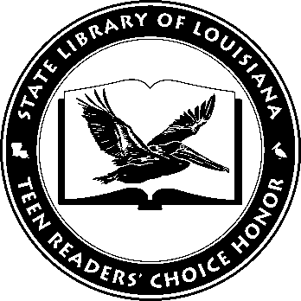

Louisiana’s Teen Readers’ Choice
Ballot 2017

100 Sideways Miles. Andrew Smith

Don’t Even Think About It. Sarah Mlynowski

Fake ID. Lamar Giles

How It Went Down. Kekla Magoon

I’ll Give You the Sun. Jandy Nelson

Nearly Gone. Elle Cosimano

Red Rising. Pierce Brown

To All the Boys I’ve Loved Before. Jenny Han

We Were Liars. E. Lockhart

When I Was the Greatest. Jason Reynolds, photographs Michael Frost

The Louisiana Young Readers’ Choice Award is a reading enrichment program of the Louisiana Center for the Book in the State Library of Louisiana with additional support from the following:
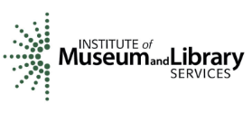
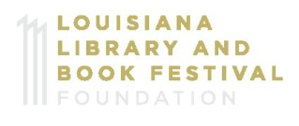

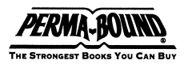

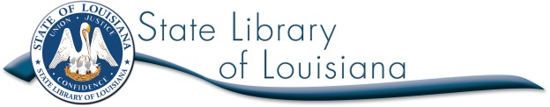

Louisiana’s Teen Readers’ Choice
Ballot 2017

100 Sideways Miles. Andrew Smith

Don’t Even Think About It. Sarah Mlynowski

Fake ID. Lamar Giles

How It Went Down. Kekla Magoon

I’ll Give You the Sun. Jandy Nelson

Nearly Gone. Elle Cosimano

Red Rising. Pierce Brown

To All the Boys I’ve Loved Before. Jenny Han

We Were Liars. E. Lockhart

When I Was the Greatest. Jason Reynolds, photographs Michael Frost

The Louisiana Young Readers’ Choice Award is a reading enrichment program of the Louisiana Center for the Book in the State Library of Louisiana with additional support from the following:
