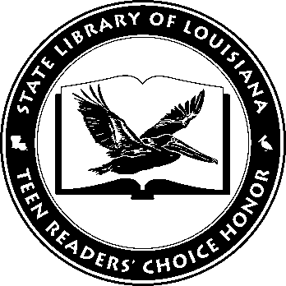

Louisiana’s Teen Readers’ Choice
Ballot 2019-2020

The 57 Bus: A True Story of Two Teenagers and the Crime That Changed Their Lives Dashka Slater

An Enchantment of Ravens Margaret Rogerson

Geekerella: A Fangirl Fairy Tale (Once Upon a Con) Ashley Poston

Goodbye Days Jeff Zenter

The Hate U Give Angie Thomas

Long Way Down Jason Reynolds

Nyxia Scott Reintgen

One of Us is Lying Karen M. McManus

Warcross Marie Lu

You Bring the Distant Near Mitali Perkins

The Louisiana Young Readers’ Choice Award is a reading enrichment program of the Louisiana Center for the Book in the State Library of Louisiana with additional support from the following:
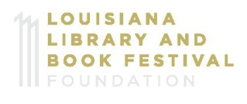

Louisiana’s Teen Readers’ Choice
Ballot 2019-2020

The 57 Bus: A True Story of Two Teenagers and the Crime That Changed Their Lives Dashka Slater

An Enchantment of Ravens Margaret Rogerson

Geekerella: A Fangirl Fairy Tale (Once Upon a Con) Ashley Poston

Goodbye Days Jeff Zenter

The Hate U Give Angie Thomas

Long Way Down Jason Reynolds

Nyxia Scott Reintgen

One of Us is Lying Karen M. McManus

Warcross Marie Lu

You Bring the Distant Near Mitali Perkins

The Louisiana Young Readers’ Choice Award is a reading enrichment program of the Louisiana Center for the Book in the State Library of Louisiana with additional support from the following:
