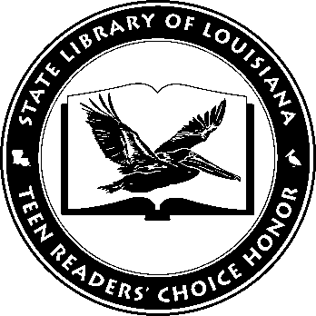

Louisiana’s Teen Readers’ Choice
Ballot 2018-2019

Aging Out Alton Carter

The Female of the Species Mindy McGinnis

Heartless Marissa Meyer

Highly Illogical Behavior John Corey Whaley

Riders Veronica Rossi

Scythe: Arc of a Scythe Neal Shusterman

The Serpent King Jeff Zentner,

The Sun is Also a Star Nicola Yoon

This Is Our Story Ashley Elston

Three Dark Crowns Kendare Blake

The Louisiana Young Readers’ Choice Award is a reading enrichment program of the Louisiana Center for the Book in the State Library of Louisiana with additional support from the following:
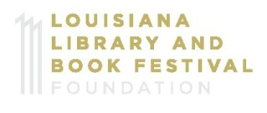

Louisiana’s Teen Readers’ Choice
Ballot 2018-2019

Aging Out Alton Carter

The Female of the Species Mindy McGinnis

Heartless Marissa Meyer

Highly Illogical Behavior John Corey Whaley

Riders Veronica Rossi

Scythe: Arc of a Scythe Neal Shusterman

The Serpent King Jeff Zentner,

The Sun is Also a Star Nicola Yoon

This Is Our Story Ashley Elston

Three Dark Crowns Kendare Blake

The Louisiana Young Readers’ Choice Award is a reading enrichment program of the Louisiana Center for the Book in the State Library of Louisiana with additional support from the following:
