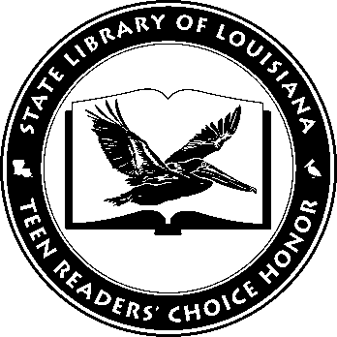

Louisiana’s Teen Readers’ Choice
Ballot 2015

Code Name Verity. Elizabeth Wein

Croak. Gina Damico

Discovering Wes Moore. Wes Moore

Every Day. David Levithan

The Fault in Our Stars. John Green

I Hunt Killers (Jasper Dent, Book 1). Barry Lyga

The Selection. Kiera Cass

Seraphina. Rachel Hartman

Something Like Normal. Trish Doller

The Statistical Probability of Love at First Sight. Jennifer E. Smith

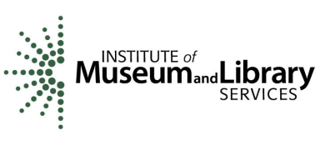
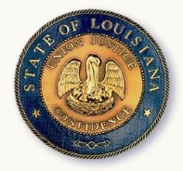
State Library of Louisiana
Department of Culture, Recreation and Tourism

Louisiana’s Teen Readers’ Choice
Ballot 2015

Code Name Verity. Elizabeth Wein

Croak. Gina Damico

Discovering Wes Moore. Wes Moore

Every Day. David Levithan

The Fault in Our Stars. John Green

I Hunt Killers (Jasper Dent, Book 1). Barry Lyga

The Selection. Kiera Cass

Seraphina. Rachel Hartman

Something Like Normal. Trish Doller

The Statistical Probability of Love at First Sight. Jennifer E. Smith

State Library of Louisiana
Department of Culture, Recreation and Tourism

