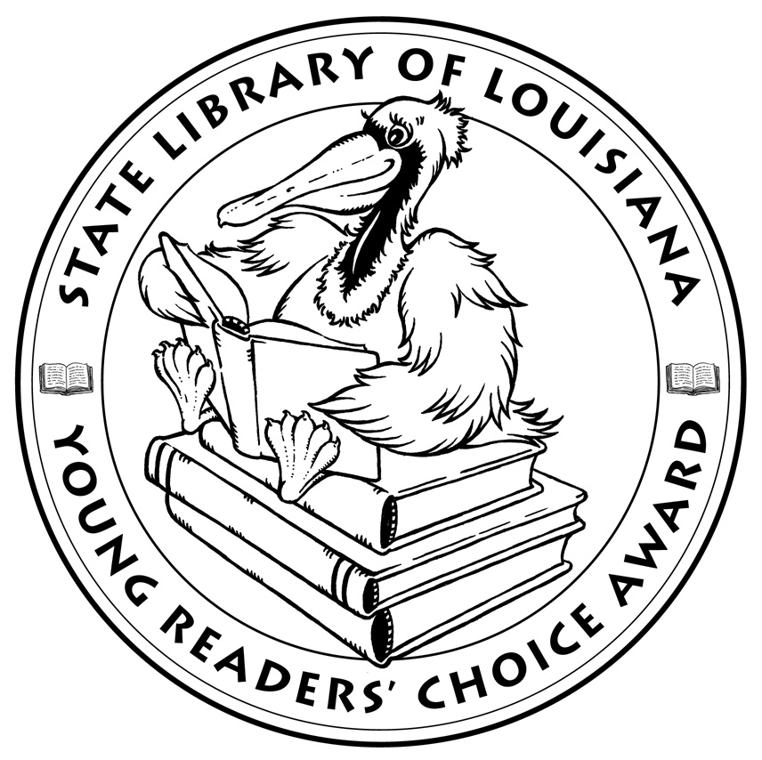

Louisiana’s Young Readers’ Choice
Ballot 2013 Grades 3-5

All the Water in the World. George Ella Lyon. Illus. Katherine Tillotson

America Is Under Attack: The Day the Towers Fell – September 11, 2001. Don Brown.

Balloons Over Broadway: The True Story of the Puppeteer of Macy’s Parade. Melissa Sweet.

Bongo Fishing. Thatcher Hurd.

Close to Famous. Joan Bauer.

Eight Keys. Suzanne LaFleur.

Escape by Night: A Civil War Adventure. Laurie Myers. Illus. Amy June Bates.

The Incredible Life of Balto. Meghan McCarthy.

Lots and Lots of Coins. Margarette S. Reid. Illus. True Kelley.

Nurse, Soldier, Spy: The Story of Sarah Edmonds, a Civil War Hero. Marissa Moss. Illus. John Hendrix

Olivia’s Birds. Olivia Bouler.

The Secret Kingdom: Chronicles of the Red King, Book 1. Jenny Nimmo.

Ten Rules You Absolutely Must Not Break if You Want to Survive the School Bus. John Grandits. Illus. Michael Allen Austin.

Trundle’s Quest. Allan Jones. Illus. Gary Chalk.

Waiting for the Magic. Patricia MacLachlan. Illus. Amy June Bates.


State Library of Louisiana
Department of Culture, Recreation and Tourism

Louisiana’s Young Readers’ Choice
Ballot 2013 Grades 3-5

All the Water in the World. George Ella Lyon. Illus. Katherine Tillotson

America Is Under Attack: The Day the Towers Fell – September 11, 2001. Don Brown.

Balloons Over Broadway: The True Story of the Puppeteer of Macy’s Parade. Melissa Sweet.

Bongo Fishing. Thatcher Hurd.

Close to Famous. Joan Bauer.

Eight Keys. Suzanne LaFleur.

Escape by Night: A Civil War Adventure. Laurie Myers. Illus. Amy June Bates.

The Incredible Life of Balto. Meghan McCarthy.

Lots and Lots of Coins. Margarette S. Reid. Illus. True Kelley.

Nurse, Soldier, Spy: The Story of Sarah Edmonds, a Civil War Hero. Marissa Moss. Illus. John Hendrix

Olivia’s Birds. Olivia Bouler.

The Secret Kingdom: Chronicles of the Red King, Book 1. Jenny Nimmo.

Ten Rules You Absolutely Must Not Break if You Want to Survive the School Bus. John Grandits. Illus. Michael Allen Austin.

Trundle’s Quest. Allan Jones. Illus. Gary Chalk.

Waiting for the Magic. Patricia MacLachlan. Illus. Amy June Bates.

State Library of Louisiana
Department of Culture, Recreation and Tourism

