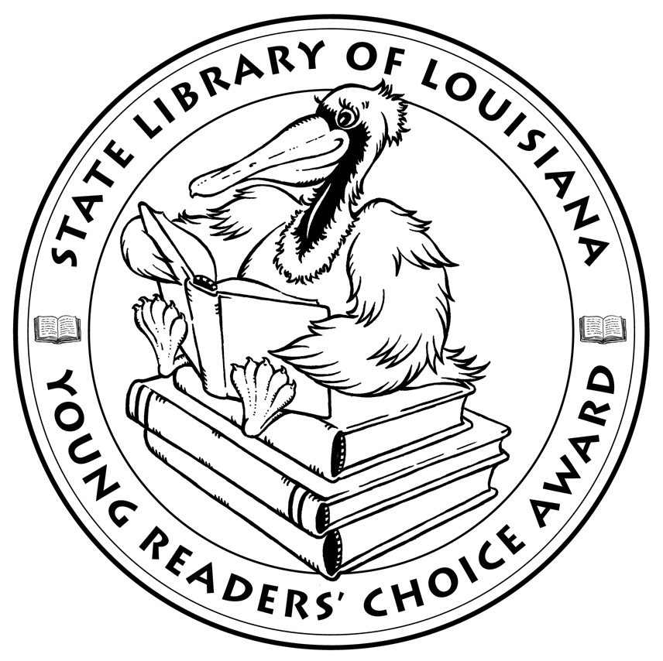

Louisiana’s Young Readers’ Choice
Ballot 2016
Grades 3-5

Brave Girl: Clara and the Shirtwaist Makers' Strike of 1909. Michelle Markel

Case File 13: Zombie Kid. J. Scott Savage

Einstein the Class Hamster. Janet Tashjian, illus. Jake Tashjian

Elvis and the Underdogs. Jenny Lee, illus. Kelly Light

Escape from Mr. Lemoncello’s Library. Chris Grabenstein

Farmer Will Allen and the Growing Table. Jacqueline Briggs Martin

Fortunately, the Milk. Neil Gaiman, illus. Skottie Young

Henry and the Cannons: An Extraordinary True Story of the American Revolution. Don Brown

Hey, Charleston!: The True Story of the Jenkins Orphanage Band. Anne F. Rockwell, illus. Colin Bootman

Hoop Genius: How a Desperate Teacher and a Rowdy Gym Class Invented Basketball. John Coy, illus. Joe Morse

The Matchbox Diary. Paul Fleischman, illus. Bagram Ibatoulline

The Mischievians. William Joyce

Mountain Dog. Margarita Engle, illus. Olga and Aleksey Ivanov

Sugar. Jewell Parker Rhodes

Rump: The True Story of Rumpelstiltskin. Liesl Shurtliff

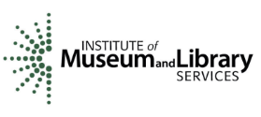
The Louisiana Young Readers’ Choice Award is a reading enrichment program of the Louisiana Center for the Book in the State Library of Louisiana with additional support from the following:
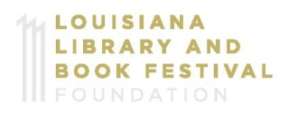


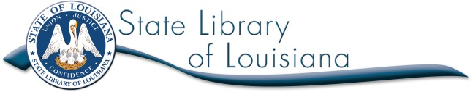

Louisiana’s Young Readers’ Choice
Ballot 2016
Grades 3-5

Brave Girl: Clara and the Shirtwaist Makers' Strike of 1909. Michelle Markel

Case File 13: Zombie Kid. J. Scott Savage

Einstein the Class Hamster. Janet Tashjian, illus. Jake Tashjian

Elvis and the Underdogs. Jenny Lee, illus. Kelly Light

Escape from Mr. Lemoncello’s Library. Chris Grabenstein

Farmer Will Allen and the Growing Table. Jacqueline Briggs Martin

Fortunately, the Milk. Neil Gaiman, illus. Skottie Young

Henry and the Cannons: An Extraordinary True Story of the American Revolution. Don Brown

Hey, Charleston!: The True Story of the Jenkins Orphanage Band. Anne F. Rockwell, illus. Colin Bootman

Hoop Genius: How a Desperate Teacher and a Rowdy Gym Class Invented Basketball. John Coy, illus. Joe Morse

The Matchbox Diary. Paul Fleischman, illus. Bagram Ibatoulline

The Mischievians. William Joyce

Mountain Dog. Margarita Engle, illus. Olga and Aleksey Ivanov

Sugar. Jewell Parker Rhodes

Rump: The True Story of Rumpelstiltskin. Liesl Shurtliff

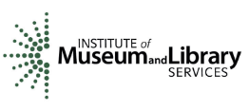
The Louisiana Young Readers’ Choice Award is a reading enrichment program of the Louisiana Center for the Book in the State Library of Louisiana with additional support from the following:

