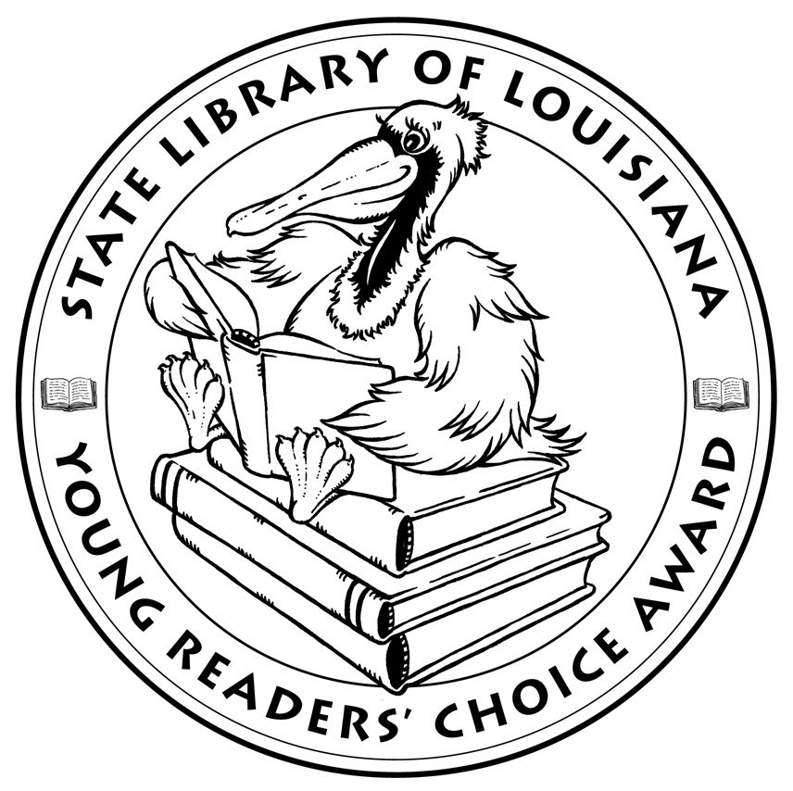

**Louisiana’s Young Readers’ Choice**

**Ballot 2016**

**Grades 3-5**

**Brave Girl: Clara and the Shirtwaist Makers' Strike of 1909**. Michelle Markel

**Case File 13:  Zombie Kid**. J. Scott Savage

**Einstein the Class Hamster. Janet Tashjian, illus. Jake Tashjian**

**Elvis and the Underdogs**. Jenny Lee, illus. Kelly Light

**Escape from Mr. Lemoncello’s Library**. Chris Grabenstein

**Farmer Will Allen and the Growing Table**. Jacqueline Briggs Martin

**Fortunately, the Milk**. Neil Gaiman, illus. Skottie Young

**Henry and the Cannons: An Extraordinary True Story of the American Revolution**. Don Brown

**Hey, Charleston!: The True Story of the Jenkins Orphanage Band**. Anne F. Rockwell, illus. Colin Bootman

**Hoop Genius: How a Desperate Teacher and a Rowdy Gym Class Invented Basketball**. John Coy, illus. Joe Morse

**The Matchbox Diary**. Paul Fleischman, illus. Bagram Ibatoulline

**The Mischievians**. William Joyce

**Mountain Dog**. Margarita Engle, illus. Olga and Aleksey Ivanov

**Sugar**. Jewell Parker Rhodes

**Rump: The True Story of Rumpelstiltskin**. Liesl Shurtliff

*The Louisiana Young Readers’ Choice Award is a reading enrichment program of the Louisiana Center for the Book in the State Library of Louisiana with additional support from the following:*

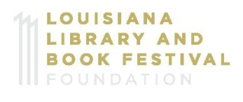



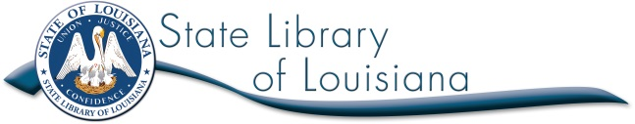

**Louisiana’s Young Readers’ Choice**

**Ballot 2016**

**Grades 3-5**

**Brave Girl: Clara and the Shirtwaist Makers' Strike of 1909**. Michelle Markel

**Case File 13:  Zombie Kid**. J. Scott Savage

**Einstein the Class Hamster. Janet Tashjian, illus. Jake Tashjian**

**Elvis and the Underdogs**. Jenny Lee, illus. Kelly Light

**Escape from Mr. Lemoncello’s Library**. Chris Grabenstein

**Farmer Will Allen and the Growing Table**. Jacqueline Briggs Martin

**Fortunately, the Milk**. Neil Gaiman, illus. Skottie Young

**Henry and the Cannons: An Extraordinary True Story of the American Revolution**. Don Brown

**Hey, Charleston!: The True Story of the Jenkins Orphanage Band**. Anne F. Rockwell, illus. Colin Bootman

**Hoop Genius: How a Desperate Teacher and a Rowdy Gym Class Invented Basketball**. John Coy, illus. Joe Morse

**The Matchbox Diary**. Paul Fleischman, illus. Bagram Ibatoulline

**The Mischievians**. William Joyce

**Mountain Dog**. Margarita Engle, illus. Olga and Aleksey Ivanov

**Sugar**. Jewell Parker Rhodes

**Rump: The True Story of Rumpelstiltskin**. Liesl Shurtliff

*The Louisiana Young Readers’ Choice Award is a reading enrichment program of the Louisiana Center for the Book in the State Library of Louisiana with additional support from the following:*





