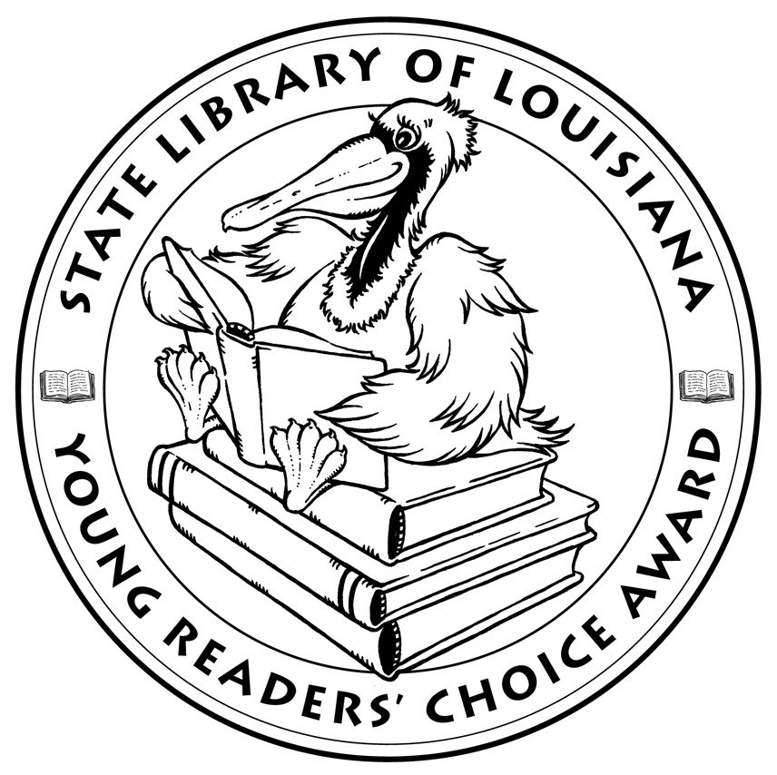

**Louisiana’s Young Readers’ Choice**

**Ballot 2017**

**Grades 3-5**

**Almost Super**. Marion Jensen

**The Blossoming Universe of Violet Diamond**. Brenda Woods

**Eddie Red Undercover: Mystery on Museum Mile. Marcia Wells, illus. Marcos Calo**

**I Survived True Stories: Five Epic Disasters**. Lauren Tarshis

**Ivan the Remarkable True Story of the Shopping Mall Gorilla**. Katherine Applegate, illus. G. Brian Karas

**Kung Pow Chicken: Let’s Get Cracking**. Cyndi Marko

**Lend A Hand: Poems About Giving**. John Frank, illus. London Ladd

**Lindbergh: The Tale of a Flying Mouse**. Torben Kuhlman, illus. Suzanne Levesque

**Little Melba and Her Big Trombone**. Katheryn Russell-Brown, illus. Frank Morrison

**Mr. Ferris and His Wheel**. Kathryn Gibbs Davis, illus. Gilbert Ford

**The Noisy Paintbox: The Colors and Sounds of Kandinsky’s Abstract Art**. Barb Rosenstock, illus. Marie GrandPré

**Odd, Weird & Little**. Patrick Jennings

**Pack of Dorks**. Beth Vrabel

**Shooting at the Stars: The Christmas Truce of 1914**. John Hendrix

**Wind Dancer**. Chris Platt

*The Louisiana Young Readers’ Choice Award is a reading enrichment program of the Louisiana Center for the Book in the State Library of Louisiana with additional support from the following:*

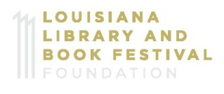



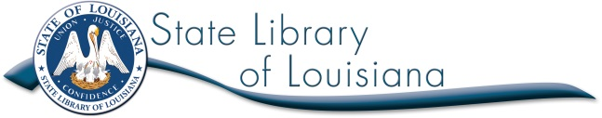

**Louisiana’s Young Readers’ Choice**

**Ballot 2017**

**Grades 3-5**

**Almost Super**. Marion Jensen

**The Blossoming Universe of Violet Diamond**. Brenda Woods

**Eddie Red Undercover: Mystery on Museum Mile. Marcia Wells, illus. Marcos Calo**

**I Survived True Stories: Five Epic Disasters**. Lauren Tarshis

**Ivan the Remarkable True Story of the Shopping Mall Gorilla**. Katherine Applegate, illus. G. Brian Karas

**Kung Pow Chicken: Let’s Get Cracking**. Cyndi Marko

**Lend A Hand: Poems About Giving**. John Frank, illus. London Ladd

**Lindbergh: The Tale of a Flying Mouse**. Torben Kuhlman, illus. Suzanne Levesque

**Little Melba and Her Big Trombone**. Katheryn Russell-Brown, illus. Frank Morrison

**Mr. Ferris and His Wheel**. Kathryn Gibbs Davis, illus. Gilbert Ford

**The Noisy Paintbox: The Colors and Sounds of Kandinsky’s Abstract Art**. Barb Rosenstock, illus. Marie GrandPré

**Odd, Weird & Little**. Patrick Jennings

**Pack of Dorks**. Beth Vrabel

**Shooting at the Stars: The Christmas Truce of 1914**. John Hendrix

**Wind Dancer**. Chris Platt

*The Louisiana Young Readers’ Choice Award is a reading enrichment program of the Louisiana Center for the Book in the State Library of Louisiana with additional support from the following:*





