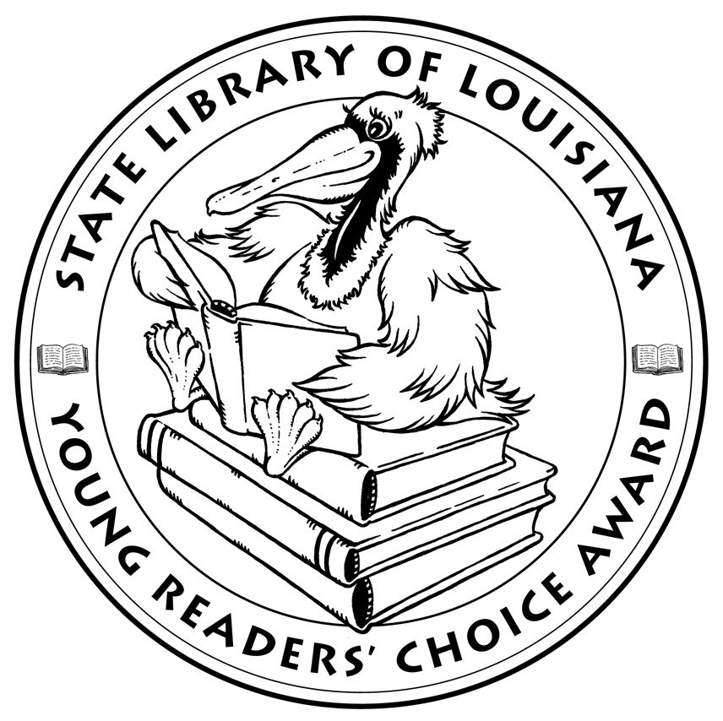

**Louisiana’s Young Readers’ Choice**

**Ballot 2018**

**Grades 3-5**

**Bigfoot is Missing**! J. Patrick Lewis

**Crenshaw**. Katherine Applegate

**The Doublecross: And Other Skills I Learned as a**

**Superspy. Jackson Pearce**

**Ellie’s Story**. W. Bruce Cameron

**Finding Serendipity**. Angelica Banks

**Finding Winnie: The True Story of the World’s**

**Most Famous Bear**. Lindsay Mattick, illus. Sophie

Blackall

**Flunked**. Jen Calonita

**Fort**. Cynthia DeFelice

**The House That Jane Built: A Story About Jane**

**Addams**. Tanya Lee Stone, illus. Kathryn Brown

**Luna & Me: The True Story of a Girl Who Lived**

**in a Tree to Save a Forest**. Jenny Sue Kostecki-

Shaw

**Marvelous Cornelius: Hurricane Katrina and the**

**Spirit of New Orleans**. Phil Bildner, illus. John Parra

**Queen of the Diamond: The Lizzie Murphy**

**Story**. Emily Arnold McCully

**Ratscalibur**. Josh Lieb

**The Terrible Two**. Mac Barnett and Jory John

**Trombone Shorty**. Troy Andrews

*The Louisiana Young Readers’ Choice Award is a reading enrichment program of the Louisiana Center for the Book in the State Library of Louisiana with additional support from the following:*

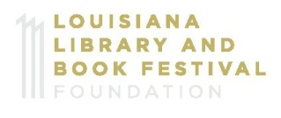





**Louisiana’s Young Readers’ Choice**

**Ballot 2018**

**Grades 3-5**

**Bigfoot is Missing**! J. Patrick Lewis

**Crenshaw**. Katherine Applegate

**The Doublecross: And Other Skills I Learned as a**

**Superspy. Jackson Pearce**

**Ellie’s Story**. W. Bruce Cameron

**Finding Serendipity**. Angelica Banks

**Finding Winnie: The True Story of the World’s**

**Most Famous Bear**. Lindsay Mattick, illus. Sophie

Blackall

**Flunked**. Jen Calonita

**Fort**. Cynthia DeFelice

**The House That Jane Built: A Story About Jane**

**Addams**. Tanya Lee Stone, illus. Kathryn Brown

**Luna & Me: The True Story of a Girl Who Lived**

**in a Tree to Save a Forest**. Jenny Sue Kostecki-

Shaw

**Marvelous Cornelius: Hurricane Katrina and the**

**Spirit of New Orleans**. Phil Bildner, illus. John Parra

**Queen of the Diamond: The Lizzie Murphy**

**Story**. Emily Arnold McCully

**Ratscalibur**. Josh Lieb

**The Terrible Two**. Mac Barnett and Jory John

**Trombone Shorty**. Troy Andrews

*The Louisiana Young Readers’ Choice Award is a reading enrichment program of the Louisiana Center for the Book in the State Library of Louisiana with additional support from the following:*



