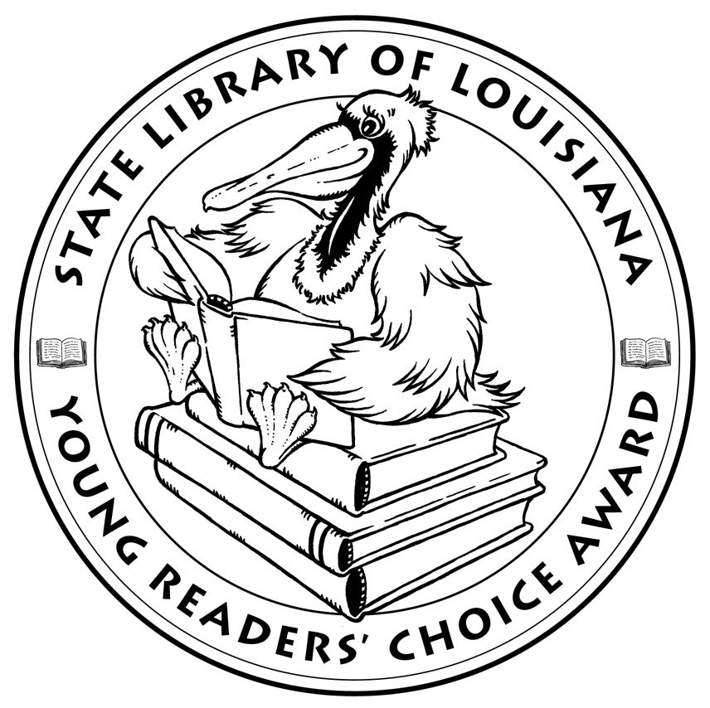

**Louisiana’s Young Readers’ Choice**

**Ballot 2018-2019**

**Grades 3-5**

**Ada’s Violin: The Story of the Recycled**

**Orchestra of Paraguay** Susan Hood, illus. Sally

Wern Comport

**Adrift at Sea: A Vietnamese Boy’s Story of**

**Survival** Marsha Forchuk Skrypuch with Tuan Ho,

illus. Brian Deines

**The Bad Guys. Aaron Blabey**

**FRAMED! A T.O.A.S.T. Mystery** James Ponti

**The Marvelous Thing That Came From a Spring:**

**The Accidental Invention of the Toy That Swept**

**the Nation** Gilbert Ford

**My Life in Pictures** Deborah Zemke

**Seven and a Half Tons of Steel** Janet Nolan, illus.

Thomas Gonzalez

**Soar** Joan Bauer

**Step Right Up: How Doc and Jim Key Taught the**

**World About Kindness** Donna Janell Bowman

**Tiny Stitches – The Life of Medical Pioneer**

**Vivien Thomas** Gwendolyn Hooks, illus. Colin

Bootman

**Towers Falling** Jewell Parker Rhodes

**The Voyage to Magical North** Claire Fayers

**The William Hoy Story** Nancy Churnin, illus. Jez

Tuya

**Wish** Barbara O’Connor

**Word of Mouse** James Patterson & Chris Grabenstein

*The Louisiana Young Readers’ Choice Award is a reading enrichment program of the Louisiana Center for the Book in the State Library of Louisiana with additional support from the following:*

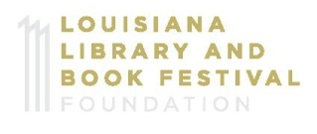







**Louisiana’s Young Readers’ Choice**

**Ballot 2018-2019**

**Grades 3-5**

**Ada’s Violin: The Story of the Recycled**

**Orchestra of Paraguay** Susan Hood, illus. Sally

Wern Comport

**Adrift at Sea: A Vietnamese Boy’s Story of**

**Survival** Marsha Forchuk Skrypuch with Tuan Ho,

illus. Brian Deines

**The Bad Guys. Aaron Blabey**

**FRAMED! A T.O.A.S.T. Mystery** James Ponti

**The Marvelous Thing That Came From a Spring:**

**The Accidental Invention of the Toy That Swept**

**the Nation** Gilbert Ford

**My Life in Pictures** Deborah Zemke

**Seven and a Half Tons of Steel** Janet Nolan, illus.

Thomas Gonzalez

**Soar** Joan Bauer

**Step Right Up: How Doc and Jim Key Taught the**

**World About Kindness** Donna Janell Bowman

**Tiny Stitches – The Life of Medical Pioneer**

**Vivien Thomas** Gwendolyn Hooks, illus. Colin

Bootman

**Towers Falling** Jewell Parker Rhodes

**The Voyage to Magical North** Claire Fayers

**The William Hoy Story** Nancy Churnin, illus. Jez

Tuya

**Wish** Barbara O’Connor

**Word of Mouse** James Patterson & Chris Grabenstein

*The Louisiana Young Readers’ Choice Award is a reading enrichment program of the Louisiana Center for the Book in the State Library of Louisiana with additional support from the following:*



