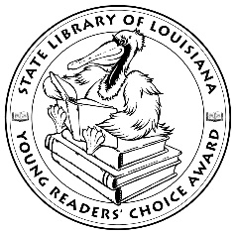

**Louisiana’s Young Readers’ Choice**

**Ballot 2019-2020**

**Grades 3-5**

**Army Brats** Daphne Benedis-Grab

**Balderdash: John Newbery and the Boisterous Birth of Children’s Books**

Michelle Markel, illustrated by Nancy Carpenter

**A Boy Called Bat Elana K. Arnold illus. Charles Santoso**

**Crown: An Ode to the Fresh Cut** Derrick Barnes

**Give Bees a Chance** Bethany Barton

**Grace Hopper: Queen of Computer Code** Laurie Wallmark illus. Katy Wu

**Imagine That!: How Dr. Seuss Wrote Cat in the Hat** Judy Sierra

**Jake the Fake Keeps it Real (Book 1)** Craig Robinson & Adam Mansbach illus. Keith Knight

**Lemons** Melissa Savage

**Malala: Activist for Girl’s Education** Raphaelle Frier illus. Aurelia Fronty

**Sled Dog School** Terry Lynn Johnson

**The Explorers: The Door in the Alley** Adrienne Kress

**The Princess and the Peas** Rachel Himes

**Wedgie & Gizmo** Suzanne Selfors illus. Barbara Fisinger

**Wishtree** Katherine Applegate illus. Charles Santoso

*The Louisiana Young Readers’ Choice Award is a reading enrichment program of the Louisiana Center for the Book in the State Library of Louisiana with additional support from the following:*

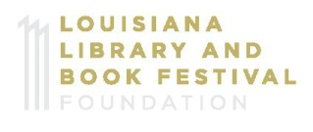







**Louisiana’s Young Readers’ Choice**

**Ballot 2019-2020**

**Grades 3-5**

**Army Brats** Daphne Benedis-Grab

**Balderdash: John Newbery and the Boisterous Birth of Children’s Books**

Michelle Markel, illus. Nancy Carpenter

**A Boy Called Bat Elana K. Arnold illus. Charles Santoso**

**Crown: An Ode to the Fresh Cut** Derrick Barnes

**Give Bees a Chance** Bethany Barton

**Grace Hopper: Queen of Computer Code** Laurie Wallmark illus. Katy Wu

**Imagine That!: How Dr. Seuss Wrote Cat in the Hat** Judy Sierra

**Jake the Fake Keeps it Real (Book 1)** Craig Robinson & Adam Mansbach illus. Keith Knigh

**Lemons** Melissa Savage

**Malala: Activist for Girl’s Education**

Raphaelle Frier illus. Aurelia Fronty

**Sled Dog School** Terry Lynn Johnson

**The Explorers: The Door in the Alley** Adrienne Kress

**The Princess and the Peas** Rachel Himes

**Wedgie & Gizmo** Suzanne Selfors illus. Barbara Fisinger

**Wishtree** Katherine Applegate illus. Charles Santoso

*The Louisiana Young Readers’ Choice Award is a reading enrichment program of the Louisiana Center for the Book in the State Library of Louisiana with additional support from the following:*





