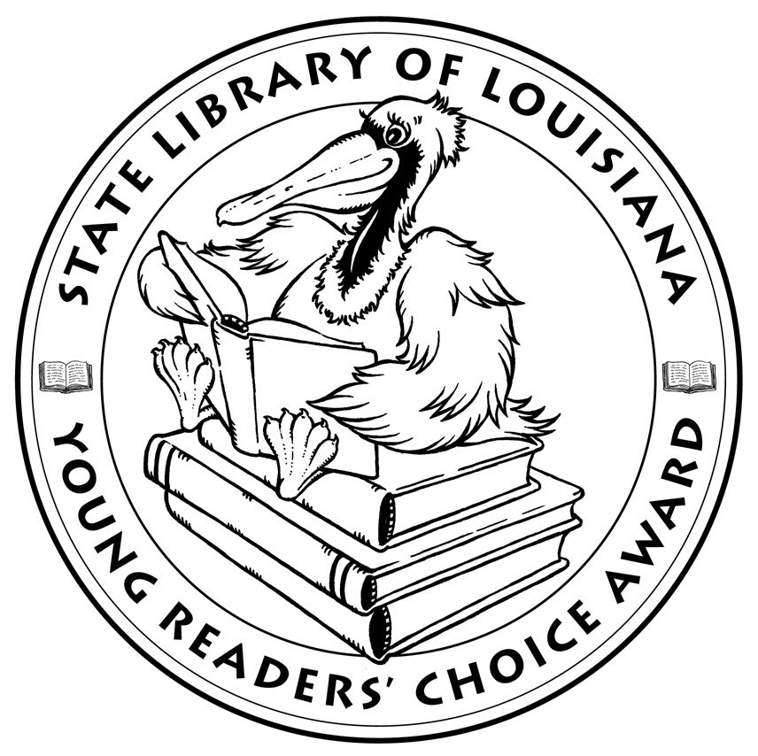

**Louisiana’s Young Readers’ Choice**

**Ballot 2016**

**Grades 6-8**

**Athlete vs. Mathlete**. W.C. Mack

**The Boy on the Wooden Box: How the Impossible Became Possible... on Schindler's List: A Memoir**. Leon Leyson

**Counting By 7’s**. Holly Goldberg Sloan

**The Darkest Path**. Jeff Hirsch

**Dogs of War**. Sheila Keenen, illus. Nathan Fox

**The Heartbreak Messenger**. Alexander Vance

**Jack Strong Takes a Stand**. Tommy Greenwald, illus. Melissa Mendés

**One Came Home**. Amy Timberlake

**QB 1**.Mike Lupica

**SYLO**. D.J. MacHale

**Wake Up Missing**. Kate Messner

**Zero Tolerance**. Claudia Mills

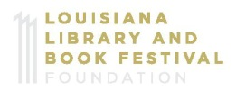*The Louisiana Young Readers’ Choice Award is a reading enrichment program of the Louisiana Center for the Book in the State Library of Louisiana with additional support from the following:*





**Louisiana’s Young Readers’ Choice**

**Ballot 2016**

**Grades 6-8**

**Athlete vs. Mathlete**. W.C. Mack

**The Boy on the Wooden Box: How the Impossible Became Possible... on Schindler's List: A Memoir**. Leon Leyson

**Counting By 7’s**. Holly Goldberg Sloan

**The Darkest Path**. Jeff Hirsch

**Dogs of War**. Sheila Keenen, illus. Nathan Fox

**The Heartbreak Messenger**. Alexander Vance

**Jack Strong Takes a Stand**. Tommy Greenwald, illus. Melissa Mendés

**One Came Home**. Amy Timberlake

**QB 1**.Mike Lupica

**SYLO**. D.J. MacHale

**Wake Up Missing**. Kate Messner

**Zero Tolerance**. Claudia Mills

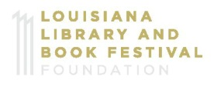*The Louisiana Young Readers’ Choice Award is a reading enrichment program of the Louisiana Center for the Book in the State Library of Louisiana with additional support from the following:*

