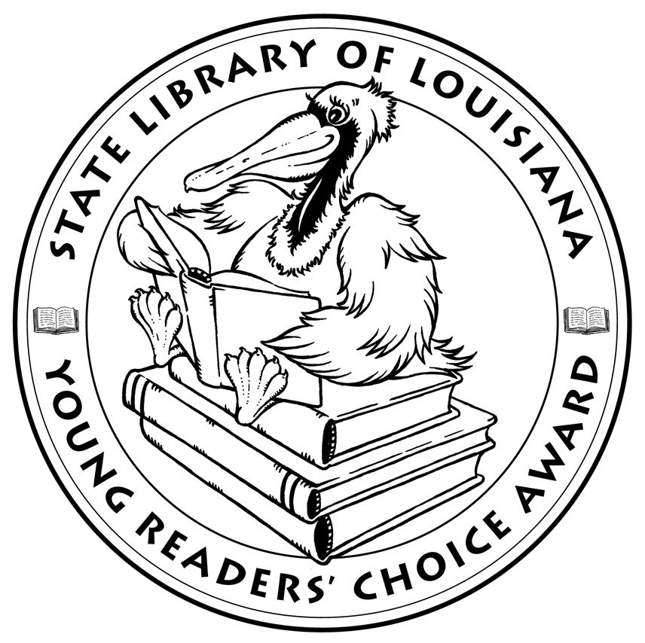

**Louisiana’s Young Readers’ Choice**

**Ballot 2017**

**Grades 6-8**

**The Crossover**. Kwame Alexander

**The Dirt Diary**. Anna Staniszewski

**The Fourteenth Goldfish**. Jennifer Holm

**I Kill the Mockingbird**. Paul Acampora

**Loot: How to Steal a Fortune**. Jude Watson

**The Night Gardener**. Jonathan Auxier

**The One Safe Place**. Tania Unsworth

**The Perfect Place**. Teresa E. Harris

**Rain Reign**.Ann M. Martin

**Saving Lucas Biggs**. Marisa de los Santos, David Teague

**Surrounded by Sharks**. Michael Northrop

**Upside Down in the Middle of Nowhere**. Julie T. Lamana

*The Louisiana Young Readers’ Choice Award is a reading enrichment program of the Louisiana Center for the Book in the State Library of Louisiana with additional support from the following:*

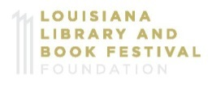



**Louisiana’s Young Readers’ Choice**

**Ballot 2017**

**Grades 6-8**

**The Crossover**. Kwame Alexander

**The Dirt Diary**. Anna Staniszewski

**The Fourteenth Goldfish**. Jennifer Holm

**I Kill the Mockingbird**. Paul Acampora

**Loot: How to Steal a Fortune**. Jude Watson

**The Night Gardener**. Jonathan Auxier

**The One Safe Place**. Tania Unsworth

**The Perfect Place**. Teresa E. Harris

**Rain Reign**.Ann M. Martin

**Saving Lucas Biggs**. Marisa de los Santos, David Teague

**Surrounded by Sharks**. Michael Northrop

**Upside Down in the Middle of Nowhere**. Julie T. Lamana

*The Louisiana Young Readers’ Choice Award is a reading enrichment program of the Louisiana Center for the Book in the State Library of Louisiana with additional support from the following:*

