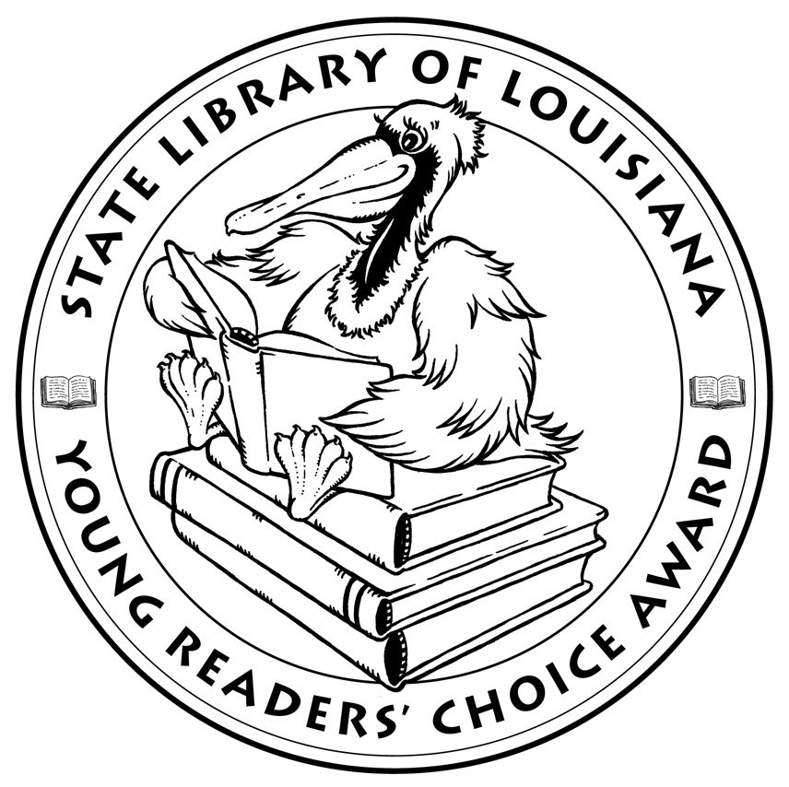

**Louisiana’s Young Readers’ Choice**

**Ballot 2018**

**Grades 6-8**

**5 to 1**. Holly Bodger

**Awkward**. Svetlana Chmakova

**Backlash**. Sarah Darer Littman

**The Blackthorn Key**. Kevin Sands

**A Blind Guide to Stinkville**. Beth Vrabel

**Book Scavenger**. Jennifer Chambliss Bertman

**Charlie and the Grandmothers**. Katy Towell

**The Disappearance of Emily H**. Barrie Summy

**Ferals**.Jacob Grey

**Fuzzy Mud**. Louis Sachar

**How Lunchbox Jones Saved Me from Robots,**

**Traitors, and Missy the Cruel**. Jennifer Brown

**Lost in the Sun**. Lisa Graff

*The Louisiana Young Readers’ Choice Award is a reading enrichment program of the Louisiana Center for the Book in the State Library of Louisiana with additional support from the following:*

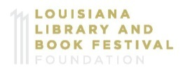



**Louisiana’s Young Readers’ Choice**

**Ballot 2018**

**Grades 6-8**

**5 to 1**. Holly Bodger

**Awkward**. Svetlana Chmakova

**Backlash**. Sarah Darer Littman

**The Blackthorn Key**. Kevin Sands

**A Blind Guide to Stinkville**. Beth Vrabel

**Book Scavenger**. Jennifer Chambliss Bertman

**Charlie and the Grandmothers**. Katy Towell

**The Disappearance of Emily H**. Barrie Summy

**Ferals**.Jacob Grey

**Fuzzy Mud**. Louis Sachar

**How Lunchbox Jones Saved Me from Robots,**

**Traitors, and Missy the Cruel**. Jennifer Brown

**Lost in the Sun**. Lisa Graff

*The Louisiana Young Readers’ Choice Award is a reading enrichment program of the Louisiana Center for the Book in the State Library of Louisiana with additional support from the following:*

