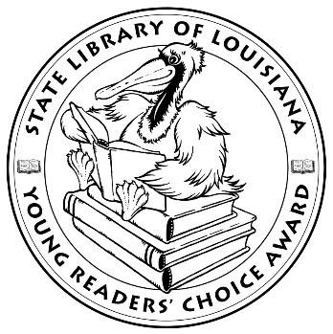

**Louisiana’s Young Readers’ Choice**

**Ballot 2019-2020**

**Grades 6-8**

**All’s Faire in Middle School** Victoria Jameson

**Beyond the Bright Sea** Lauren Wolk

**Brave** Svetlana Chmakova

**Clayton Byrd Goes Underground** Rita Williams-Garcia

**Forget Me Not** Ellie Terry

**Frogkisser!** Garth Nix

**Greetings from Witness Protect!** Jake Burt

**In the Shadow of the Sun** Anne Sibley O’Brien

**Insignificant Events in the Life of a Cactus** Dusti Bowling

**Refugee** Alan Gratz

**Slider** Pete Hautman

**The Red Bandanna (Young Readers Adaptation)** Tom Rinaldi

*The Louisiana Young Readers’ Choice Award is a reading enrichment program of the Louisiana Center for the Book in the State Library of Louisiana with additional support from the following:*

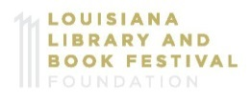



**Louisiana’s Young Readers’ Choice**

**Ballot 2019-2020**

**Grades 6-8**

**All’s Faire in Middle School** Victoria Jameson

**Beyond the Bright Sea** Lauren Wolk

**Brave** Svetlana Chmakova

**Clayton Byrd Goes Underground** Rita Williams-Garcia

**Forget Me Not** Ellie Terry

**Frogkisser!** Garth Nix

**Greetings from Witness Protect!** Jake Burt

**In the Shadow of the Sun** Anne Sibley O’Brien

**Insignificant Events in the Life of a Cactus** Dusti Bowling

**Refugee** Alan Gratz

**Slider** Pete Hautman

**The Red Bandanna (Young Readers Adaptation)** Tom Rinaldi

*The Louisiana Young Readers’ Choice Award is a reading enrichment program of the Louisiana Center for the Book in the State Library of Louisiana with additional support from the following:*

