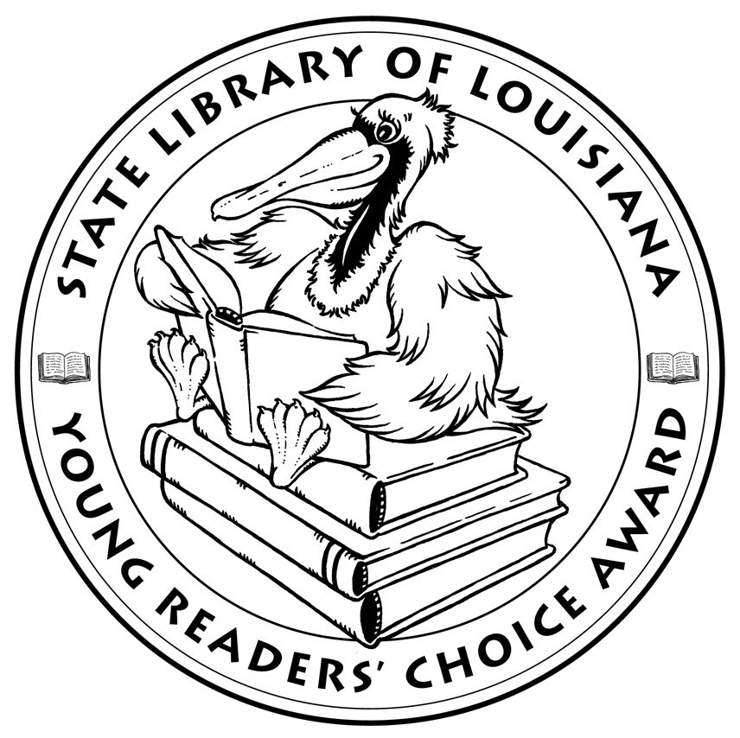

**Louisiana’s Young Readers’ Choice**

**Ballot 2018-2019**

**Grades 6-8**

**The Adventurer’s Guide to Successful Escapes**

Wade Albert White

**Booked** Kwame Alexander

**Dara Palmer’s Major Drama** Emma Shevah

**Fuzzy** Tom Angleberger

**Ghost** Jason Reynolds

**Ghosts** Raina Telgemeier

**The Girl Who Drank the Moon** Kelly Barnhill

**Once Was a Time** Leila Sales

**Projekt 1065** Alan Gratz

**Terror at Bottle Creek** Watt Key

**The Thing About Leftovers** C.C. Payne

**Top Prospect** Paul Volponi

*The Louisiana Young Readers’ Choice Award is a reading enrichment program of the Louisiana Center for the Book in the State Library of Louisiana with additional support from the following:*



**Louisiana’s Young Readers’ Choice**

**Ballot 2018-2019**

**Grades 6-8**

**The Adventurer’s Guide to Successful Escapes**

Wade Albert White

**Booked** Kwame Alexander

**Dara Palmer’s Major Drama** Emma Shevah

**Fuzzy** Tom Angleberger

**Ghost** Jason Reynolds

**Ghosts** Raina Telgemeier

**The Girl Who Drank the Moon** Kelly Barnhill

**Once Was a Time** Leila Sales

**Projekt 1065** Alan Gratz

**Terror at Bottle Creek** Watt Key

**The Thing About Leftovers** C.C. Payne

**Top Prospect** Paul Volponi

*The Louisiana Young Readers’ Choice Award is a reading enrichment program of the Louisiana Center for the Book in the State Library of Louisiana with additional support from the following:*

