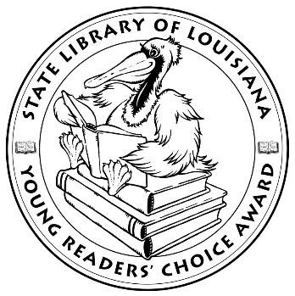

**Louisiana Young Readers’ Choice**

**Ballot 2020-2021**

**Grades 6-8**

**The Benefits of Being an Octopus** Ann Braden

**Boy Bites Bug** Rebecca Petruck

**City of Ghosts Victoria Schwab**

**Game Changer** Tommy Greenwald

**Love Like Sky** Leslie C. Youngblood

**Marcus Vega Doesn’t Speak Spanish** Pablo Cartaya

**The Night Diary** Veera Hirandani

**The Serpent’s Secret (Kiranmala and the Kingdom Beyond 1)** Sayantani DasGupta

**Small Spaces** Katherine Arden

**So Done** Paula Chase

**The Storm Runner (Storm Runner 1)** J.C. Cervantes

**Tight** Torrey Maldonado

*The Louisiana Young Readers’ Choice Award is a reading enrichment program of the Louisiana Center for the Book in the State Library of Louisiana with additional support from the following:*











**Louisiana Young Readers’ Choice**

**Ballot 2020-2021**

**Grades 6-8**

**The Benefits of Being an Octopus** Ann Braden

**Boy Bites Bug** Rebecca Petruck

**City of Ghosts Victoria Schwab**

**Game Changer** Tommy Greenwald

**Love Like Sky** Leslie C. Youngblood

**Marcus Vega Doesn’t Speak Spanish** Pablo Cartaya

**The Night Diary** Veera Hirandani

**The Serpent’s Secret (Kiranmala and the Kingdom Beyond 1)** Sayantani DasGupta

**Small Spaces** Katherine Arden

**So Done** Paula Chase

**The Storm Runner (Storm Runner 1)** J.C. Cervantes

**Tight** Torrey Maldonado

*The Louisiana Young Readers’ Choice Award is a reading enrichment program of the Louisiana Center for the Book in the State Library of Louisiana with additional support from the following:*





