NURSE, SOLDIER, SPY: THE STORY OF SARAH EDMONDS,

A CIVIL WAR HERO

By Marissa Moss

LOUISIANA YOUNG READERS’ CHOICE NOMINEE 2012
GRADE 3-5

Submitted by Beth Hidalgo, School Librarian, Lakeside Primary School, Prairieville, LA
And
Angela Germany, Children and Teen Services Consultant State Library of Louisiana

Title: Nurse, Soldier, Spy: The Story of Sarah Edmonds, Civil War Hero
Author: Marissa Moss
Publisher: Abrams Books for Young Readers, New York
Pages: 48

SUMMARY
Sarah Emma Edwards, at the age of 16, runs away from home, escaping an arranged marriage by dressing as a man. When the Civil War began Sarah enlisted in the Union Army as Frank Thompson. Sarah learns how to be a soldier, then field nurse and later became a spy, reporting important information about Confederate forces to the Union Army. She fought in many major battles alongside her male counterparts in addition to nursing wounded and dying soldiers back to health on the battlefield. Although she considered nursing to be her most important role during the war, she was also asked to be a spy for the Union because of her remarkable service. Sarah Edmonds was a courageous woman and patriot who served her country at any cost.

AWARDS
Amelia Bloomer Project’s Recommended Titles List for 2012
CCBC Choices 2012 List
2012 International Reading Association Teachers’ Choices Project

AUTHOR’S BIOGRAPHY
Author/illustrator Marissa Moss has told and illustrated her own stories ever since she was a young girl. Born in Pennsylvania and raised in California, Marissa studied art whenever she had the chance, even accepting a job illustrating a book while still in high school. After studying art history and publishing in college, she got a job as a waitress in order to support herself while writing stories and sending them out to editors. After five years of doing so, her first book was finally published. Marissa concentrated on picture books for a while before delving into journal-style format with her Amelia’s Notebook series. Told from the perspective of an adolescent girl, the Amelia’s Notebook series has earned Starred Reviews and other small awards. More information about Marisa Moss can be found on her official website, located at http://www.marissamoss.com.

ILLUSTRATOR’S BIOGRAPHY
John Hendrix has always loved to draw. Throughout his career, he has drawn for numerous magazines, book companies, and ad campaigns. His illustrations have won many awards, including the Society of Illustrator’s Silver Medal in both 2006 and 2008. The very first book he illustrated, Abe Lincoln Crosses a Creek, was named an ALA Notable Book of 2008. John’s book John Brown: His Fight for Freedom that he both wrote and illustrated has won an Oppenheim Toy Portfolio Gold Seal and the honor of being named one of the “Best Books of 2009” by Publisher’s Weekly. John currently teaches illustration and typography at Washington University in St. Louis where he currently resides. John’s website is located at http://johnhendrix.com/portfolio/.

OTHER TITLES BY AUTHOR
A Soldier’s Secret: The Incredible True Story of Sarah Edmonds, Civil War Hero (2012)
Sky High: The True Story of Maggie Gee (2009)
Amelia’s Notebook series (2008-current)
Mighty Jackie, the Strike-Out Queen (2004)
Brave Harriet (2001)

OTHER TITLES BY ILLUSTRATOR
A Boy Called Dickens (2012)
John Brown: His Fight for Freedom (2009)
Abe Lincoln Crosses a Creek: A Tall, Thin Tale (2008)

RELATED TITLES (Students may also enjoy these titles)
Clara Barton: I Want to Help! by Cathy East Dubowski. Bearport Publishers, 2006.
31 p.
Sarah Emma Edmonds was a Great Pretender: The True Story of a Civil War Spy by Carrie Jones. Carolrhoda Books, 2011. 32 p.
Secrets of Civil War Spies by Nancy LeSourd. Zonderkidz, 2008. 218 p.
You Wouldn’t Want to be a Civil War Soldier: A War You’d Rather Not Fight by Thomas M. Ratliff. Franklin Watts, 2012. 32 p.

CLASSROOM CONNECTIONS
Social Studies
Geography in the book: Sarah Edmonds story began in Canada and then she went on to be in Flint, Michigan. She was in the Battle of Bull Run, Battle of Fair Oaks, and the Battle of Williamsburg. Locate all these places on a map. Make deductions about what these places were like and how far it was to travel between them. For an art option, ask your students to draw either one of the battles or a map with the places Sarah traveled.

Civil War Medicine: In the book, Sarah worked as a nurse. During the Civil War, medicine and medical knowledge was very different from today. Consider sharing some of the information found on the National Museum of Civil War Medicine’s website with your students. They have (http://www.civilwarmed.org/) some virtual tours like this one http://www.civilwarmed.org/pry-house-field-hospital-museum/exhibits/. There is also a short video about Clara Barton, who was a famous nurse and relief worker during the civil war. Clara founded the American Red Cross.
Discussion: You could ask your students to think about the things they have seen and have used on them at their Dr.’s office. They have probably had their ears checked, their throats inspected with a wooden stick holding down their tongue. They have probably had their heart and breathing listened too with a stethoscope. They will know what a shot is and perhaps they have had their throat swabbed with an extra-long Q-tip too. Now show them a picture of a Civil War doctor’s tools. Just by looking at the picture, what do they think? Is this different from what they are used to seeing a doctor use? Why or why not?

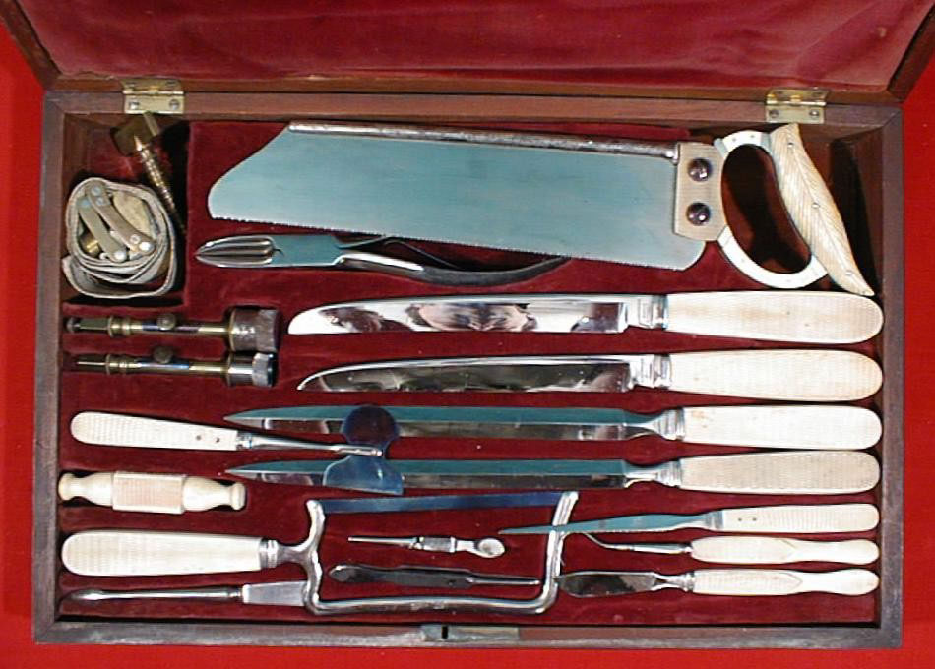

Here is a breakdown of what some of the items are for http://www.nps.gov/wicr/forteachers/upload/Medical-Tools-for-teachers.pdf.

Louisiana Civil War Submarine: The Louisiana State Museum in downtown Baton Rouge has a Civil War submarine that is very interesting to learn about. The museum has a virtual exhibit for this early Louisiana submarine here http://www.crt.state.la.us/museum/online_exhibits/Civil_War_Submarine/.

Slavery & Abolitionist Movement/Abraham Lincoln
http://www.proteacher.com/090053.shtml
Underground Railroad (interactive)
http://education.nationalgeographic.com/education/multimedia/interactive/the-underground-railroad/?ar_a=1

Civil War Food
This is a link to a recipe for hardtack, one of the stapes for civil war soldiers. There are also links to more civil war foods http://www.educationworld.com/a_lesson/00-2/lp2001.shtml.

Battling Boredom
This is a lesson plan exploring what Civil war soldiers did day to day to battle boredom and it asks your students to compare that to what they do today when bored, http://www.educationworld.com/a_lesson/00-2/lp2009.shtml. They can draw a Venn Diagram to compare.

VOCABULARY

There is a Glossary in the back of the book. Assign some of the words for your students to look up the definition.

Discussion Questions:

Why Did Sarah Edmonds originally dress as a man? Why do you think she continued to dress as a man?

On her first mission, why did Sarah Edmonds choose to disguise herself as a slave?

Sarah worked as a nurse, pulling people off the battle field with explosions going off all around her then she snuck behind enemy lines to spy. Do you think you would be able to do something brave like that? Why or why not?

Sarah felt freedom by dressing up as a man. What do you think that says about the status of women during Civil War times? How were women looked upon during that time in history?

Why was Sarah Evans and the doctor mad at the colonial they pulled off the battle field at the Battle of Williamsburg? Do you think that was fair?

While she was spying on the Confederate troops what were some of the important things she discovered?

Think about how we fight war today and the roles that men and women play. Compare that to how war was fought and roles of men and women during the civil war.

