2020-2021 LTRC Annotated Nominated Title List
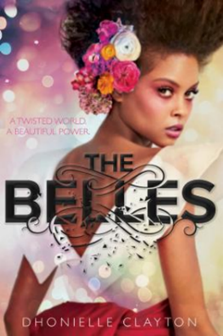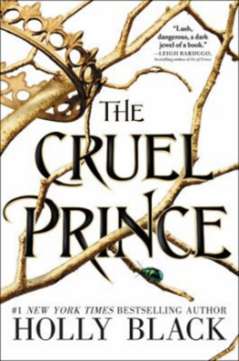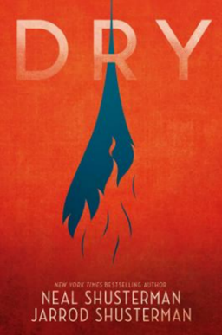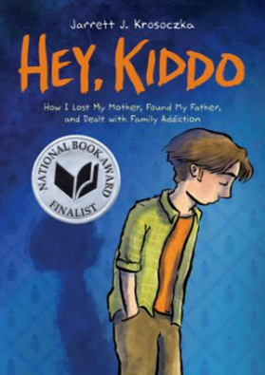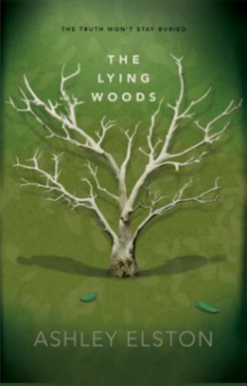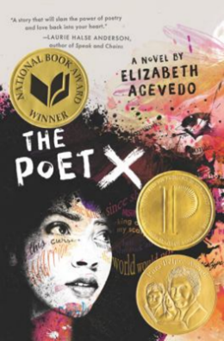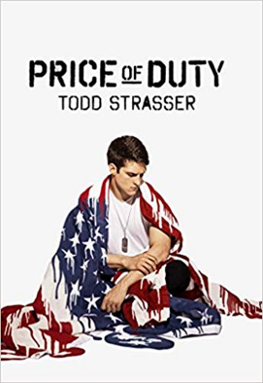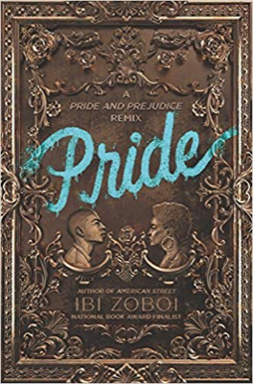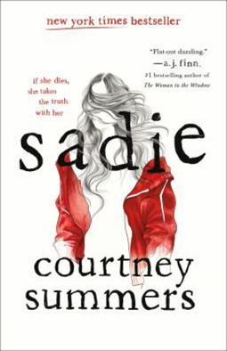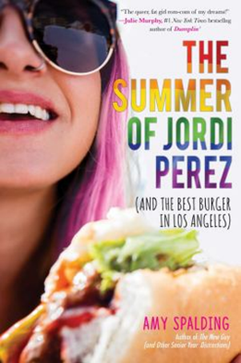
- Belles, The by Dhonielle Clayton
Freeform, 2018. HC: 978-1484728499, 448 pp., $17.99. PB: 978-1484732519, $10.99.
[African American, dark fantasy, beauty, fashion, magic, female protagonist]
Summary: In a world where Beauty is a commodity only a few control, one Belle will learn the dark secrets behind her powers, and rise up to change the world. (Publisher)
Awards: YALSA Best Fiction for Young Adults List, 2018-2019 Florida Teens Read Award finalist, Kirkus Reviews' Best Books of 2018, 2018 Goodreads Choice Awards: Young Adult Nominee, Booklist 2018 Editors' Choice. Seventeen.com: The 20 Best YA Books of 2018, 2019 Carnegie Medal Nominee, Bank Street Children's Book Committee Best Children's Books of the Year 2019 list, 2018 Cybils Award Young Adult Speculative Fiction Nominee. Chicago Public Library: Best Books of 2018, B&NTeen: Favorite YA Books of 2018, The Boston Globe: The Best Children's Books of 2018, Indigo: Best Diverse Teen Books of 2018, Nerdy Book Club: 2018 Nerdy Award winner, EpicReads: Best Young Adult Books of 2018, Buzzfeed: Best YA of 2018, Booklist: Editor's Choice Best Books for Youth 2018, Paste Magazine: 30 Best YA Novels of 2018
Accelerated Reader: IL: UG - BL: 4.7 - AR Pts: 16.0 AR Quiz No. 195051

- Cruel Prince (The Folk of the Air: Book 1), The by Holly Black
Little, Brown Books for Young Readers, 2018. HC: 978-0316310277, 384 pp., $19.99. PB: 978-0316310314, 416 pp., $12.99
[female protagonist, fairies, bullying, outcasts, political thriller]
Summary: Jude, seventeen and mortal, gets tangled in palace intrigues while trying to win a place in the treacherous High Court of Faerie, where she and her sisters have lived for a decade. (LOC)
Awards: A New York Times Bestseller, An IndieBound Bestseller, A Boston Globe Best Book of 2018, An ALA 2019 Children's Notables List Pick
Accelerated Reader: IL: UG - BL: 5.3 - AR Pts: 16.0 AR Quiz No. 193493

- Dry by Neal Shusterman and Jarrod Shusterman
Simon & Schuster Books for Young Readers, 2018. HC: 978-1481481960, 400 pp., $18.99. PB: 978-1481481977, 416 pp., $12.99 (coming Sept. 2019)
[droughts, survival, brothers and sisters, California, climate change, alternating POV, contemporary, apocalyptic, action]
Summary: A lengthy California drought escalates to catastrophic proportions, turning Alyssa's quiet suburban street into a warzone, and she is forced to make impossible choices if she and her brother are to survive. (LOC)
Accelerated Reader: IL: UG - BL: 5.5 - AR Pts: 16.0 AR Quiz No. 198982

- Hey, Kiddo by Jarrett J. Krosoczka
Graphix, 2018. HC: 978-0545902472, 320 pp., $24.99. PB: 978-0545902489, 320 pp., $14.99.
[parental addiction, family addiction identity, coming of age, male protagonist, memoir]
Summary: Jarrett goes through his childhood trying to make his non-normal life as normal as possible, expressing himself through drawing even as so little is being said to him about what's going on. (AR)
Awards: A National Book Award Finalist
Accelerated Reader: IL: UG - BL: 3.5 - AR Pts: 2.0 AR Quiz No. 198847

- Lying Woods, The by Ashley Elston
Disney-Hyperion, 2018. HC: 978-1368014786, 336 pp., $17.99. PB: 978-1368015912, 336 pp., $9.99 (coming Nov. 2019)
[Louisiana, male protagonist, boarding school, white collar crime, alternating narrators, missing persons, mystery]
Summary: Owen Foster is pulled from his elite New Orleans boarding school when his father's assets are seized. Back in his small town, he begins to piece together his father's past despite mounting danger. (AR)
Awards: Teenreads' Teen Choice Book Award 2019 nominee, BookRiot: 125+ Upcoming YA Books You'll Want on Your October to December Radar, BNTeen: 21 of November's Best New Young Adult Books, Hypable: Our most-anticipated November 2018 YA book releases
Accelerated Reader: IL: UG - BL: 4.8 - AR Pts: 14.0 AR Quiz No. 500590

- Poet X, The by Elizabeth Acevedo
HarperTeen, 2018. HC: 978-0062662804, 368 pp., $17.99. PB: 978-0062662811, 384 pp., $12.99 (coming March 2020).
[coming of age, Afro-Latina, Harlem, contemporary, slam poetry, immigrants, self-esteem, body image, female protagonist]
Summary: A young girl in Harlem discovers slam poetry as a way to understand her mother’s religion and her own relationship to the world. (AR)
Awards: Winner of the National Book Award for Young People’s Literature, the Michael L. Printz Award, and the Pura Belpré Award
Accelerated Reader: IL: UG - BL: 5.2 - AR Pts: 5.0 AR Quiz No. 195165

- Price of Duty by Todd Strasser
Simon & Schuster Books for Young Readers, 2018. HC: 978-1481497091, 192 pp., $17.99. PB: 978-1481497107, 192 pp., $11.99.
[boys and men, PTSD, war, soldiers, hero, family life, male protagonist]
Summary: Hailed as a hero, twenty-year-old Jake returns to his pro-military hometown and family injured physically and emotionally, unsure if he can return to active duty but uncomfortable with the alternative. (LOC)
Accelerated Reader: IL: UG - BL: 4.9 - AR Pts: 6.0 AR Quiz No. 500313

- Pride by Ibi Zoboi
Balzer + Bray, 2018. HC: 978-0062564047, 304 pp., $17.99. PB: 978-0062564054, 304 pp., $10.99 (coming December 2019)
[Pride and Prejudice retelling, Afro-Latino, romance, gentrification, New York City, female protagonist]
Summary: Zuri Benitez has pride. Brooklyn pride, family pride, and pride in her Afro-Latino roots. But pride might not be enough to save her rapidly gentrifying neighborhood from becoming unrecognizable. (AR)
Accelerated Reader: IL: UG - BL: 4.6 - AR Pts: 9.0 AR Quiz No. 197782

- Sadie by Courtney Summer
Wednesday Books, 2018. HC: 978-1250105714, 320 pp., $17.99.
[sisters, revenge, stuttering, podcasts, missing girls, alternating narrators, Colorado, male/female protagonists]
Summary: Told from the alternating perspectives of nineteen-year-old Sadie who runs away from her isolated small Colorado town to find her younger sister's killer, and a true crime podcast exploring Sadie's disappearance. (LOC)
Awards: A New York Times bestseller, An Edgar Award Winner, A Booklist Top 10 YA Book for Adult Readers, One of the Best YA Novels of 2018 by Publishers Weekly, One of B&N Teen Blog's Best YA Books of 2018, Bustle's Best Young Adult Books of 2018, Good Morning America's Best Books of 2018, In NPR's Guide to 2018's Greatest Reads, In Paste's 30 Best Young Adult Novels of 2018, Nominated for YALSA's 2019 Quick Pick for Reluctant Readers
Accelerated Reader: IL: UG - BL: 5.0 - AR Pts: 11.0 AR Quiz No. 198315

- Summer of Jordi Perez, The (And the Best Burger in Los Angeles) by Amy Spalding
Sky Pony, 2018. HC: 978-1510727663, 284 pp., $16.99. PB: 978-1510751842, 284 pp., $8.99 (coming April 2020)
[LGBT+, humor, family, self-esteem, female protagonist, summer, romance, contemporary, body image]
Summary: Plus-size, never-been-kissed, fashion blogger Abby lands a dream job at her favorite Los Angeles boutique, and enters into an opposites-attract summer romance with a fellow intern. Abby’s summer-before-senior year adventures also include helping her friend Jax rate burger joints for Jax’s dad’s new app, a welcome break from her mother’s famous health food blog.
Awards: Named one of the Best YA Books of 2018 by Cosmopolitan
Accelerated Reader: N/A

