2021-2022 LYRC 3-5 Annotated Nominated Title List
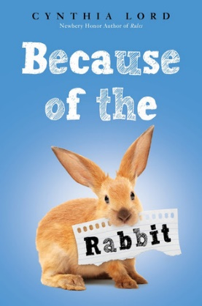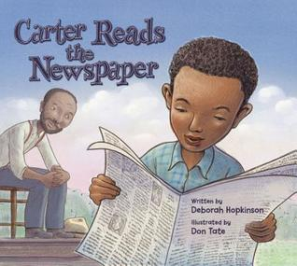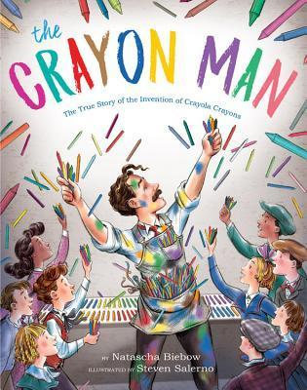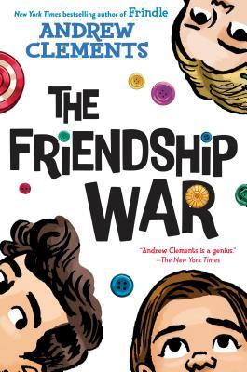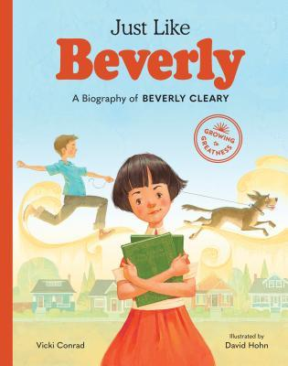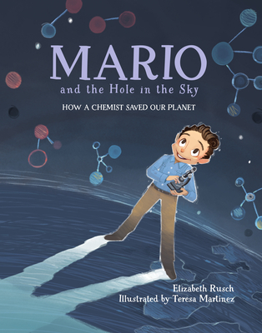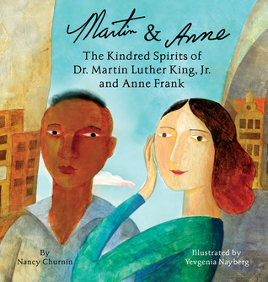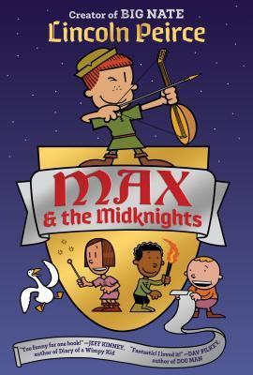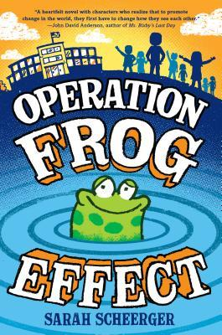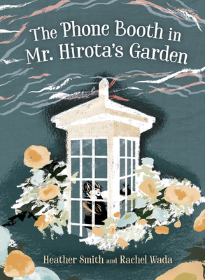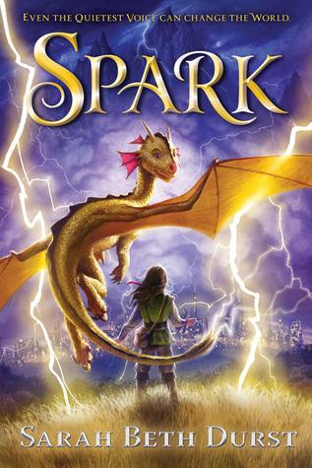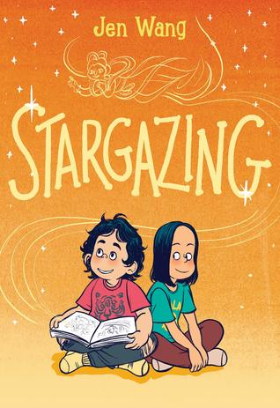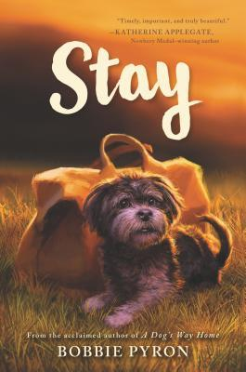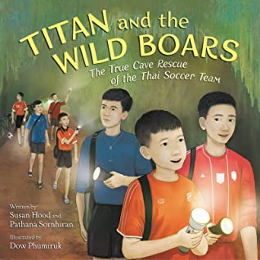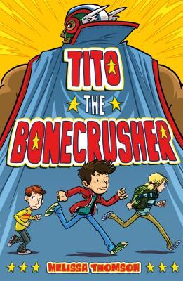

- Because of the Rabbit by Cynthia Lord
Scholastic Press (Scholastic), 2019. HC: 978-0545914246, 192 pp., $17.99. PB: 978- 1338538960, 192 pp., $6.99.
[Realistic fiction, white female protagonist, animals, new school, friendship, disability]
Summary: On the last night of summer, Emma and her Maine game warden father rescue a small domestic rabbit stuck in a fence; the very next day Emma starts fifth grade after years of being home schooled, excited and apprehensive about making new friends, but she is paired with Jack, a hyperactive boy, who does not seem to fit in with anyone--except that they share a love of animals, which draws them together, because of the rabbit. (LOC)
Awards: ALSC Notable Children’s Book
Accelerated Reader: IL: MG - BL: 4.3 - AR Pts: 4.0 AR Quiz No. 500700

- Carter Reads the Newspaper by Deborah Hopkinson, illustrated by Don Tate
Peachtree Publishing, 2019. HC: 978-1561459346, 36 pp., $17.95.
[Picture Book Biography, black male, founder of Black History Month, education, literacy]
Summary: Carter G. Woodson was born to two formerly enslaved people ten years after the end of the Civil War. Though his father could not read, he believed in being an informed citizen, so Carter read the newspaper to him every day. (AR)
Awards: Carter G. Woodson Book Award Honor, ALSC Notable Children’s Book, NYPL: Top Ten Books for Kids
Accelerated Reader: IL: LG - BL: 4.5 - AR Pts: 0.5 AR Quiz No. 199656

- Crayon Man, The: The True Story of the Invention of Crayola Crayons by Natascha Biebow, illustrated by Steven Salerno
Houghton Mifflin Harcourt, 2019. HC: 978-1328866844, 48 pp., $17.99.
[Picture Book Biography, white male, inventor, art]
Summary: This book tells the story of the invention of the Crayola crayon by inventor Edwin Binney. (AR)
Awards: Irma Black Award Winner, Junior Library Guild Selection
Accelerated Reader: IL: LG - BL: 5.1 - AR Pts: 0.5 AR Quiz No. 503111

- Friendship War, The by Andrew Clements
Random House Books for Young Readers (Penguin Random House), 2019. HC: 978-0399557590, 208 pp., $17.99. PB: 978- 0399557620, 208 pp., $7.99.
[Realistic fiction, white female protagonist, fads, social hierarchy, friendship]
Summary: When Grace takes boxes of old buttons from a building her grandfather bought, she starts a fad at school that draws her closer to one friend, but further from another. (LOC)
Accelerated Reader: IL: MG - BL: 5.0 - AR Pts: 5.0 AR Quiz No. 500228

- Just Like Beverly: A Biography of Beverly Cleary by Vicki Conrad, illustrated by David Hohn
Little Bigfoot, Sasquatch Books (Penguin Random House), 2019. HC: 978- 1632172228, 48 pp., $18.99.
[Picture Book Biography, white female, author, learning disability, literacy]
Summary: This book is a biography of Beverly Cleary, from her roots in Portland to her years as a librarian and eventually a children's book writer. (AR)
Award: Junior Library Guild Selection
Accelerated Reader: IL: LG - BL: 4.2 - AR Pts: 0.5 AR Quiz No. 504645

- Mario and the Hole in the Sky: How a Chemist Saved Our Planet by Elizabeth Rusch, illustrated by Teresa Martínez
Charlesbridge (Penguin Random House), 2019. HC: 978- 1580895811, 40 pp., $16.99.
[Picture Book Biography, Mexican male, chemist, environmentalist, advocacy]
Summary: Growing up in Mexico City, Mario was a curious boy who studied hidden worlds through a microscope. He would grow up to become the chemist who brought the world back from the brink of environmental catastrophe. (AR)
Awards: Cook Prize Winner, SCBWI Golden Kite Award Winner
Accelerated Reader: IL: LG - BL: 5.4 - AR Pts: 0.5 AR Quiz No. 195545

- Martin and Anne: The Kindred Spirits of Dr. Martin Luther King, Jr. and Anne Frank by Nancy Churnin, illustrated by Yevgenia Nayberg
Creston Books (Lerner Publishing), 2019. HC: 978-1939547538, 32 pp., $17.99.
[Picture Book Dual Biography, black male and German Jewish female, civil rights, Holocaust]
Summary: This picture-book biography compares and contrasts the lives of Martin Luther King, Jr. and Anne Frank, who were both born in 1929. (AR)
Awards: A Notable Book for a Global Society
Accelerated Reader: IL: LG - BL: 4.3 - AR Pts: 0.5 AR Quiz No. 501418

- Max and the Midknights by Lincoln Peirce
Crown Books for Young Readers (Penguin Random House), 2019. HC: 978-1101931080, 288 pp., $13.99.
[Historical fantasy, Middle Ages, white female protagonist, nonconformity, friendship, humor]
Summary: Max and a group of friends dubbed the Midknights go on a quest to rescue the Kingdom of Byjovia from the mean King Gastley. (AR)
Awards: NYPL: Best Books of 2019
Accelerated Reader: IL: MG - BL: 3.3 - AR Pts: 3.0 AR Quiz No. 500227

- Operation Frog Effect by Sarah Scheerger
Random House Books for Young Readers (Penguin Random House), 2019. HC: 978-0525644125, 320 pp., $16.99. PB: 978-0525644156, 320 pp., $7.99.
[Realistic fiction, told from eight perspectives, journaling, class pets, teamwork, school]
Summary: Ms. Graham's fifth-grade class wants to promote change in the world. When eight of them take an assignment too far, though, they must take responsibility for their actions and unite for a cause they all believe in. (AR)
Awards: Cybil Award Finalist
Accelerated Reader: IL: MG - BL: 4.7 - AR Pts: 6.0 AR Quiz No. 504668

- Phone Booth in Mr. Hirota’s Garden, The by Heather Smith, illustrated by Rachel Wada
Orca Book Publishers, 2019. HC: 978-1459821033, 32 pp., $19.95.
[Realistic fiction, based on a true story, Japanese male protagonist, tsunami, survival, grief]
Summary: When the tsunami destroyed Makio's village, Makio lost his father. Sadly, he was not alone. Everyone lost someone the day the big wave came. With the villagers silenced by grief, Makio's anger at the ocean grows. (AR)
Awards: SLJ: Best Books of 2019, Kirkus: Best Books of 2019
Accelerated Reader: IL: LG - BL: 2.3 - AR Pts: 0.5 AR Quiz No. 507861

- Spark by Sarah Beth Durst
Clarion Books (Houghton Mifflin Harcourt), 2019. HC: 978- 1328973429, 320 pp., $17.99. PB: 978- 0358206385, 320 pp., $7.99.
[Dystopian fantasy, white female protagonist, dragons, magic, weather, rebellion]
Summary: Naturally quiet since birth, Mina and her stormbeast, Pixit, lead others like themselves in defying authority and attempting to spread the truth that Alorria's idyllic weather comes at a steep cost. (LOC)
Awards: Amazon: Best Books of May 2019
Accelerated Reader: IL: MG - BL: 4.9 - AR Pts: 10.0 AR Quiz No. 503772

- Stargazing by Jen Wang
First Second (Macmillan), 2019. HC: 978-1250183873, 224 pp., $21.99. PB: 978-1250183880, 224 pp., $12.99.
[Realistic fiction, graphic novel, Chinese-American female protagonist, friendship]
Summary: In a Chinese-American community, perfectionist Christine and artistic, confident, impulsive Moon become unlikely best friends. (AR)
Awards: Asian/Pacific American Award for Literature, ALSC Notable Children’s Book
Accelerated Reader: IL: MG - BL: 2.5 - AR Pts: 1.0 AR Quiz No. 504742

- Stay by Bobbie Pyron
Katherine Tegen Books (HarperCollins), 2019. HC: 978-0062839220, 304 pp., $16.99. PB: 978-0062839237, 320 pp., $6.99
[Realistic fiction, white female protagonist, animals, homelessness, mental illness, friendship]
Summary: Piper finds her life is turned upside down when her family moves into a shelter in a whole new city, but a special dog helps to change her outlook. (AR)
Awards: Junior Library Guild Selection, SIBA Okra Pick
Accelerated Reader: IL: MG - BL: 4.1 - AR Pts: 7.0 AR Quiz No. 503969

- Titan and the Wild Boars: The True Cave Rescue of the Thai Soccer Team by Susan Hood and Pathana Sornhiran, illustrated by Dow Phumiruk
HarperCollins Children’s Books (HarperCollins), 2019. HC: 978-0062907721, 48 pp., $17.99.
[Picture Book Nonfiction, Thai male soccer team, survival, rescue]
Summary: This picture book shares the account of the remarkable rescue of the Wild Boar soccer team trapped by monsoon rains in Thailand's Tham Luang Caves. (AR)
Awards: Chicago Public Library: Best Books of 2019
Accelerated Reader: IL: LG - BL: 5.0 - AR Pts: 0.5 AR Quiz No. 504322

- Tito the Bonecrusher by Melissa Thomson
Farrar, Straus and Giroux Books for Young Readers (Macmillan), 2019. HC: 978- 0374303532, 240 pp., $16.99. PB: 978- 1250233318, 240 pp., $7.99
[Realistic fiction, white male protagonist, family, friendship, humor]
Summary: Oliver enlists the help of his favorite pro wrestler to spring his dad from a Florida correctional center, where he's jailed for a crime he didn't commit. (AR)
Awards: Junior Library Guild Selection, Kirkus: Best Books of 2019
Accelerated Reader: IL: MG - BL: 5.1 - AR Pts: 7.0 AR Quiz No. 503112

