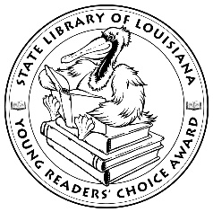

**Louisiana Young Readers’ Choice**

**Ballot 2020-2021**

**Grades 3-5**

**Because of the Rabbit** Cynthia Lord

**Carter Reads the Newspaper** Deborah Hopkinson, illustrated by Don Tate

**The Crayon Man: The True Story of the Invention of Crayola Crayons Natascha Biebow, illustrated by Steven Salerno**

**The Friendship War** Andrew Clements

**Just Like Beverly: A Biography of Beverly Cleary** Vicki Conrad, illustrated by David Hohn

**Martin and Anne: The Kindred Spirits of Dr. Martin Luther King, Jr. and Anne Frank** Nancy Churnin, illustrated by Yevgenia Nayberg

**Mario and the Hole in the Sky: How a Chemist Saved Our Planet** Elizabeth Rusch, illustrated by Teresa Martinez

**Max and the Midknights** Lincoln Peirce

**Operation Frog Effect** Sarah Scheerger

**The Phone Booth in Mr. Hirota’s Garden** Heather Smith, illustrated by Rachel Wada

**Spark** Sarah Beth Durst

**Stargazing** Jen Wang

**Stay** Bobbie Pyron

**Titan and the Wild Boars: The True Cave Rescue of the Thai Soccer Team** Susan Hood and Pathana Sornhiran, illustrated by Dow Phumiruk

**Tito the Bonecrusher** Melissa Thomson

*The Louisiana Young Readers’ Choice Award is a reading enrichment program of the Louisiana Center for the Book in the State Library of Louisiana with additional support from the following:*

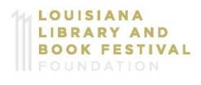

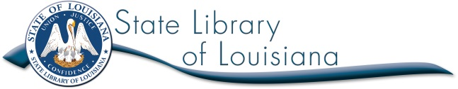



**Louisiana Young Readers’ Choice**

**Ballot 2020-2021**

**Grades 3-5**

**Because of the Rabbit** Cynthia Lord

**Carter Reads the Newspaper** Deborah Hopkinson, illustrated by Don Tate

**The Crayon Man: The True Story of the Invention of Crayola Crayons Natascha Biebow, illustrated by Steven Salerno**

**The Friendship War** Andrew Clements

**Just Like Beverly: A Biography of Beverly Cleary** Vicki Conrad, illustrated by David Hohn

**Martin and Anne: The Kindred Spirits of Dr. Martin Luther King, Jr. and Anne Frank** Nancy Churnin, illustrated by Yevgenia Nayberg

**Mario and the Hole in the Sky: How a Chemist Saved Our Planet** Elizabeth Rusch, illustrated by Teresa Martinez

**Max and the Midknights** Lincoln Peirce

**Operation Frog Effect** Sarah Scheerger

**The Phone Booth in Mr. Hirota’s Garden** Heather Smith, illustrated by Rachel Wada

**Spark** Sarah Beth Durst

**Stargazing** Jen Wang

**Stay** Bobbie Pyron

**Titan and the Wild Boars: The True Cave Rescue of the Thai Soccer Team** Susan Hood and Pathana Sornhiran, illustrated by Dow Phumiruk

**Tito the Bonecrusher** Melissa Thomson

*The Louisiana Young Readers’ Choice Award is a reading enrichment program of the Louisiana Center for the Book in the State Library of Louisiana with additional support from the following:*



