2021-2022 LYRC 6-8 Annotated Nominated Title List
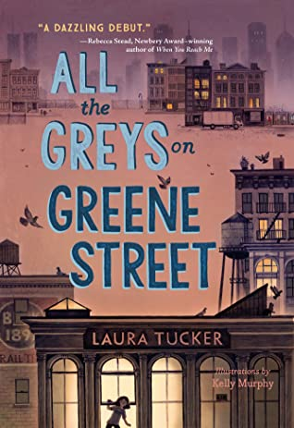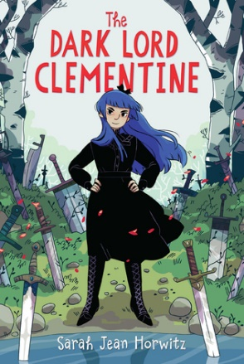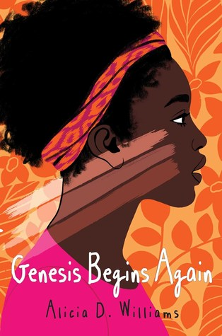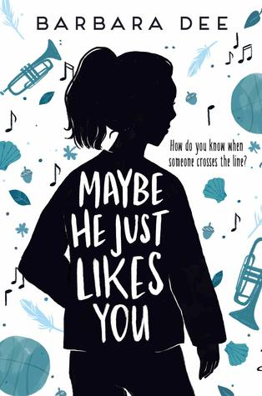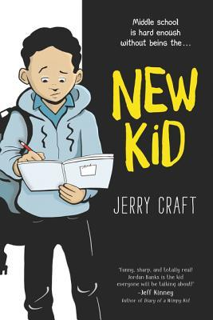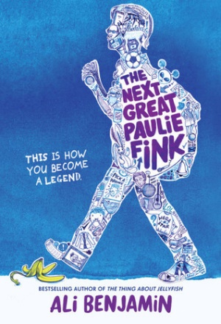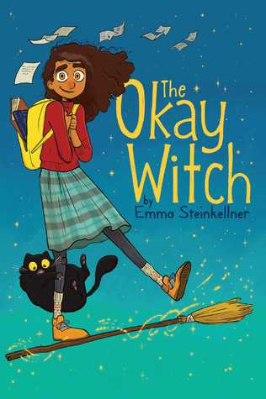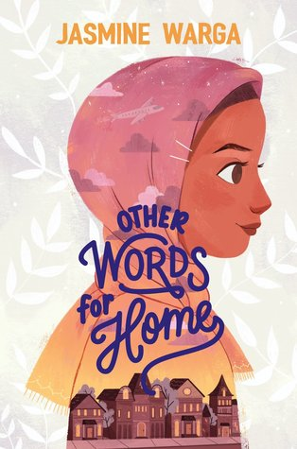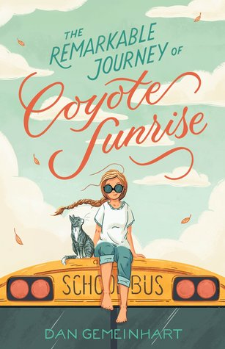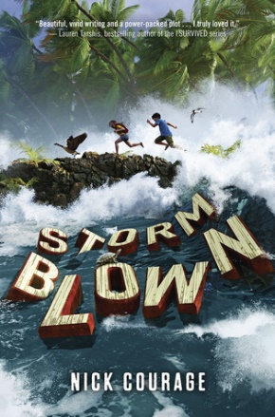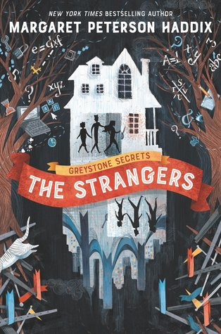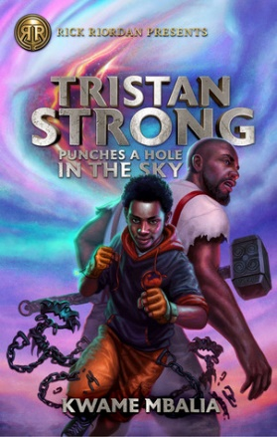

- All the Greys on Greene Street by Laura Tucker
Viking Books for Young Readers (Penguin Random House), 2019. HC: 978-0451479532, 320 pp., $17.99. PB: 978-0451479556, 320 pp., $8.99.
[Historical Fiction, 1981 New York City, white female protagonist, art, mental illness, friendship]
Summary: A 12-year-old artist in 1981 SoHo searches for answers when her father, a restorer of antique paintings, abruptly disappears in the middle of the night. (AR)
Awards: ALSC Notable Children’s Book, Publishers Weekly: Best Books of 2019
Accelerated Reader: IL: MG - BL: 5.9 - AR Pts: 12.0 AR Quiz No. 503860

- Dark Lord Clementine, The by Sarah Jean Horwitz
Algonquin Young Readers (Algonquin Books), 2019. HC: 978-1616208943, 336 pp., $17.95. PB: 978-1643751337, 336 pp., $8.95 (coming April 2021).
[Fantasy, white female protagonist, magic, curses]
Summary: When her father is cursed by a rival witch, twelve-year-old Clementine Morcerous assumes his duties as Dark Lord of the realm, but soon questions her father's code of good and evil. (LOC)
Accelerated Reader: IL: MG - BL: 6.8 - AR Pts: 12.0 AR Quiz No. 506907

- Genesis Begins Again by Alicia D. Williams
Atheneum/Caitlyn Dlouhy Books (Simon and Schuster), 2019. HC: 978-1481465809, 384 pp., $17.99. PB: 978-1481465816, 384 pp., $8.99.
[Realistic, black female protagonist, colorism, texturism, parental alcoholism, poverty]
Summary: Thirteen-year-old Genesis tries again and again to lighten her black skin, thinking it is the root of her family's troubles, before discovering reasons to love herself as is. (LOC)
Awards: Morris Award Finalist, Newbery Honor Book, Coretta Scott King/John Steptoe New Talent Author Award, YALSA Top Ten Best Fiction for Young Adults, ALSC Notable Children’s Book, NPR: Favorite Books of 2019, SLJ: Best Middle Grade Books of 2019, Kirkus: Best Middle Grade Books of 2019
Accelerated Reader: IL: MG - BL: 4.5 - AR Pts: 11.0 AR Quiz No. 199648

- Maybe He Just Likes You by Barbara Dee
Aladdin (Simon and Schuster), 2019. HC: 978-1534432376, 304 pp., $17.99. PB: 978-1534432383, 320 pp., $7.99 (coming September 2020).
[Realistic fiction, white female protagonist, sexual harassment]
Summary: When boys in her class start touching seventh-grader Mila and making her feel uncomfortable, she does not want to tell her friends or mother until she reaches her breaking point. (LOC)
Awards: ALSC Notable Children’s Book, Washington Post: Best Children’s Books of 2019
Accelerated Reader: IL: MG - BL: 4.2 - AR Pts: 7.0 AR Quiz No. 505166

- New Kid (New Kid 1) by Jerry Craft
Quill Tree Books (HarperCollins), 2019. HC: 978-0062691200, 256 pp., $21.99. PB: 978-0062691194, 256 pp., $12.99.
[Realistic fiction, graphic novel, black male protagonist, racism, microaggressions]
Summary: Seventh grader Jordan Banks loves nothing more than drawing cartoons about his life, but instead of sending him to the art school of his dreams, his parents enroll him in a prestigious private school known for its academics. (AR)
Awards: Newbery Award Winner, YALSA Quick Pick for Reluctant Readers List, Coretta Scott King Author Award Winner, ALSC Notable Children’s Book, Publishers Weekly: Best Books of 2019
Accelerated Reader: IL: MG - BL: 2.9 - AR Pts: 2.0 AR Quiz No. 500606

- Next Great Paulie Fink, The by Ali Benjamin
Little, Brown Young Readers (Hachette), 2019. HC: 978- 0316380881, 368 pp., $17.99. PB: 978- 0316380874, 368 pp., $7.99.
[Realistic fiction, white female protagonist, social hierarchy, humor]
Summary: Led by new student Caitlyn, seventh-graders at a tiny rural school in Vermont create a reality-show inspired competition to determine who will replace the school's legendary class clown, Paulie Fink. (LOC)
Awards: Publishers Weekly: Best Books of 2019, Amazon: Best Books of the Month (April 2019)
Accelerated Reader: IL: MG - BL: 4.9 - AR Pts: 9.0 AR Quiz No. 500764

- Okay Witch, The by Emma Steinkellner
Aladdin (Simon and Schuster), 2019. HC: 978-1534431461, 272 pp., $20.99. PB: 978-1534431454, 272 pp., $12.99.
[Fantasy, graphic novel, non-white female protagonist, witches, family secrets]
Summary: When thirteen-year-old Moth Hush learns she comes from a long line of witches, she unlocks a hidden witch world, where secrets from generations past unravel and threaten her family. (AR)
Awards: YALSA Quick Pick for Reluctant Readers List, YALSA Great Graphic Novels for Teens, SLJ: Best Graphic Novels of 2019
Accelerated Reader: IL: MG - BL: 3.1 - AR Pts: 2.0 AR Quiz No. 505277

- Other Words for Home by Jasmine Warga
Balzer + Bray (HarperCollins), 2019. HC: 978-0062747808, 352 pp., $16.99. PB: 978-0062747815, 368 pp., $7.99 (coming April 2021)
[Realistic fiction, verse, Syrian female protagonist, refugees, racism, Islamophobia]
Summary: Sent with her mother to the safety of a relative's home in Cincinnati when her Syrian hometown is overshadowed by violence, Jude worries for the family members who were left behind as she adjusts to a new life with unexpected surprises. (LOC)
Awards: Newbery Honor, ALSC Notable Children’s Book, Publishers Weekly: Best Books of 2019
Accelerated Reader: IL: MG - BL: 5.3 - AR Pts: 5.0 AR Quiz No. 504111

- Remarkable Journey of Coyote Sunrise, The by Dan Gemeinhart
Henry Holt and Co. Books for Young Readers (Macmillan), 2019. HC: 978-1250196705, 352 pp., $16.99. PB: 978-1250233615, 352 pp., $8.99.
[Realistic fiction, white female protagonist, grief, family, friendship, LGBTQIA+]
Summary: Twelve-year-old Coyote and her father rush to Poplin Springs, Washington, in their old school bus save a memory box buried in a park that will soon be demolished. (LOC)
Awards: CYBILS Award Winner, Junior Library Guild Selection, Amazon: Top 20 Children’s Books of 2019
Accelerated Reader: IL: MG - BL: 4.7 - AR Pts: 12.0 AR Quiz No. 199391

- Storm Blown by Nick Courage
Delacorte Books for Young Readers (Penguin Random House), 2019. HC: 978-0525645962, 352 pp., $16.99.
[Realistic fiction, survival, white female protagonist and Puerto Rican male protagonist]
Summary: In San Juan, Puerto Rico, Alejandro worries about his great-uncle while helping guests at a resort, and in New Orleans, Emily worries about her sick brother, as a major hurricane rages, changing both their lives forever. (LOC)
Accelerated Reader: IL: MG - BL: 6.6 - AR Pts: 10.0 AR Quiz No. 503962

- Strangers, The (Greystone Secrets 1) by Margaret Peterson Haddix
Katherine Tegan Books (HarperCollins), 2019. HC: 978-0062838377, 416 pp., $17.99. PB: 978-0062838384, 432 pp., $8.99.
[Science fiction, white male, female, and male protagonists, mystery, missing persons]
Summary: Told from separate viewpoints, Chess, Emma, and Finn Greystone, ages twelve, ten, and eight, investigate why their mother went missing and uncover their ties to an alternate world. (LOC)
Awards: LITA Excellence in Science Fiction, Publishers Weekly: Best Books of 2019
Accelerated Reader: IL: MG - BL: 5.1 - AR Pts: 11.0 AR Quiz No. 501254

- Tristan Strong Punches a Hole in the Sky by Kwame Mbalia
Rick Riordan Presents (Disney), 2019. HC: 978-1368039932, 496 pp., $17.99. PB: 978-1368042413, 528 pp., $8.99 (coming September 2020)
[Fantasy, black male protagonist, inspired by African American folk tales and West African gods]
Summary: Seventh-grader Tristan Strong tumbles into the MidPass and, with allies John Henry and Brer Rabbit, must entice the god Anansi to come out of hiding and seal the hole Tristan accidentally ripped in the sky. (LOC)
Awards: Coretta Scott King Author Honor, ALSC Notable Children’s Book, Publishers Weekly: Best Books of 2019
Accelerated Reader: IL: MG - BL: 4.8 - AR Pts: 15.0 AR Quiz No. 505341

