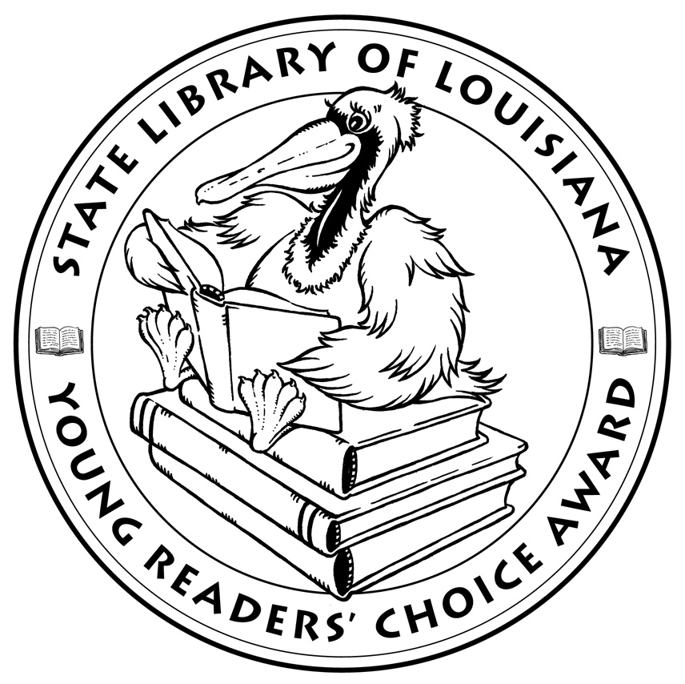

Louisiana’s Young Readers’ Choice
Ballot 2014 Grades 6-8

Charlie Joe Jackson’s Guide to Not Reading. Tommy Greenwald

The Fourth Stall. Chris Rylander

Hidden. Helen Frost

How to Rock Braces and Glasses. Meg Haston

The Prisoner of Cell 25 (Michael Vey, Book 1). Richard Paul Evans

Quarterback Season. Fred Bowen

The Running Dream. Wendelin Van Draanen

Silhouetted by the Blue. Traci L. Jones

Variant. Robison E. Wells

Wild Life. Cynthia DeFelice

Wonderstruck. Brian Selznick

A World Without Heroes. Brandon Mull


State Library of Louisiana
Department of Culture, Recreation and Tourism

Louisiana’s Young Readers’ Choice
Ballot 2014 Grades 6-8

Charlie Joe Jackson’s Guide to Not Reading. Tommy Greenwald

The Fourth Stall. Chris Rylander

Hidden. Helen Frost

How to Rock Braces and Glasses. Meg Haston

The Prisoner of Cell 25 (Michael Vey, Book 1). Richard Paul Evans

Quarterback Season. Fred Bowen

The Running Dream. Wendelin Van Draanen

Silhouetted by the Blue. Traci L. Jones

Variant. Robison E. Wells

Wild Life. Cynthia DeFelice

Wonderstruck. Brian Selznick

A World Without Heroes. Brandon Mull

State Library of Louisiana
Department of Culture, Recreation and Tourism

