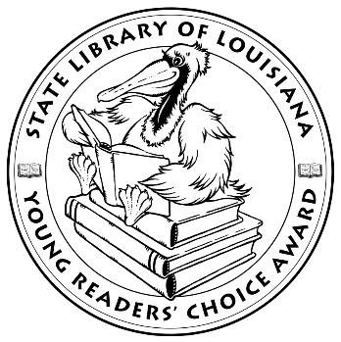

**Louisiana Young Readers’ Choice**

**Ballot 2021-2022**

**Grades 6-8**

**All the Greys on Greene Street** Laura Tucker

**The Dark Lord Clementine** Sarah Jean Horwitz

**Genesis Begins Again Alicia D. Williams**

**Maybe He Just Likes You** Barbara Dee

**New Kid (New Kid 1)** Jerry Craft

**The Next Great Paulie Fink** Ali Benjamin

**The Okay Witch** Emma Steinkellner

**Other Words for Home** Jasmine Warga

**The Remarkable Journey of Coyote Sunrise** Dan Gemeinhart

**Storm Blown** Nick Courage

**The Strangers (Greystone Secrets 1)** Margaret Peterson Haddix

**Tristan Strong Punches a Hole in the Sky (Tristan Strong 1)** Kwame Mbalia

*The Louisiana Young Readers’ Choice Award is a reading enrichment program of the Louisiana Center for the Book in the State Library of Louisiana with additional support from the following:*











**Louisiana Young Readers’ Choice**

**Ballot 2021-2022**

**Grades 6-8**

**All the Greys on Greene Street** Laura Tucker

**The Dark Lord Clementine** Sarah Jean Horwitz

**Genesis Begins Again Alicia D. Williams**

**Maybe He Just Likes You** Barbara Dee

**New Kid (New Kid 1)** Jerry Craft

**The Next Great Paulie Fink** Ali Benjamin

**The Okay Witch** Emma Steinkellner

**Other Words for Home** Jasmine Warga

**The Remarkable Journey of Coyote Sunrise** Dan Gemeinhart

**Storm Blown** Nick Courage

**The Strangers (Greystone Secrets 1)** Margaret Peterson Haddix

**Tristan Strong Punches a Hole in the Sky (Tristan Strong 1)** Kwame Mbalia

*The Louisiana Young Readers’ Choice Award is a reading enrichment program of the Louisiana Center for the Book in the State Library of Louisiana with additional support from the following:*





